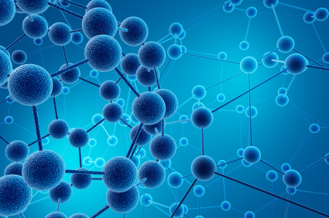The Geography of Science

Lesson 1: Introducing flashpoints

Key ideas:
- What are geographical flashpoints?
- Swine flu, the Sichuan earthquake and climate change are all examples of flashpoints.
- What role/interest do geographers and scientists have to play in these flashpoint examples?

Starter activity:
What are geographical flashpoints?
Students brainstorm examples of different major world events that can impact many people/places. E.g. Tsunamis, hurricanes, pandemics, volcanic eruptions, forest fires, floods, draughts, landslides.

Main activity:
Investigating flashpoints:
Flashpoints are major world events which may impact on a large number of people/places which can be used to focus on how geographers and scientists can work together to find solutions.

Task:
1) Using the three flashpoint fact files, students fill in the table on the resource sheet entitled “What are flashpoints?” You might find it useful to produce this resource on A3 paper.

Students could study all three flashpoint cards individually or in pairs/groups. Alternatively, you might prefer to split the class into groups to consider one card each and then share the results with the rest of the class.

2) Using the downloadable PowerPoint quiz, students could answer the quiz questions about the three flashpoints in pairs/small groups or as a class. Students will need to have read/need to use all three flashpoint fact files for this activity.

Plenary:
Reinforce key issues of the lesson. Perhaps include:

What are flashpoints?
What flashpoint examples have we studied?
Why are flashpoints of interest to both geographers and scientists?
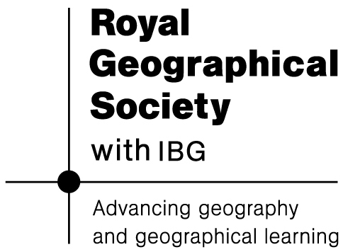
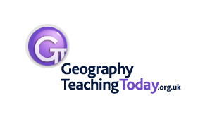
Can you think of any other specific flashpoint examples that we could also have studied?

