Interdependent India
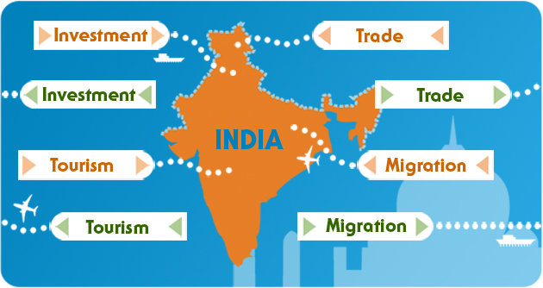

Look at the 8 facts below, all about India:

1. 6.2million Indian tourists holiday abroad every year. This is increasing by 15% annually. 700,000 visited the UK in 2006.

2. India has signed many international treaties or agreements to make the world safer. It is the world’s second largest contributor to UN peace keeping forces with 10,000 troops.

3. The success of hi-tech industries has seen large numbers of Indians return, in what is being called the ‘brain gain’.

4. Millions of tourists visit India for its scenery, food, spirituality and more. In 2006, more than 150,000 medical tourists who flew in for lipo-suction and open heart surgery for a fraction of what they would pay at home.

5. India buys goods and services from other countries. Gucci, Chanel and Giorgio Armani fashion imports are rising by 11% a year.

6. Millions of Indians live in other countries. 2.5 million live in the US. One in nine Indian Americans is a millionaire – that’s 10% of America’s millionaires.

7. India sells goods and services to other countries. Its firms spent over $7billion buying-out foreign companies in 2006.

8. Hundreds of foreign companies have set up outsourcing centres in India. 30 major firms from Lloyds TSB to Virgin Trains use Indian call-centres.

Each fact fits into one of the following categories:

- Trade coming into India
- Trade going out from India
- Investment coming into India
- Investment going out from India
- Tourism coming into India
- Tourism going out from India
- Migration coming into India
- Migration going out from India

Which fact belongs in which category? Correct answers are at the bottom!

When you’ve sorted out all the facts into their categories, sum up, in one sentence, how India is interdependent with other countries.

Answers to the questions are on the next page.
Answers:

1. 6.2million Indian tourists holiday abroad every year. This is increasing by 15% annually. 700,000 visited the UK in 2006. Tourism - out

2. India has signed many international treaties or agreements to make the world safer. It is the world’s second largest contributor to UN peace keeping forces with 10,000 troops. Investment - out

3. The success of hi-tech industries has seen large numbers of Indians return, in what is being called the ‘brain gain’. Migration - in

4. Millions of tourists visit India for its scenery, food, spirituality and more. In 2006, more than 150,000 medical tourists who flew in for lipo-suction and open heart surgery for a fraction of what they would pay at home. Tourism - in

5. India buys goods and services from other countries. Gucci, Chanel and Giorgio Armani fashion imports are rising by 11% a year. Trade - in

6. Millions of Indians live in other countries. 2.5 million live in the US. One in nine Indian Americans is a millionaire – that’s 10% of America’s millionaires. Migration - out

7. India sells goods and services to other countries. Its firms spent over $7billion buying-out foreign companies in 2006. Trade - out

8. Hundreds of foreign companies have set up outsourcing centres in India. 30 major firms from Lloyds TSB to Virgin Trains only use Indian call-centres. Investment - in

