MODULE 2: what causes climate change?

STUDENT ACTIVITY
The global climate has changed many times over the geological history of the earth, scientists can use rocks and fossils to reconstruct the climate of a place over millions of years. There are natural events and cycles which will alter the climate of the world significantly, such as solar activity and volcanic eruptions. There are three ways in which the climate of the earth can be changed. The temperature of the Earth is determined by the balance between energy coming in from the Sun in the form of visible radiation (sunlight) and energy constantly being emitted from the surface of the Earth to outer space in the form of invisible infrared radiation (heat).
- By changing the incoming energy from the Sun, for example by changes in Earth’s orbit or in the Sun itself;
- By changing the fraction of solar radiation that is reflected, for example by changes in cloud cover, vegetation or atmospheric particles such as volcanic material.
- By changing greenhouse gas concentrations, for instance, the amount of carbon dioxide in the atmosphere.

Activity one
Changes in solar activity affect global temperatures by changing the amount of incoming energy from the Sun. Changes in the energy output of the Sun, and the Earth’s orbit around the Sun, do have an effect on the Earth’s climate.
Ice ages have come and gone in regular cycles for nearly three million years. There is strong evidence that these are linked to regular variations in the Earth’s orbit around the Sun, the so-called Milankovitch cycles. These cycles change the amount of the Sun’s energy received by different places on the Earth’s surface. Graphic 2.1 shows the Variation in the energy output of the Sun over the past 150 years

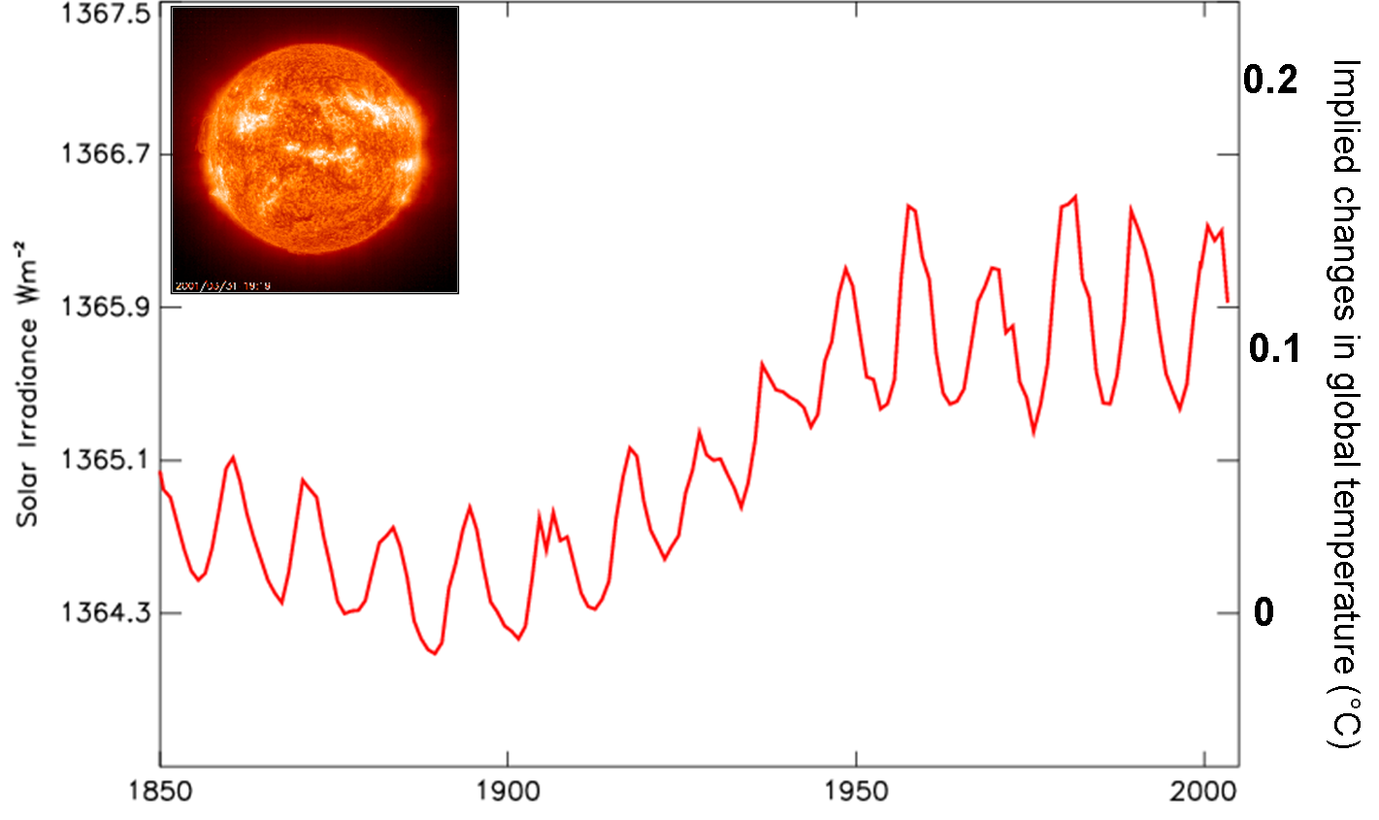
Met Office Hadley Centre for Climate Prediction and Research, 2005, Climate Change and the greenhouse effect. P10

- This graphic shows the Sun's energy output over typical 11 year cycles.
- The horizontal, x, axis, shows the time in years from 1850 to 2000.
- The vertical, y, axis , shows the amount of energy the earth gets from the Sun.
- The Sun's energy output varies with the number of sun spots, on an 11 year cycle.

- During which period is there the greatest increase in the energy output of the sun?
- How significant do you think this in explaining the evidence for climate change?

Activity two
There were three volcanic eruptions big enough to affect the climate in the 20th century by changing the fraction of solar radiation that is reflected.
Material (particles) from violent volcanic eruptions can be projected far above the highest cloud, and into the stratosphere where they can significantly increase how much incoming solar energy is reflected. Major volcanic eruptions can reduce average global surface temperature by about 0.5°C for months or even years. Graphic 2.2 shows a measure of the amount of volcanic dust in the atmosphere
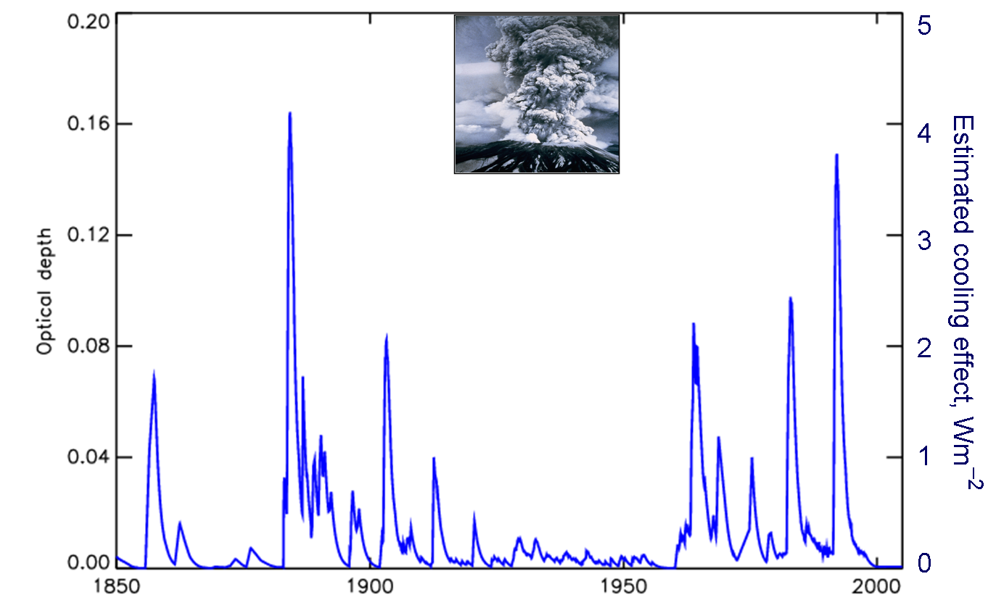
Met Office Hadley Centre for Climate Prediction and Research, 2005, Climate Change and the greenhouse effect. P11
- This graphic shows the amount of volcanic dust in the atmosphere from 1850-2000.
- The horizontal, x, axis shows time in years from 1850-2000.
- The vertical, y, axis shows the amount of volcanic dust in the atmosphere.

- Identify the three spikes in the graph with the greatest measure of volcanic dust in the atmosphere in the 20th century.
- Use the internet or reference books to research the names and dates of these volcanoes.
- What is the name and date of the volcano that caused the largest spike in the graph in the 19th century?

Activity three
The temperature of the Earth is determined by the balance between energy coming in from the Sun in the form of visible solar radiation (sunlight) and energy constantly being emitted from the surface of the Earth to outer space in the form of invisible infrared radiation (heat).
Clouds can affect the amount of solar radiation reaching the surface of the earth. Clouds are made up of water vapour and vary in their altitude in the atmosphere and their thickness.
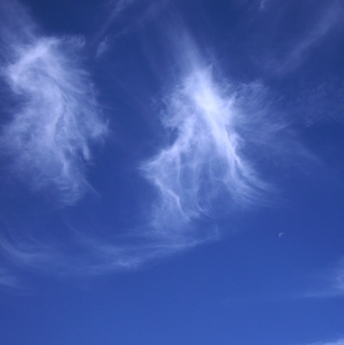
Royal MeteOrological Society CloudBank
High clouds like these cirrus clouds tend to warm the climate because they can absorb infrared radiation (heat) from the Earth's surface.
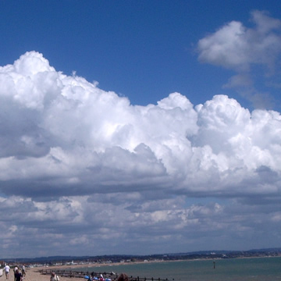
Royal MeteOrological Society CloudBank
Low clouds like the cumulus clouds tend to cool the climate because they can reflect away incoming solar energy.
- Make a diary of the types of clouds where you live and the temperature over a week

Activity four
The energy coming in from the Sun can pass through the clear atmosphere pretty much unchanged and therefore heat the surface of the Earth. But the infrared radiation emanating from the surface of the Earth is partly absorbed by some gases in the atmosphere, and some of it is re-emitted downwards. The effect of this is to warm the surface of the Earth and lower part of the atmosphere. This is called the greenhouse effect.

The absorbing gases in the atmosphere are primarily water vapour (responsible for about two-thirds of the effect) and carbon dioxide. methane, nitrous oxide, ozone and several other gases present in the atmosphere in small amounts also contribute to the greenhouse effect. .

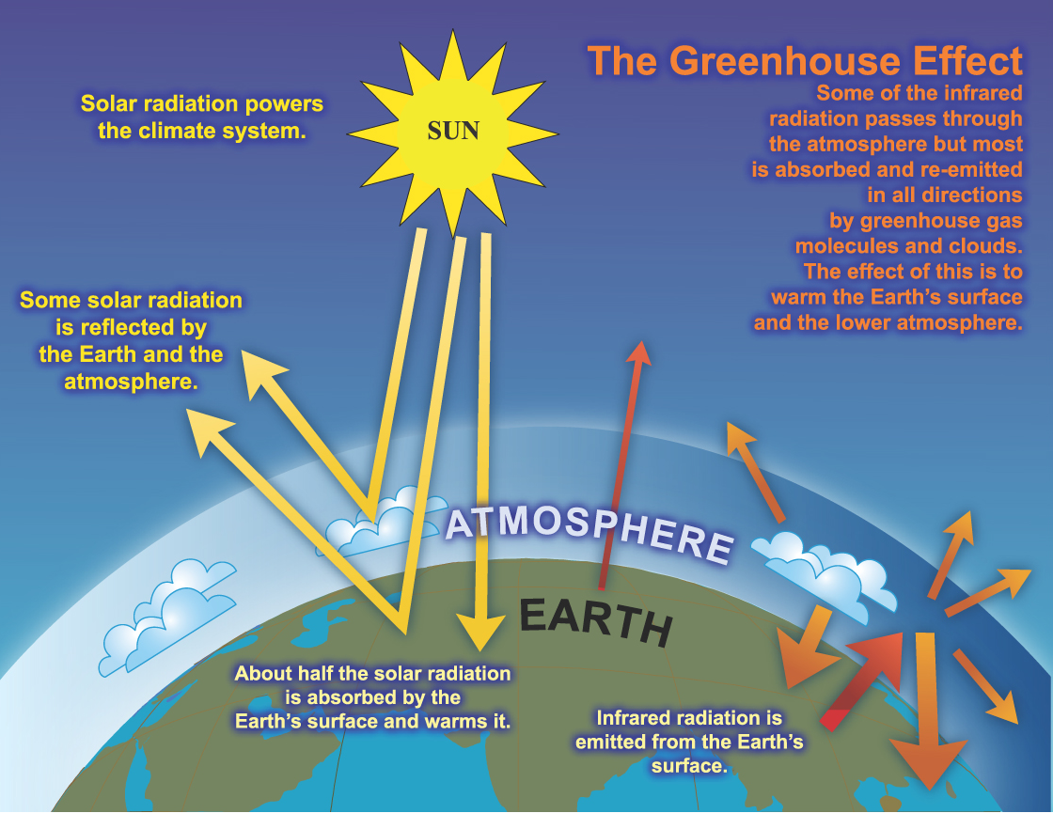
Intergovernmental Panel on Climate Change (2007) IPCC Fourth Assessment Report. Climate Change. [Accessed June 2009] Available from World Wide Web: http://ipcc.ch/graphics/graphics/ar4-wg1/jpg/faq-2-1-fig-1.jpg

You can see an interactive model at http://www.geographyteachingtoday.org.uk/images/activities/climate_system.html

- What would happen to the atmospheric temperature of the earth if there was no greenhouse effect?
- What would that mean for life on earth?

PERSONAL ACTIVITY
Why do you think it is called the ‘greenhouse’ effect?

WHAT ARE THE EFFECTS OF HUMAN ACTIONS?
There are three ways in which the climate of the earth can be changed. The temperature of the Earth is determined by the balance between energy coming in from the Sun in the form of visible radiation (sunlight) and energy constantly being emitted from the surface of the Earth to outer space in the form of invisible infrared radiation (heat). Human actions can contribute to them.
- By changing the incoming energy from the Sun, for example by changes in Earth’s orbit or in the Sun itself.
- By changing the fraction of solar radiation that is reflected, for example by adding sulphate particles to the atmosphere or removing vegetation. This can alter the amount of solar radiation that is absorbed by a surface and not reflected back into Space. A light coloured surface such as snow or a white roof will reflect back the radiation; a dark coloured surface such as tarmac or bare earth will absorb the radiation.
- By changing greenhouse gas concentrations, for instance, the amount of carbon dioxide in the atmosphere has increased by about 35% in the industrial era, and this increase is known to be due to human activities, primarily the burning of fossil fuels and removal of forests.

Activity Five
Naturally occurring gases in our atmosphere, such as carbon dioxide and methane, provide an insulating effect without which the earth would be a frozen planet. However, levels of greenhouses gases in the atmosphere have increased, preventing more heat escaping to Space and leading to ‘global warming’.

Graphic 2.5 shows levels of carbon dioxide, methane and nitrous oxide in the atmosphere over the past 2000 years. Any increases in the levels of greenhouse gases in the atmosphere mean that less heat escapes to Space and global temperatures increase - an effect known as 'global warming'.

Over the past 150 years in the industrial era, human activities have increased the emissions of three principal greenhouse gases: carbon dioxide, methane and nitrous oxide. These gases accumulate in the atmosphere, causing concentrations to increase with time.
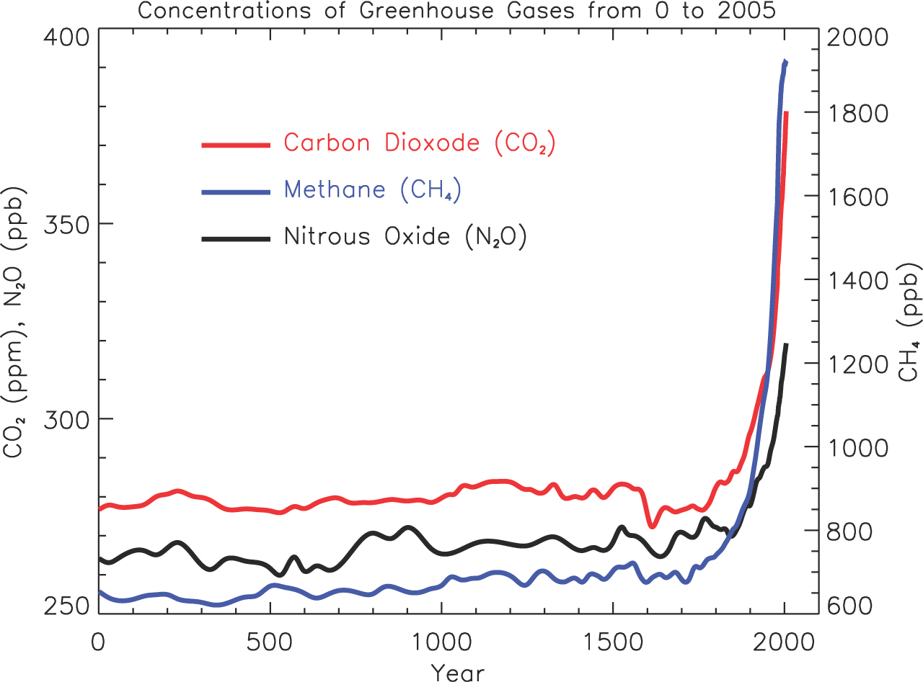
Intergovernmental Panel on Climate Change (2007) IPCC Fourth Assessment Report. Climate Change. [Accessed June 2009] Available from World Wide Web: http://ipcc.ch/graphics/graphics/ar4-wg1/jpg/faq-1-3-fig-1.jpg

- The horizontal, x, axis shows time in years from 0 to 2000 AD.
- The vertical, y, axis shows the concentration of each gas in the atmosphere.
- Each coloured line shows the amount of one greenhouse gas in the atmosphere.

- What has happened to the concentrations of greenhouses gasses since 1800?
- Investigate which human activities contribute to increasing the levels of
  - Carbon dioxide (CO₂)
  - Methane (CH₄)
  - Nitrous oxide (N₂0)

There are other, lesser, contributors such as CFCs (whose emissions have decreased substantially) and ozone.

Water vapour is the most abundant and important greenhouse gas in the atmosphere. Each greenhouse gas can only ‘trap’ radiation with a specific range of wavelengths. Water vapour already traps all the outgoing radiation it can. As the climate changes and the amount of water vapour in the atmosphere changes, there will therefore be little effect on the amount of heat trapped.

Aerosols are small particles present in the atmosphere with widely varying size, concentration and chemical composition. Fossil fuel and biomass burning have increased aerosols containing sulphur compounds, organic compounds and black carbon (soot).

The world’s climate has been getting warmer since 1900. However, this overall warming has not occurred evenly across the world’s surface and different places, because of their location and geography, are affected in different ways.

Activity Six
Scientists use computer modelling to help them to explain patterns such as the observed rise in global average temperatures. In this Graphic 2.6 the green area shows climate model recreations of 20th century climate, when only the natural changes in volcanic and solar activity are fed into the model.
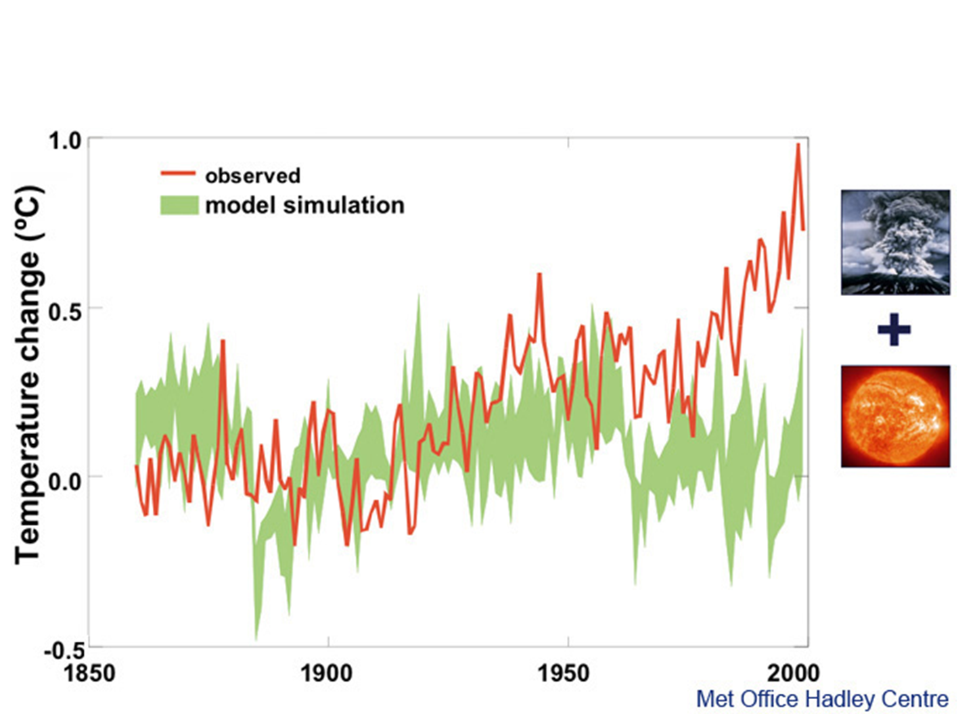
Met Office Hadley Centre for Climate Prediction and Research, 2005, Climate Change and the greenhouse effect. P28/29

- The horizontal, x, axis shows time in years from 1850 to 2000
- The vertical, y, axis shows how different the temperature is from the 1961-1990 average.
- The red line shows the temperature of the Earth's surface, as measured by instruments and satellites.

- What do you notice about the observed temperatures and the model simulation?
In Graphic 2.7 changes in atmospheric greenhouse gas concentrations and other human-made pollutants are fed into the model along with the natural changes of volcanic eruptions and solar activity.
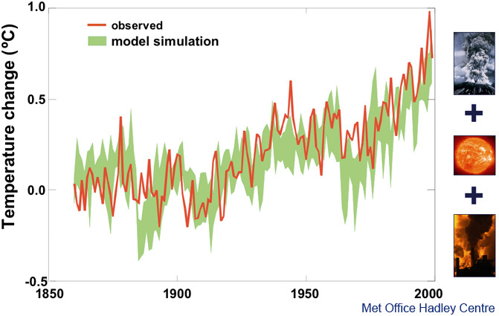
Met Office Hadley Centre for Climate Prediction and Research, 2005, Climate Change and the greenhouse effect. P28/29

- What do you notice about the observed temperatures and the model simulations?

Activity Seven
Create a five-minute PowerPoint presentation about the causes of climate change.
Either create your own PowerPoint presentation or use the PowerPoint template from the Climate4Classrooms website. This template gives you a structure for your presentation and detailed notes on 8 slides. Simply add titles, graphics and extra information.
Work in pairs and use the facts, figures, graphs, diagrams and photos in Graphics 1-10 from the website and in units 1 – 6 (plus your own research if desired) to explain the following:
- What is climate change?
What does it mean? How is our climate changing?
- How is it caused?
What are the natural causes of climate change (e.g. changes in the Sun’s energy)? What is the greenhouse effect? (Mention that it is an important natural phenomenon and without it, the Earth would be too cold to support human life.) How has the greenhouse effect changed over time? (Mention that levels of greenhouse gases in the atmosphere have increased, trapping in more heat and leading to global warming).
- How are people contributing to it?
What are people doing to increase the amount of greenhouse gases in the atmosphere (e.g. burning more fossil fuels such as coal or gas which emit CO₂). What evidence do you have to prove this?
Additional tips for learners
- Before you begin, decide who your audience is, e.g. your class, an assembly for younger students in your school or an after-school parents meeting. You will need to explain why is it important that they know more about climate change?
- Think of a title for your presentation, e.g. ‘Climate change uncovered’, and subtitles for each section. Divide it into approximately 10-15 screens and plan what goes on each one.
- Use signposts to guide your audience. Include a contents slide to show what they can expect to learn; which parts you will talk about first, middle, and last; and what will happen at the end of your presentation.
- Communicate information creatively, e.g. a powerful image or cartoon, a compelling quote, a shocking statistic, or a gripping animation or audio interview.
- Make difficult concepts easy to understand, e.g. use a diagram to explain the greenhouse effect or make it personal by showing how people contribute to it.
- Back everything up with evidence, e.g. the world’s leading scientists think global temperatures are likely to rise by 2-4°C before the end of the 21st century.
- Involve your audience. This will allow you to check that they understand you, keep them more attentive, and give you the opportunity to learn from them. Try these:
  - Every 2-3 slides, insert a few simple questions to review the information you have just presented, e.g. what is this picture is showing; what do you find most surprising about this?
  - Ask someone in the audience to describe a picture or diagram. This gives another perspective on the information and shows how people interpret information differently.
  - Halfway through your presentation, ask your audience to get into pairs and spend two minutes discussing the top things they have learnt so far. Choose a few pairs to report back.
- Use the five golden rules of presenting which you can find on the Climate4Classrooms website to keep your audience alert and amazed!

PERSONAL ACTIVITY
After the presentation reflect on what worked well and what could have worked better, how would you communicate the information differently next time?
UNDERSTANDING EMISSIONS
One of the main greenhouse gasses is carbon dioxide which comes from using fossil fuels. Not all countries produce the same amount of carbon dioxide and not all individuals within a country produce the same amount. The amount of carbon dioxide produced by an individual or a country is called a carbon footprint.

Activity Eight
Graphic 2.7 shows the global emissions of carbon dioxide from the various forms of fossil fuels.

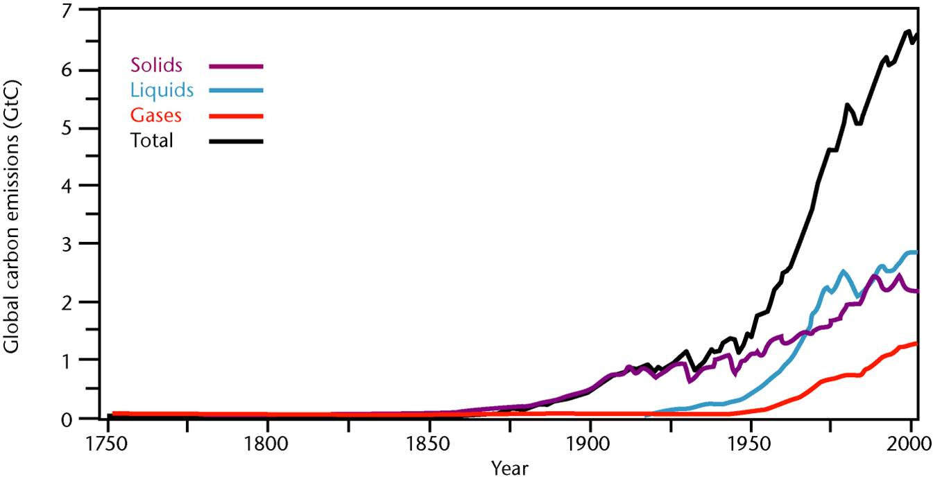
Met Office Hadley Centre for Climate Prediction and Research, 2005, Climate change and the greenhouse effect. P12

- The purple line shows changes in emissions from solid fuel (mainly coal).
- The blue line shows changes in emissions from liquid fuel (oil).
- The red line shows changes in emissions from gases.
- The black line shows the total emissions from burning fossil fuels

- When does the rise in the carbon dioxide emissions begin?
- Why do you think this is?
- When does the more rapid rise in the carbon dioxide emissions begin?
- Why do you think this is?

Activity Nine
Study Graphic 2.8. Anthropogenic emissions are those which come from human generated activities, such as driving a car or heating a building. The graphic shows changes in emissions, population, wealth and energy use across the world.
IPCC Fourth Assessment Report – Climate Change is Real and Here! By Ms Lucka Kajfez Bogataj, Former IPCC WG II Vice-chair

- What do you notice about the relationship between the number of the world’s population, their wealth and emissions?

Activity Ten
In this map, Graphic 2.9, countries have been re-sized to show them in proportion to the amount of carbon emissions they emitted in 1980.
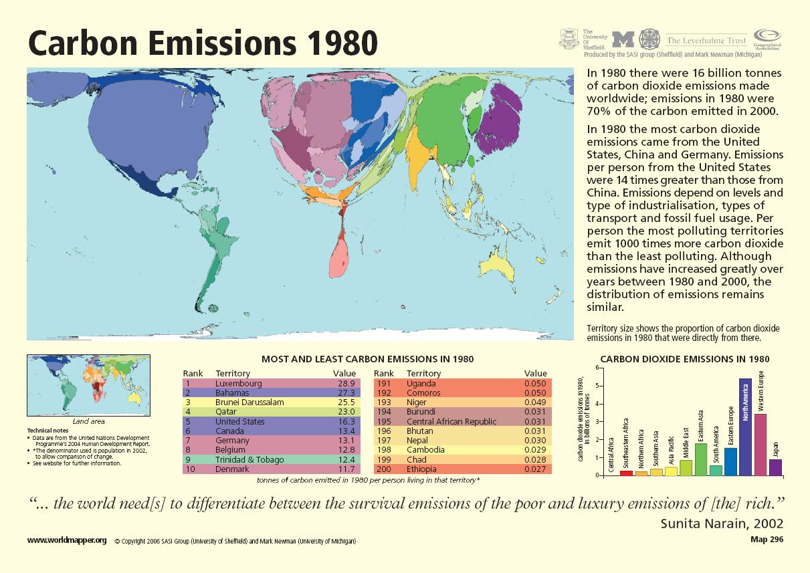

Graphic 2.10 shows how countries have been re-sized to show them in proportion to the amount of carbon emissions they emitted in 2000.

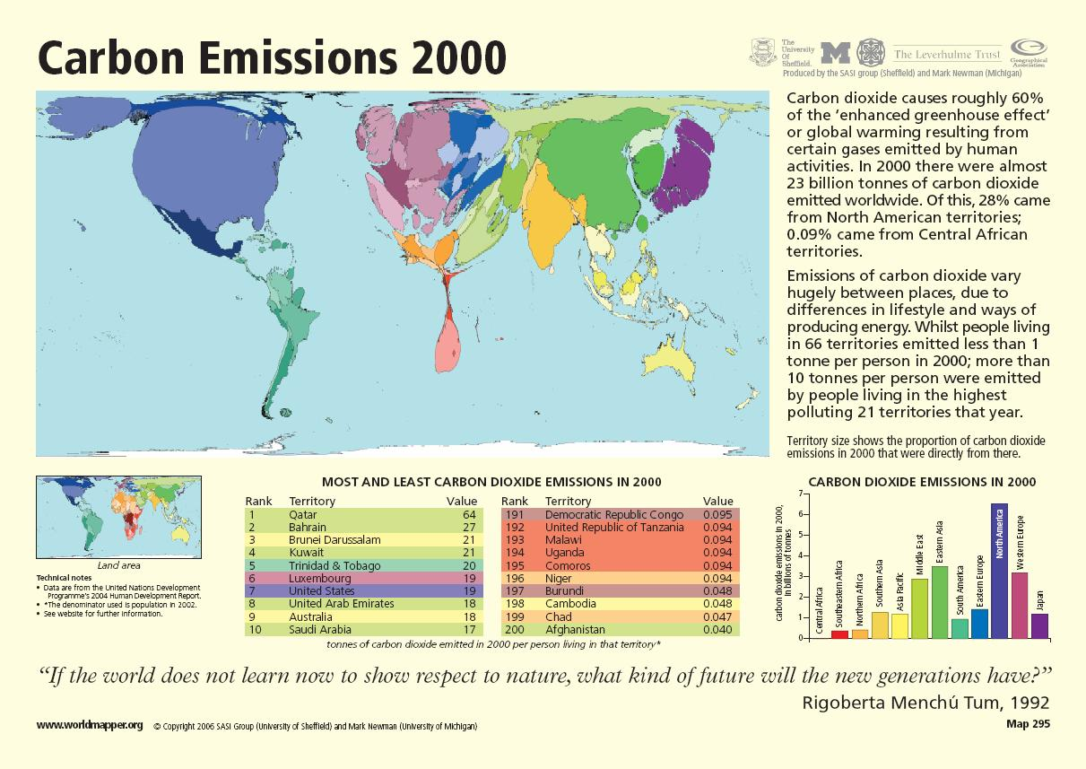

- Compare these shapes with an ‘ordinary’ world map. Identify three oversize countries, i.e. larger than their actual geographical size, and three undersize countries. What does this mean?
- Find the UK. Which continent is it bigger than in 1980 and again in 2000? What does this mean?
- Study the list of countries below the map. What does ‘value’ refer to? Which countries emitted most and least carbon per person in 1980 and 2000? Which countries appear on both lists? Have their positions changed and if so, why could this be?
- Read the information to the right of both maps. What are you most surprised to learn?
- In pairs, use all of this information to create five questions. Answer your questions in full. Cut the out the answer (not the question) and swap with another pair, asking them to figure out your original question. Share with the class.
- Study the bar-graphs in the bottom right corners of both maps. What changes have occurred in twenty years? Have any regions reduced their CO₂ emissions?

Activity Eleven
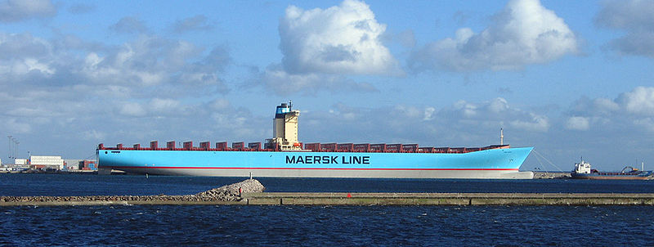
The world's longest ship, a quarter of a mile long, arrives in Britain from China to deliver goods for Christmas in 2006. More than 12,000 MP3 players, 9,000 pairs of trainers and nearly two million Christmas decorations are part of the largest ever consignment of Christmas goods to reach Europe.

China now is to the 21st Century as Britain was to the 19th Century – the world's manufacturing superpower. In the 19th century, Britain was the ‘Workshop of the World’. Now China is the 21st Century's ‘Workshop of the World’.
China is now the world's biggest manufacturer and exporter of toys, steel and electrical goods and has overtaken the United States of America in terms of the amount of carbon dioxide it produces.

- Why has China overtaken the USA in terms of the amount of carbon dioxide it produces?
- However the average American person produces nearly three times as much carbon dioxide than the average Chinese person. Can you think of reasons to explain this?

Activity Twelve
Categorise the following statements as to whether or not they are high carbon producing activities or low carbon producing activities. Then categorise them as to whether they are affected by location, wealth or knowledge about the effect of carbon dioxide emissions.
- People living in colder climates use energy to heat their homes
- People install solar panels
- People living in hot climates use air conditioning
- People insulate their homes
- Some of the poorest countries are located in tropical climates and people are too poor to afford air conditioning. They have to find alternative ways to cool their houses.
- People go on holiday abroad and travel by plane
- People go on holiday in their own country and travel by train
- People do not go on holiday
- People drive large four wheel cars
- People drive small hybrid cars
- People do not own cars
- People buy new goods
- People buy second hands goods

Can you think of some more examples of lifestyle actions which are affected by location, wealth or knowledge?

PERSONAL ACTIVITY
Complete a carbon footprint questionnaire such s the one in http://www.yourclimateyourlife.org.uk/1_footprint.html
How could you change your lifestyle to reduce your carbon footprint?

