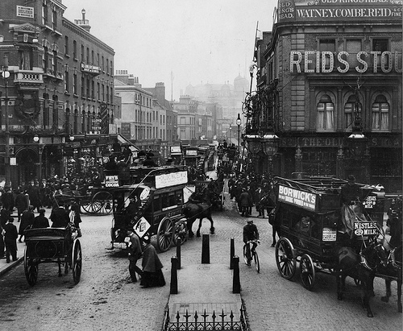
Our Place in History

Lesson 3: Mapping change

Key ideas:
- The growth of an area and change over time can be mapped.
- Similarities and differences between the local area in the past and today can be identified.

Starter activity:
What’s in a name?
The aim of this lesson is to investigate maps of the past and from today to study change over time – but also to practice map skills. Pupils should, for this starter activity, find out the origins of the name of their local settlement using the University of Nottingham’s Institute for Name-Studies website. They should then look at an OS map of the area which can be obtained from the Ordnance Survey website and see whether they can find any evidence for the settlement’s name. This can be quite challenging, but many settlements are named after the physical features of their site and so these should be looked for. As an extension, pupils could think up an alternative name that they would give the settlement, justifying their answer using evidence from the map.

Main activity:

Mapping growth
In this activity, pupils capture a series of three maps through time from the Old-Maps website. The choice of dates should be theirs, but they should aim to include as much spread as possible to show change. They can then shade in areas of growth from one map to the next and highlight and annotate similarities and differences.

Landscape archaeology
The BBC’s Britain from Above website is an excellent introduction to looking at landscape and it might be worth introducing this activity with a clip from the local area. Pupils could then use Google Earth and the accompanying information sheet to carry out some basic armchair landscape archaeology. As an extension, they can add this information to their maps from the ‘Mapping growth’ activity.

Plenary:
A question of mapping the past
To conclude this lesson, pupils take part in a quiz which could be organised individually, in small groups or between two larger teams. They select a number between 0 and 9 on a grid, and a question on mapping the past appears. The answers are given on each slide and the questions are generic, thus asking pupils to apply their knowledge to a more general situation.

