Map of Antarctica

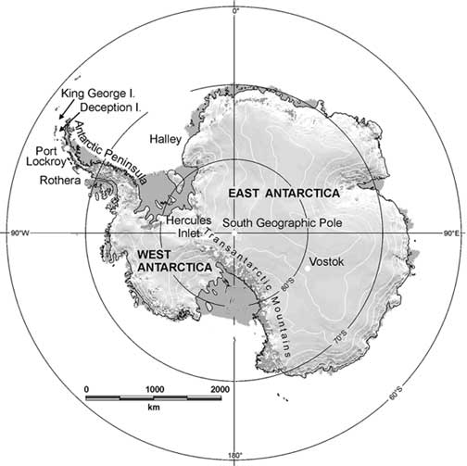
Source: British Antarctic Survey

On the map label the Ross Sea, Weddell Sea, Ross Ice Shelf and Mount Erebus.

