Using Google Maps www.maps.google.co.uk/

A: Using what’s already there

- Use the arrow tab  to view the map ‘whole screen’

- Use the scale buttons to ZOOM IN 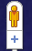 and ZOOM OUT .
(Notice the change in map type/detail at each scale.)

- PAN around the map by left clicking the direction arrows. 
To use your mouse instead, left click, hold and drag.
Return to your original position with the ‘centre arrow’ button.

- Change the VIEW to MAP, SATELLITE, EARTH or TERRAIN. 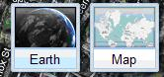
Notice the different features you can see with each view.

- SEARCH the map using the name of a place you would like to investigate.

- Turn the LAYERS on and off to view photographs, videos and Wikipedia information, property information and MORE (public transport, webcams etc.).

Discussion points

- What geographical information can you find that helps you investigate your place of interest?
- Which geographical skills are being practised here?

B: Creating a new map

- Use the SIGN IN tab at the top right.
  - Email: [insert an email from the pre-course task]
  - Password: [insert a password]

- Click on the Create new map link (in the left panel). Use your name so you know who the work belongs to!

- Add a PLACEMARK to your map.

- Practise adding a title, text and a placemark symbol.
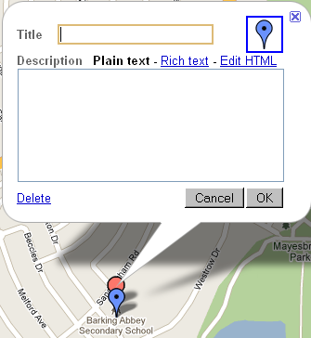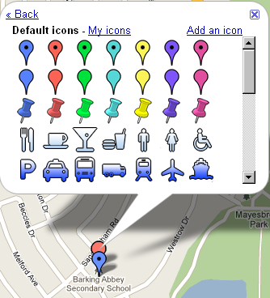

- Add a WEB LINK to a website, video or audio clip. Highlight the text and click the symbol to hyperlink.

- Try adding and editing a LINE and a SHAPE to your map.
- View your map in Google Earth

Discussion point

- Share some teaching and learning ideas, based on the use of these simple digital maps.

C: Adding photographs to your map

1. Find a photograph anywhere on the internet!

2. Right click the photograph and select PROPERTIES.

3. Highlight the entire URL (‘address’) of the photograph by left clicking and dragging the mouse over the URL. Right click and COPY this URL.

4. Return to your placemark in Google Maps.

6. EITHER click the INSERT IMAGE button. (A SCRIPT PROMPT box should appear at the top of your screen. If there is no SCRIPT PROMPT, click the yellow bar at the top of the screen to ‘allow temporary permission’.) Right click and PASTE the URL of your photograph into the script prompt box. Click OK.

7. OR open the menu of place mark symbols and ADD AN ICON. Paste the URL of the image into the script prompt box to turn the image into a map icon.

8. To add your OWN photographs (e.g. from fieldwork) – use the Panoramio instruction sheet.

D: Sharing your work

1. Decide on the PRIVACY SETTINGS for your map.

2. Click COLLABORATE and decide whom to invite, and what powers to give them!

3. Think how to use RATE THIS MAP and ADD A COMMENT functions.

4. Practise SENDING or LINKING your map e.g. to a colleague, school website or blog.

Google maps icons explained

Pan around the map. The central button returns you home.
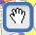
This pan icon is used in the EDIT function.

Zoom in and out. Notice how the features and map view change. You can also RIGHT click the mouse to zoom in/out.

Shows different map views

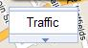 Shows video, photograph and Wikipedia information on the map

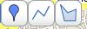
Add a point, line or area in EDIT. For lines and areas, double click to finish the shape. Delete and move nodes if you make a mistake…

Word processing tools – for use in edit mode.

(This tool allows you to add a link to a website e.g. a video clip)

Allows a photograph to be pasted in as a link.

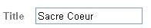
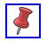
Edit the icon and title for a place marker.

Finally! View in Google Earth…
Search for places of interest
Google Maps basic navigation (www.maps.google.co.uk/)
Arrow tab to use the map ‘whole screen’

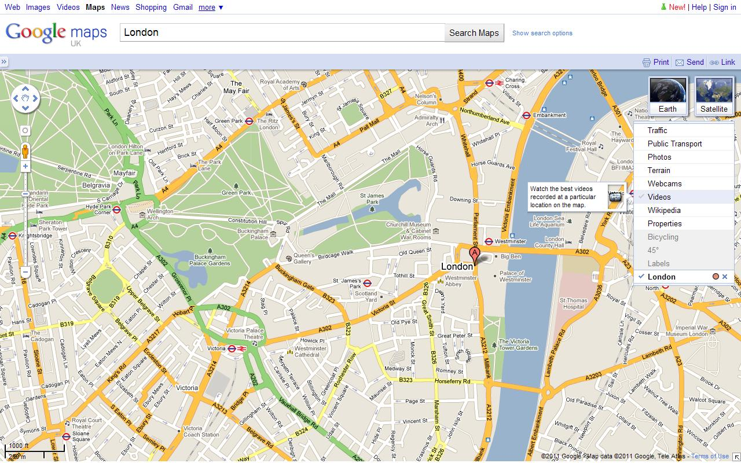
ZOOM IN and ZOOM OUT
PAN around and return to position
View function: map, satellite, earth or terrain
Layers function shows photos, video, Wikipedia content and more …

