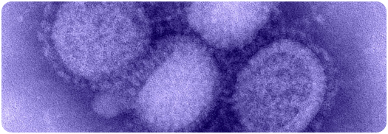

Swine flu is a virus that infects and is carried by pigs. This condition is common amongst pig populations throughout the world. Whilst it is rare for the virus to mutate into a form that can be caught by human beings this is exactly what happened in the 2009 episode. Although it is rare that a swine flu will become transmissible by humans, it has happened many times before. Eating pork from an infected animal does not convey a risk so long as the meat is properly cooked.
When contracted by a human being, the human form of swine flu has symptoms such as: chills, fever, sore throat, muscle pains, headache, coughing, weakness and discomfort.
Margaret Chan, the World Health Organisation’s Director General identified the condition as a “public health emergency of international concern,” when the first cases were reported in the USA.
Swine flu has about the same degree of mortality as other viruses. The USA has indicated that it expects that for every 1000 persons contracting the flu, 40 will be hospitalised, and one will die. If a large country has a large number suffering from the flu, it is therefore likely to have a high loss of life. As a result of this, many countries are developing a programme to vaccinate their populations for the winter months when flu can be easiest to contract and most difficult to recover from.
In order to prepare for the onset of such a virus, a country needs to protect itself at its borders and ensure that people entering the country are not bringing the virus in. This is of course a difficult task as often the symptoms may not show on a person who is carrying the virus. In Shanghai a container ship arrived where one of the crew was ill. The sailor had to be removed and quarantined until he was regarded as being no longer a risk.
The development of a virus can be uncertain but one can never be too careful

What to do with flu information

There has been much better information about the spread of flu as the result of the work of epidemiologists (scientists who study the spread of disease). This is where geography becomes important, tracking the location and growth of the virus.

Swine flu ‘flu

Flashpoint 1

swine flu: a journey across the world

Viruses such as Swine Influenza (swine flu) travel across the world quickly, transported by people travelling. Once it arrives in a new country it starts to spread.
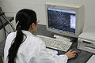
Preparing a country, let alone the planet, for the onset of a global pandemic is a very big job. It involves millions of people, all of whom have to be carefully briefed. In some areas workers at borders, airline staff etc will be at greater risk of coming into contact with the human form of the condition, and this too needs to be managed.
Geographers conduct research in epidemiology. They carefully review information that is collected and put the information on maps to find patterns. They carefully record the dates of the information and using computers are able to see the growing and or changing pattern of the spread (diffusion) of the virus. This information is very important in planning for the spread of the virus and for preparing hospitals, medical staff and for putting in place ways of reducing the likelihood of people contracting the virus.
Those looking at the virus will also need to find out what is causing the virus to move quickly and which kinds of areas are being affected. This requires not only an understanding of the virus itself, but also the way we live, where we move, which kinds of people are ‘on the move,’ and where the people are who might be most vulnerable.
The pattern of swine flu contagion in the world is an interesting one, and of particular concern is that, relatively early in the process the UK has become a virus ‘hot spot,’ exceeding the
cases in other European countries.
The development of the pandemic within Britain has been somewhat unexpected and Jeremy Laurance in the Independent suggested that this might be a blessing in disguise as it might allow the virus to pass through the population whilst the weather has been warmer meaning that it is likely less people might die from the virus. He suggests that it might just be that Britain is a little ahead of what will soon affect other countries.

Links

NHS information about Swine Flu:

BBC News: Swine flu: country by country:

Wordlist
Disease
Contagion
Diffusion
Virus
Pandemic
Epidemic

Finding further information:
Look at the sites listed below for further information. At the time of writing the swine flu pandemic was still developing without there being any certainty of its final size and scope. Look carefully at websites you know such as the BBC or Wikipedia. When you find another site, one with which you may be less familiar, try to see who produces the page, when it was last updated and seek the advice of an adult if you cannot find this information. When using the internet it is important to see who is providing information, because there are both sources of good and poor information on the internet.
“A public health emergency”

What Ya gunna do?

Preparing for Swine Flu is a massive undertaking

Britain is among the top half dozen global hot spots for swine flu. Along with Mexico, where the disease originated, the US, Canada, Chile, Argentina and Australia, we are leading the way in the battle against the bug. We have more cases, and more deaths, than any other country in Europe and the pandemic is growing exponentially here, with 55,000 new cases last week, while it is subsiding elsewhere, notably in Mexico. And because we are in the front line, we are having to learn as we go.

The Independent on Sunday, 17 July 2009.

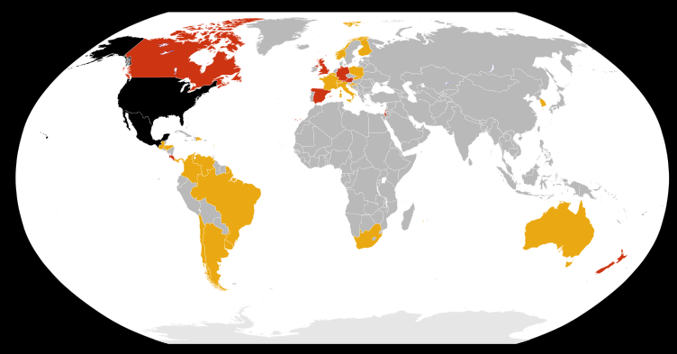

Swine Flu infected countries as of 30th April 2009

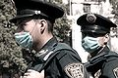

Images from Wikimedia Commons and licensed for use under Creative Commons License.

