Plate boundaries and tectonic activity

In the faded map below you can see the location of the plate boundaries.
On the right of the map there is a list of the ten significant earthquakes and volcanic eruptions since 1900. Map these on the chart below using your atlas or the Internet as means for locating these places.
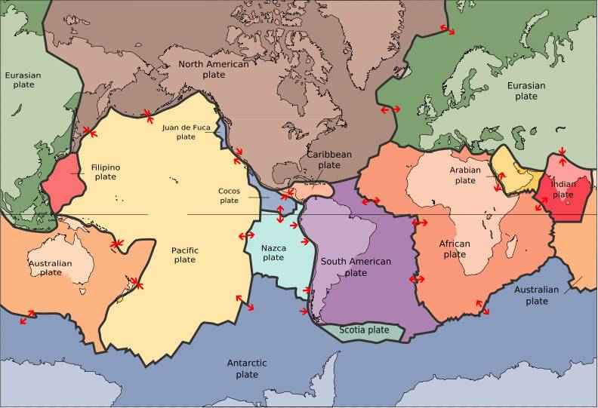

Significant Earthquakes:
1906 Off the coast of Ecuador 8.8
1923 Kamchatka 8.5
1950 India-China border 8.6
1952 Kamchatka 9.0
1957 Andreanof Islands, Aleutian Islands 9.1
1960 Chile 9.5
1964 Prince William Sound, Alaska 9.2
1965 Rat Islands, Aleutian Islands 8.7
2004 Off western Sumatra coast, Indonesia 9.0
2005 Northern Sumatra, Indonesia 8.7

Significant Eruptions:
1902 Mont Pelée, Martinique
1912 Novarupta, Alaska
1914-1917 Lassen Peak, California
1980-1986 Mount St. Helens, Washington
1983+ Kilauea, Hawaii
1984 Mauna Loa, Hawaii
1984 Nevado del Ruiz, Colombia
1986 Augustine Volcano, Alaska
1989-1990 Redoubt Volcano, Alaska
1991 Pinatubo Volcano, Philippines
1995+ Soufriere Hills Volcano, Montserrat, West Indies

What do you notice about the location of the earthquakes and volcanoes in relation to the tectonic plates?

………………………………………………………………………………………………………………………………………………………………………………………………

Look up maps in your atlas or on the Internet to see just how closely these events track plate boundaries. (Map from worldatlas.com)

………………………………………………………………………………………………………………………………………………………………………………………………………………

