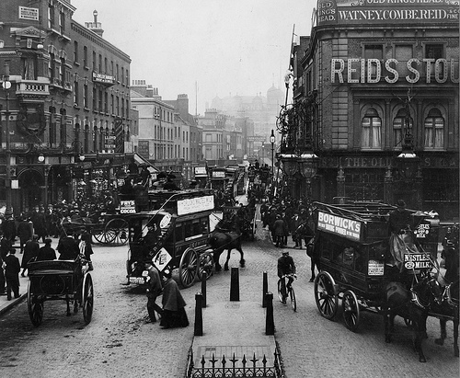
Our Place in History

Lesson 6: Going into the field

Key ideas:
- A number of fieldwork techniques can be used to investigate the local area.
- All fieldwork has certain limitations which have an impact on the data.

Starter activity:
The human camera
This first activity encourages pupils to think about the important aspects of their local area. They work in pairs with one of them being a human camera and the other being the photographer. After a ‘photograph’ is taken (the camera is led – eyes shut – to a particular location and then opens their eyes for 5 seconds to ‘capture’ the image) the human camera describes the image of the location and adds description as to how it sounds, smells and feels. These descriptions could then be shared with the rest of the class.

Main activity:
Going into the field
The main aim of this fieldwork is to investigate the different aspects of the local area which have been covered in the lessons. However, it is also designed to be flexible and can be tailored to the local area and time.

The activities include:
1. Street name search – Students map street names which may give an insight into the local history.
2. Life through the lens – students take photographs in their modern setting and compare them with old photographs taken from the same spot.
3. The local museum – students visit the local museum in order to find out more about the local area in both the recent and more distant past.
4. Local detective – students walk around a small part of the local area photographing and making notes about interesting things which might tell them about their local history.
5. The blue plaque trail – As an extension of the activity in lesson 2, students could walk the trail of blue plaques to see where famous people lived in their area in the past.
6. In religious buildings – Students can visit the local religious building which can provide a vast array of information about the past.

Plenary:
Plenary triangle
It is important that pupils can be critical about their fieldwork and are able to evaluate their findings. Pupils can complete a plenary triangle highlighting 3 interesting things which they have discovered, 2 limitations with their fieldwork and 1 thing which they could do to extend their fieldwork. These could then be discussed with the rest of the class to highlight similarities and differences.




