River basin flooding, climate change and London

The following questions are designed for AS-level students studying river flooding or climate change hazards (Edexcel, AQA, OCR and WJEC). An example is included first of a question that scored full marks at AS-level. Read it carefully, and the examiner comment, before you answer the questions set.
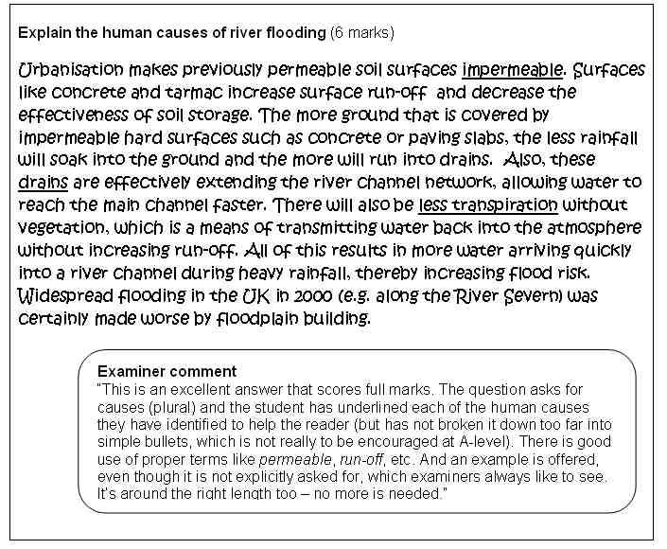

1. With reference to a river you have studied, explain why flood risk has changed over time. (6 marks)

……………………………………………………………………………………………………………

……………………………………………………………………………………………………………

……………………………………………………………………………………………………………

……………………………………………………………………………………………………………

……………………………………………………………………………………………………………

……………………………………………………………………………………………………………

……………………………………………………………………………………………………………

……………………………………………………………………………………………………………

……………………………………………………………………………………………………………

…………………………………………………………………………………………………………....

2. Explain the economic consequences that flooding of a major river like the Thames would bring. (6 marks)

……………………………………………………………………………………………………………

……………………………………………………………………………………………………………

……………………………………………………………………………………………………………

……………………………………………………………………………………………………………

……………………………………………………………………………………………………………

……………………………………………………………………………………………………………

……………………………………………………………………………………………………………

……………………………………………………………………………………………………………

……………………………………………………………………………………………………………

……………………………………………………………………………………………………………

……………………………………………………………………………………………………………

