MODULE 4: HOW DO WE PREDICT THE FUTURE?

Activity 1: Table 1
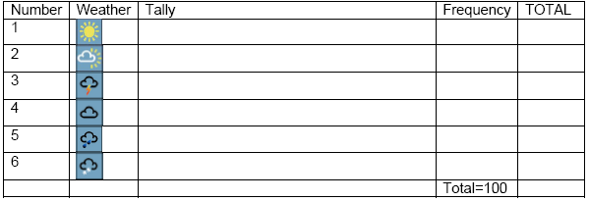
- Roll a dice and imagine it tells you the ‘weather’, e.g. 1 means sunny, 2 means sunny intervals, and so on (see the table below). Roll it 100 times and keep a tally of the numbers that appear in a table like the one below.
- In the ‘frequency’ column, note the number of times each number appears. In the ‘total’ column, put the sum of the numbers in that row, e.g. if 6 appears 10 times, write 60.
- We can compare this to the weather and climate. Each of the numbers on the dice correspond to a particular ‘weather’, with an equal probability of getting each different kind of ‘weather’ (or number on the dice). The climate is the average weather – so in this example, the climate is the average of all the numbers you have thrown. Work this out by adding up all the numbers in the ‘total’ column, and dividing by 100.
- If you throw the dice another 100 times, can you predict what the climate will be? Can you predict what the weather will be on the next throw?
- If the sides of the dice were labelled 11-16 instead of 1-6, can you predict what the new climate would be? Could you predict the weather (the number on the next throw) with any more certainty?
- Scientists find it difficult to predict what the weather is going to be like in five days time, but this doesn’t mean they cannot discover how the climate may change. The climate, or average weather, is determined by large scale features – such as how much energy the Earth is getting from the Sun. The day to day weather is much less predictable: it can be very similar to, or very different from, the climate. Can you bias your dice (change the climate) e.g. by sticking a bit of blue tack on one face? What does this tell us?

