Using Google Chart Generator http://dexautomation.com/googlechartgenerator.php

Google Chart Generator is easier to use when viewed ‘full screen’.

Bar Chart – in this example, students observed people in a location and counted the number of people there for business, shopping or as tourists (based on their attire!)
5. Add a key and colour here.
1. The chart title is typed here and the font size and colour set
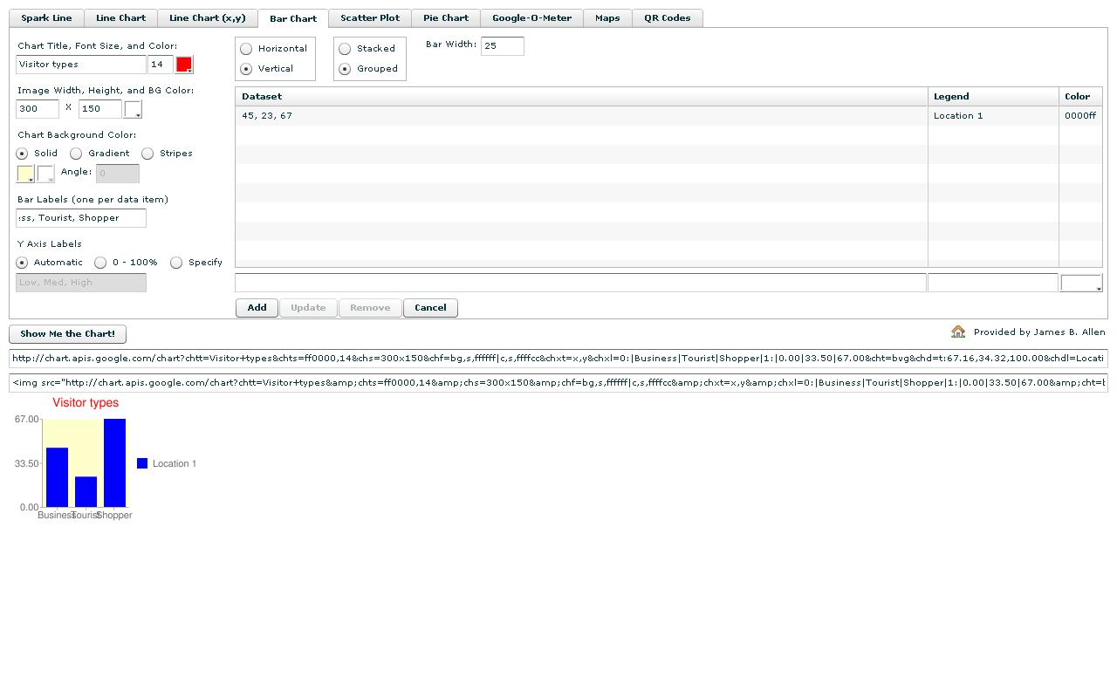

3. Type the labels for each category here
2. The chart background colour can be blank, solid colour or striped
4. Enter the data with commas and click ‘Add’
6. Generate the chart by clicking here
7. This is the URL. Copy and paste this into Google Maps as an image or place mark

