Assessment Quiz

- Look at the map below, can you name the continent?

…………………………………………………………………………………….........

- Can you name and locate the two oceans that border South America?

…………………………………………………………………………………………..

- Look at the map below, can you name and locate Brazil on the map?

…………………………………………………………………………………………..

- Look at the map below, can you name and locate the 10 countries that share a border with Brazil?

…………………………………………………………………………………………

…………………………………………………………………………………………

- Look at the map below, can you name and locate the capital city of Brazil?

…………………………………………………………………………………………..

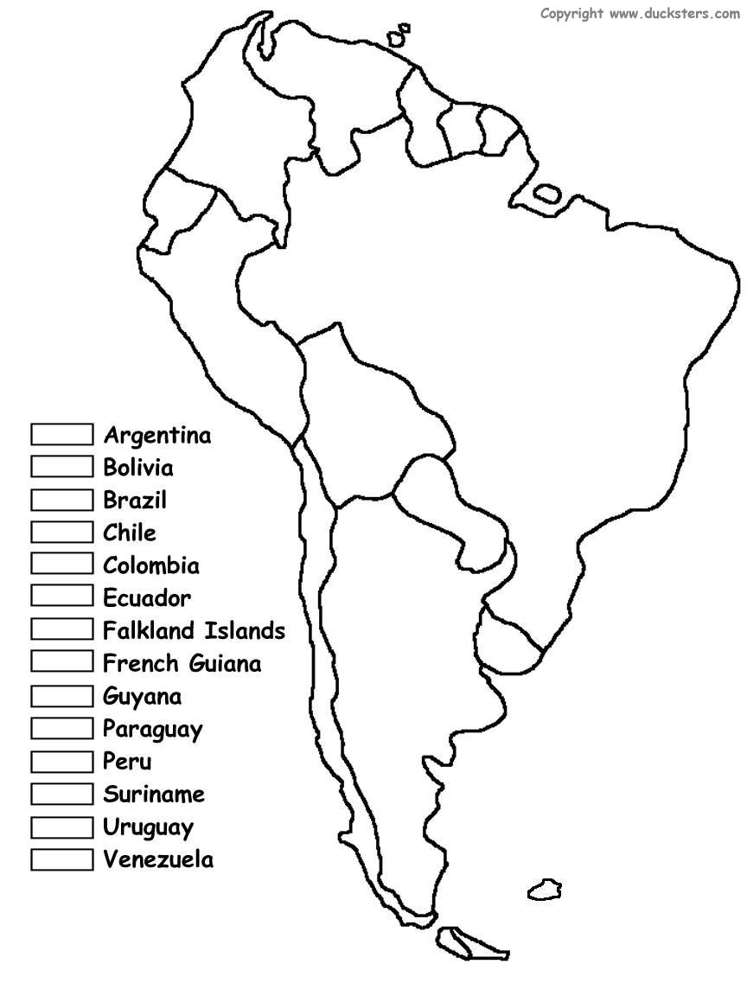

- Can you name three large cities in Brazil (excluding the capital city)?

…………………………………………………………………………………………..

- What is the name of the longest river in Brazil?

…………………………………………………………………………………………

- What is the name of the largest mountain range in Brazil?

…………………………………………………………………………………………..

- A) What is a human feature? Provide examples.

……………………………………………………………………………………….....

…………………………………………………………………………………………..

B) What is a physical feature? Provide examples.
…………………………………………………………………………………………

…………………………………………………………………………………………..

- A) Can you name the six geographical regions of Brazil?

……………………………………………………………………………………….....

…………………………………………………………………………………………..

B) Can you describe any of the features of these regions?

……………………………………………………………………………………….....

…………………………………………………………………………………………..

