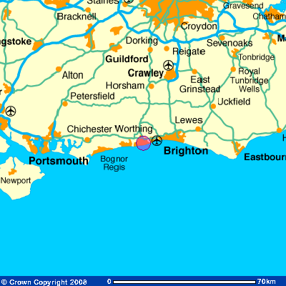
Worthing is a large seaside town with a population of around 100,000 people situated on the south coast of England. It is in the county of West Sussex. Worthing has had some famous residents in the past, including the musician Billy Idol and the author and playwrite Oscar Wilde.

Traditionally, Worthing has had an above average number of elderly residents. Over 23% of the population is aged over 65 years (the UK figure is 17%, and in some areas, for example the London Borough of Wandsworth, the figure is only 10%). Why do you think this is?

The population pyramid for Worthing reflects these figures, showing that the town has more older residents and fewer younger residents than the UK average.

However, as you can also see from the population pyramid, Worthing has quite a large proportion of people between the ages of 30 and 45 years. This is a recent trend, and possibly reflects the number of people moving into Worthing as a cheaper alternative to nearby Brighton. In 2008, the average house price in Brighton and Hove was £271,874; in Worthing it was over £50,000 cheaper at £217,874.

In 2006, Worthing Borough Council approved a project to regenerate parts of Worthing. This is how the council sees the Worthing of the future:
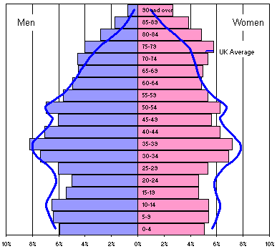
Source: UK National Statistics online

How do you think the council’s plans will affect Worthing’s population in the future?

Do you think the plans will attract younger people to the town?
A Living Town - a place where people will want to live, work, invest and visit.
A Sustainable Town - a place that will meet current and future needs
A Well Connected Town - improved accessibility and linkages
An Inclusive Town - a place with something for everyone
A More Competitive Town - a dynamic economy and a competitive retail and business centre
A More Attractive Destination - an enhanced tourism and leisure offer
A More Attractive Town - a high quality environment with a good range of facilities
A Town Which Looks To The Future - whilst respecting its heritage
(Source: Worthing Regeneration website)


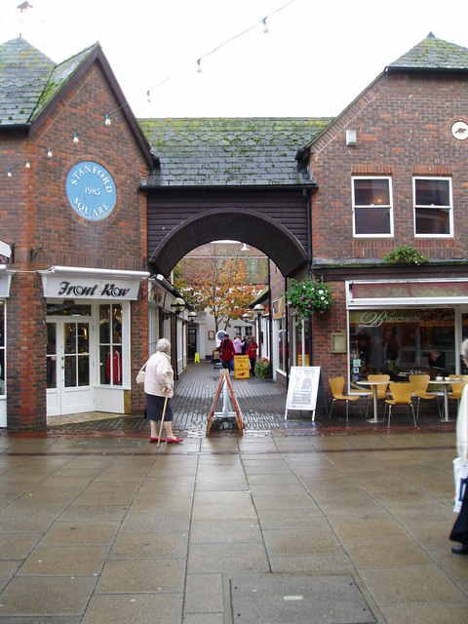
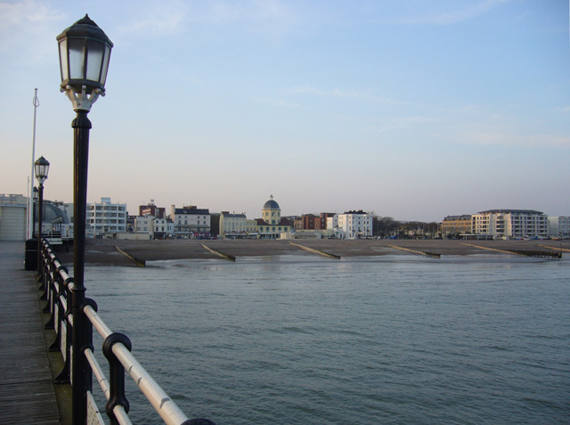
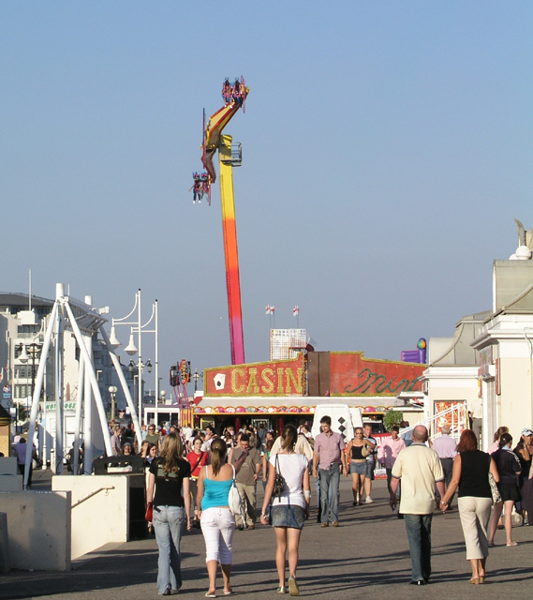
© Peter Holmes
© Katharine Oakeshott
© Andy Potter

