Who can do what?

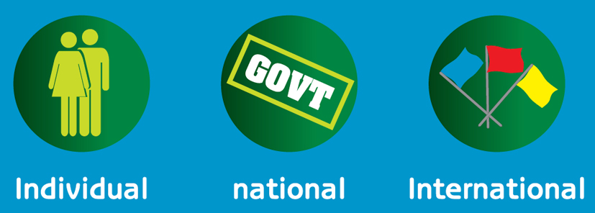

We can't stop the effects of the greenhouse gas emissions that have already taken place. But we can influence the future. But who can do what?

Decide whether each of the following 17 actions are best carried out at local scale [ L ], national scale [ N ] or International scale [ i ].

1. Install wall installation .
[ ]

2. Electricity powered by renewable energy.
[ ]

3. Use public transport.
[ ]

4. Buy locally produced vegetables.
[ ]

5. Wash clothes at a lower temperature.
[ ]

6. Provide cycle lanes.
[ ]

7. Support farmers to grow organic produce.
[ ]

8. Invest in renewable energy.
[ ]

9. Build energy efficient homes.
[ ]

10. Higher taxes on goods and activities that produce higher levels of carbon emissions.
[ ]

11. Pledge to cut carbon emissions.
[ ]

12. Work with European Union, G8 and UN to find ways to reach agreement on action to avert dangerous climate change.
[ ]

13. Invest in public transport.
[ ]

14. Use emission trading schemes.
[ ]

15. Offset carbon emissions.
[ ]

16. Develop ways of capturing and storing carbon dioxide.
[ ]

17. Ban incandescent light-bulbs.
[ ]

