
Source: huffingtonpost.com
Source: ecologyintofocus.blogspot (Daniele Bragança)

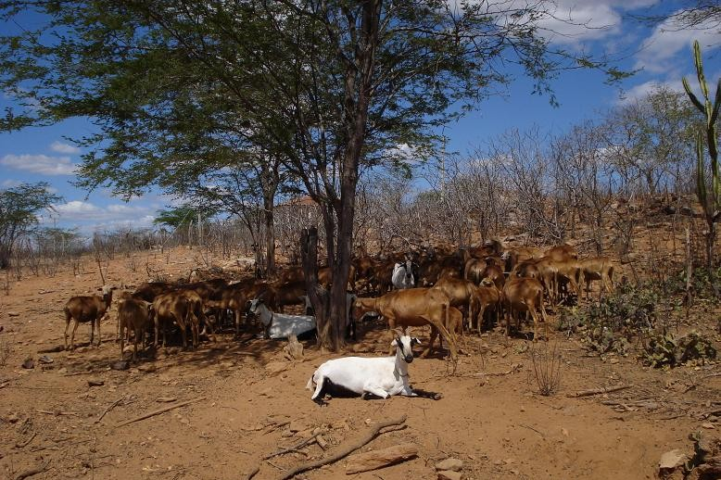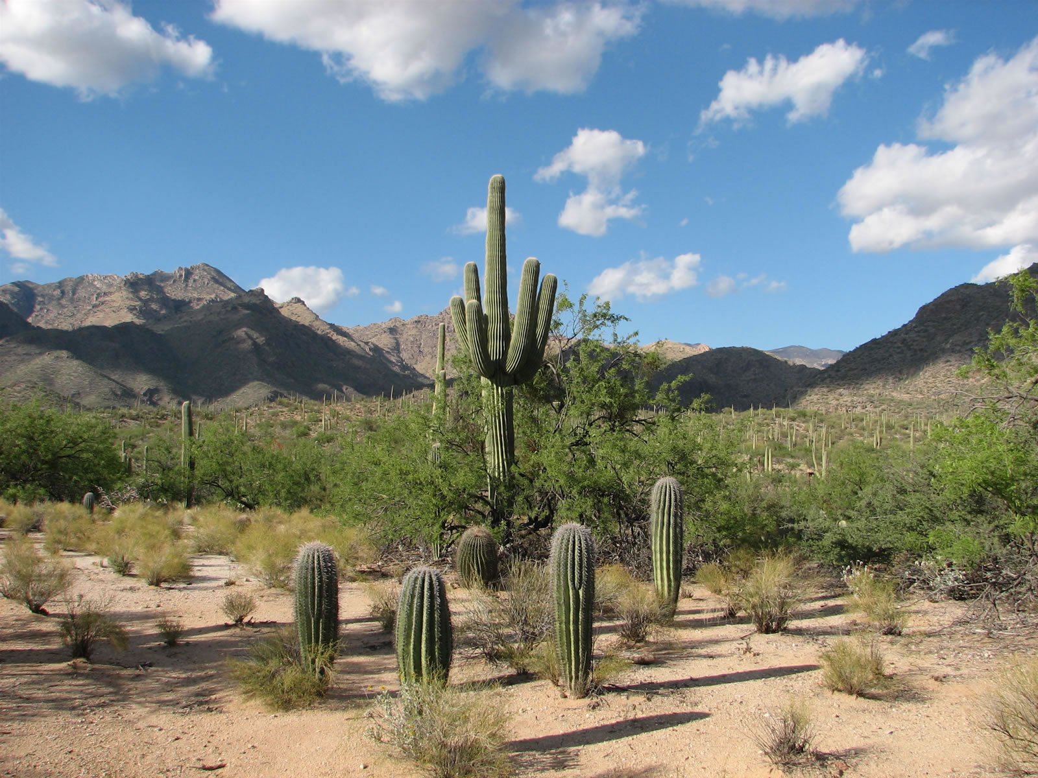
Source: ecologyintofocus.blogspot (Daniele Bragança)

Source: pinterest, Andre Hirohara

