One source of historical gazetteers is the Vision of Britain website. To access an historical description of your local area use the website www.visionofbritain.org.uk/index.jsp
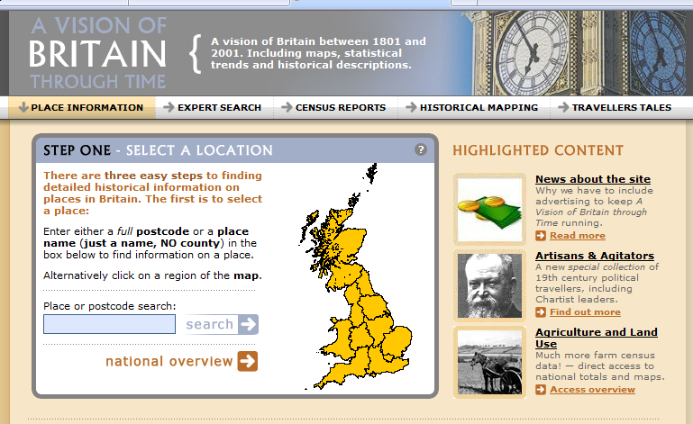

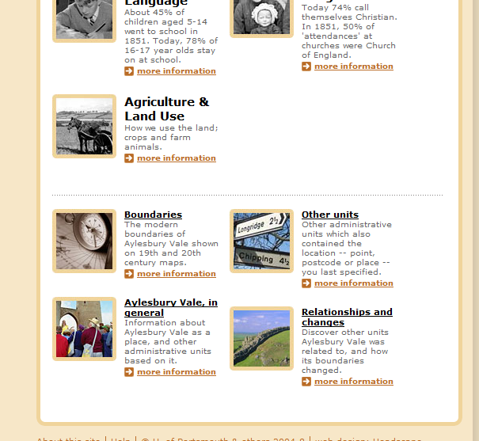
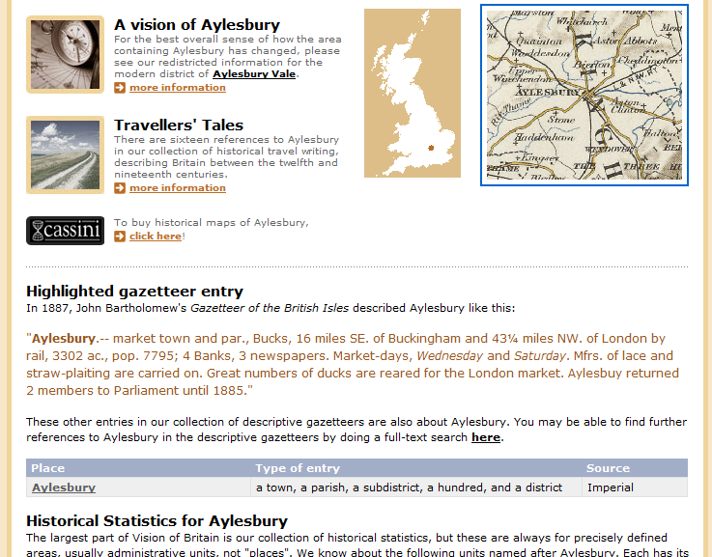
Enter your town or postcode into the box.
You then need to click on the box ‘Your location in general’. This is found at the bottom of the page.

This stage is sometimes missed out depending on the information which is entered into the blue box on the previous screen.
Whilst there is a partial gazetteer entry on this page, a more detailed entry can be accessed by clicking on the location in the table.
Text from the historical gazetteer can then be copied and pasted into a Word document so that pupils can analyse the text.

