

How to Create a Placemark Tour
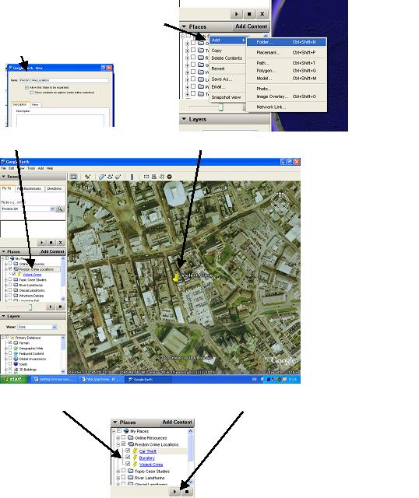
1. Create a new folder in the ‘my places’ box
by right clicking, selecting folder, and inputting
an appropriate name.

- Highlight your new folder, and then create a series of icons at all the locations you want to visit.

- Make sure all the sites you want to visit are ticked. Then press play and watch your tour.

How to inset a shaded block
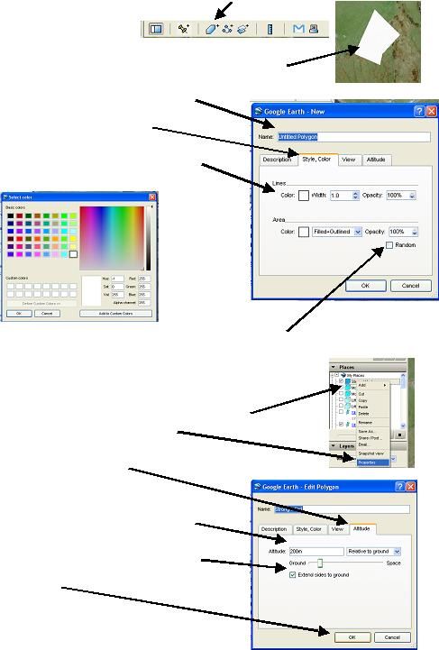
1. Click on the polygon icon.

2. Using the ‘target’ click where you want your polygon to form

3. Give your polygon an appropriate name

4. Click on the ‘style/ colour’ tab.

5. Click on the colour boxes and choose an appropriate colour.

6. Adjust the ‘opacity’ scale to 50% to make you shape semi-transparent. Then click o.k. Your polygon will appear.

How to change a shaded block into a bar chart

1. On the My Places list, right click the polygon you wish to transform.
On the pop-up menu select properties.

2. Click on the ‘altitude tab’.

3. In the altitude box add the height you wish your box to extend to
– e.g. a temperature of 17 degrees could be illustrated
by an altitude of 170m.

4. Click on the ‘extend sides to ground’ box

5. Click O.K.

How to Create a Path Video

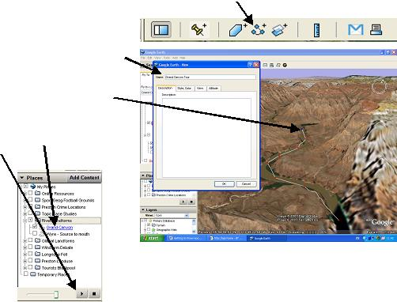
1. Click on the ‘path’ icon.

2. Give your tour a suitable name.

3. Using the target click on the points
you want your journey to follow.

4. High the path you wish to see and
press player.

How to make your placemarks more interesting
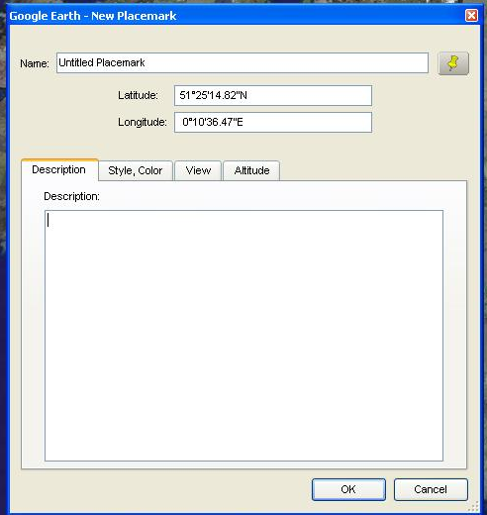
1. When creating a placemark, or by clicking ‘properties’ of an existing placement, a control box appears which allows you to adjust, add and personalize your placemarks.

Any information added to the description box will appear as a ‘pop-up’ when the placement is clicked in the main 3D viewer.

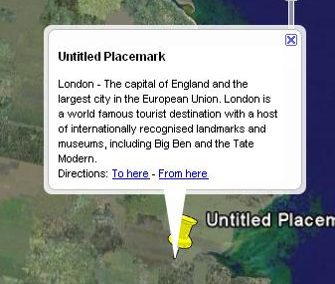

The description field can contain a lengthy description. A scroll bar appears when the description is too long to fit in the entire balloon.

2. Active links to related websites can be added by simply inputting the site’s web address. Valid web URLs are automatically converted to HTML and can be clicked on from the info balloon to produce the related web page.

3. It is also possible to use HTML to add photos to your placemark pop-ups. You can include images in your description using the following HTML tag, replace the question marks with the location of the photograph you wish to include.

<img src="???????">

E.g. To input a photo from your computer…

<img src="C:\My Documents\mypictures\burnleyfc.jpg">

E.g. To input a photo from the internet…

<img src="http://www.pghs.lancs.sch.uk/images/geography.jpg">)

4. HTML codes can also be used to ‘jazz-up’ your descriptions. With a little thought you will be able to change the font, size, and colour of your descriptions. The table below shows some of the options available.

How to insert a Map Overlay

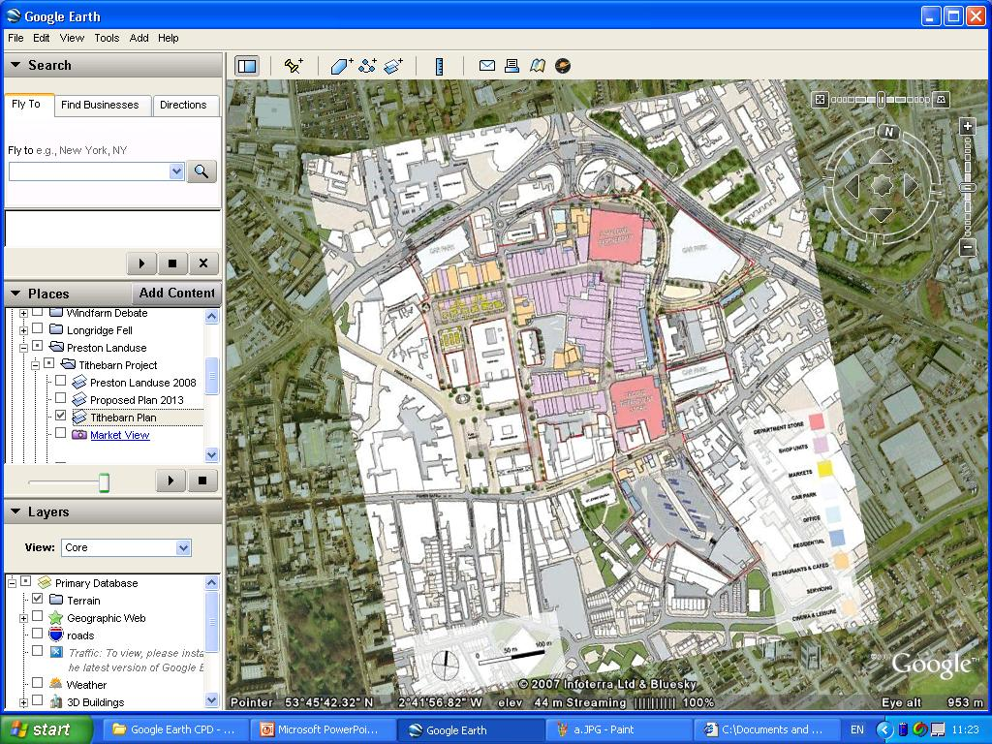
1. Make sure you have the map you wish to add in jpeg format.

- Click on the overlay button on the tool bar.

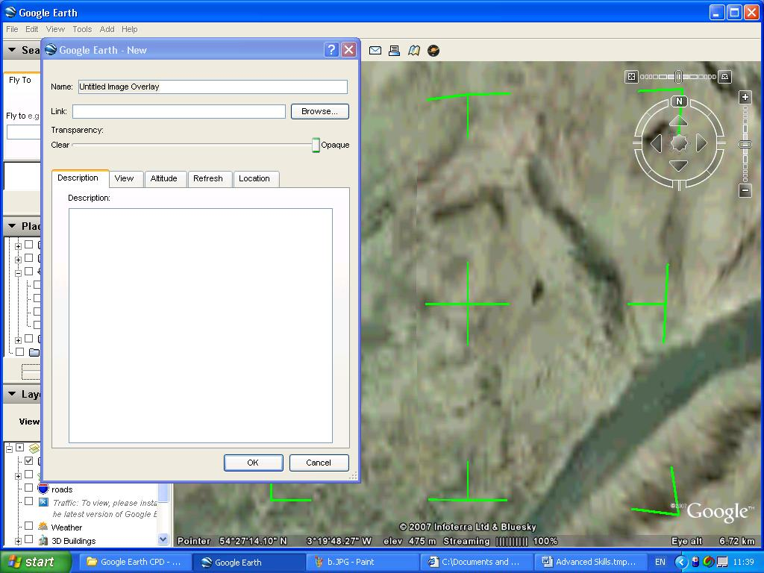
- Give your overlay an appropriate title.

- Use the browse button to locate the map you wish to integrate into Google Earth.

- Carefully position your map. You can move the overlay by placing your pointer over the central cross and holding down the left mouse key.

- You can resize the image by dragging the corners.

- Hot Tip – Use maps which have a couple of key features (lakes, mountain peaks, motorways etc…) which can be easily matched up with the actual feature in Google Earth.
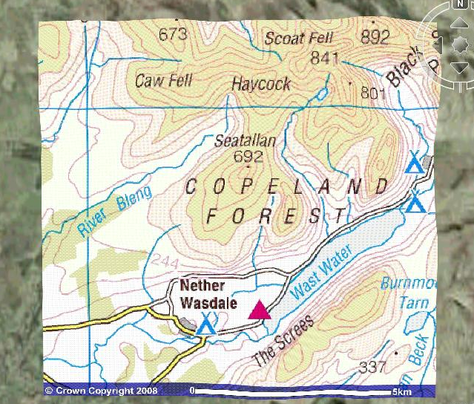
8. Hot Tip – OS maps can be downloaded free at ‘Get a Map’.

