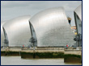
Are you flood ready?

Now find the best way of getting the message across to different types of people, some of whom are more vulnerable than others. Remember, different messages work for different kinds of people.

For instance, older people may not use new forms of communication. Poorer people may not be able to afford some technologies.

Think about the following groups and the best method to ensure that they each get the message!

- Blind people

- Hard-of-hearing people

- Old or disabled slow-moving people

- People who are out travelling about

- People who are in their homes

- Children who are at school

- Workers who are in offices

- Migrant workers who don’t understand English very well

Remember – some of these groups may be small compared to the rest of the population, but every life matters. If just a few people don’t get the flood message, then there may be injuries and even deaths.

Look at the table on the next page, think about each of the vulnerable groups and the challenges that they face. Then think about how people send messages and work out what warning would be good to get in touch with them. (You could do this in groups and have a discussion!)

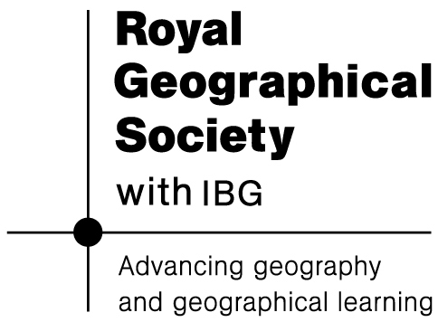


Vulnerable Groups | What’s The Best Warning and Why?
Blind or visually impaired
Deaf or hard of hearing
Impaired mobility
Elderly
Low income earners and the homeless
Non-English Speaking Minorities

Note for teachers: do not show this to students until AFTER they have had time to discuss and make their own attempt to complete the table.

Flood Warnings for Vulnerable Groups of People

Vulnerable Groups | What’s The Best Warning and Why?
Blind or visually impaired | They must be able to hear warnings. They may not watch television or be able to see rising waters. Braille printers are available for PCs, meaning that email alerts have the potential to work.
Deaf or hard of hearing | They must be able to see warnings. They may not listen to radio or be able to hear sirens or door-knocking. May not be able to hear telephone warnings (but can use mobile texting)/ subtitles on Television news.
Impaired mobility | They must receive warnings well in advance of flooding as additional time is needed to evacuate.
Elderly | They may be hard of hearing or suffer from reduced mobility or sight. They are more likely not to own devices such as mobiles, or even television and telephone in some cases.
Low income earners and the homeless | They are more likely not to own more expensive communication devices such as mobiles and in extreme cases television and telephone, so are harder to warn. Word-of-mouth would work.
Non-English Speaking Minorities | They may not understand warnings if English is not spoken as a language.

Why do we need to think hard about contacting “vulnerable groups”?

Flood danger is not spread evenly through a population, as the catastrophic flooding of New Orleans by Hurricane Katrina in 2005 showed. The elderly, the disabled and low-income earners were harder to contact, lacked their own transport and were therefore unable to flee. Low-income earners – many of whom are also elderly and disabled – were also more likely to lack insurance and were poorly prepared for flooding. As a result, deaths were higher in these groups. To be fully effective, flood warning schemes must recognise that people are not all the same. At their best, safety schemes recognise the varying needs of different social groups.

