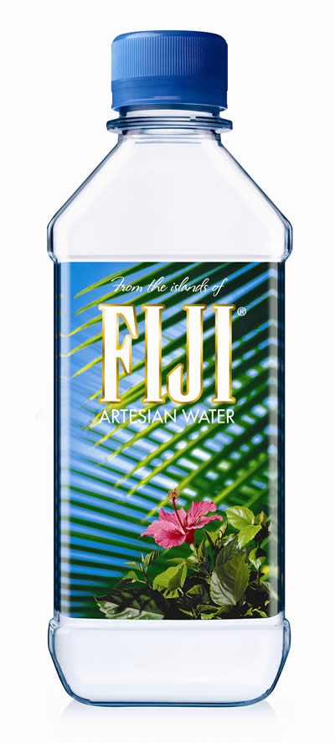
One quite well-known brand of bottled water is shipped over 20,000 km (around 10,000 miles) to reach us here in the UK! ‘Fiji Water’ is a bottled water brand that is imported from the island of the same name.
“Fiji Water” – just how far does it travel to reach Britain?

Each litre bottle costs well over one pound when bought in stores such as Waitrose or Tesco.

The very long distance travelled by this product has led to criticism in an official report by the UK’s Food Commission. They say that it seems a crazy idea for shops to be ordering water from so far away when the UK has plenty of rain and water of its own!

A spokesperson for the Food Commission has suggested that ‘all these bottled waters mean extra trucks on the road, extra fuel use and extra carbon dioxide emissions [responsible for climate change and global warming], when consumers could turn on their taps’.

It is part of a growing trend of major supermarkets ordering products from even more far-away regions. Huge container cargo ships are now used to transport non-perishable items such as bottled water around the world, with millions of journeys completed by containers each year.

Meanwhile, fresh fruit and vegetables are flown by aeroplane to the UK from far-away places like Peru or South Africa – a highly polluting form of transport, but one that gives shoppers what they want (fresh fruit & vegetables all year round).

“It seems a crazy idea for shops to be ordering water from so far away when the UK has plenty of rain”
In addition to raw products such as fruit and meat, remember that the ingredients for sandwiches and ‘ready meals’ are also likely to be delivered from cheap overseas suppliers. As a result, one single helping of a supermarket chicken casserole ‘ready meal’ that contains chicken, tomatoes and peas may have clocked up around 30,000 kilometres with just those three ingredients!

So why is so much food and drink brought to Britain each year from far-away places? The answers include:
- Shoppers want cheap food
- Shoppers want a greater variety of food and drink products than the British climate naturally provides us with (like bananas!)

- There is plenty of demand for fresh produce like strawberries or apples even when they are ‘out of season’ in the UK

In recent years it has become easier for suppliers to meet these demands. Transport costs have fallen over time. Refrigeration of perishable goods now allows sourcing from even the most remote regions. The whole world is getting more inter-connected.

Cool film clip of container sea traffic at:
http://uk.youtube.com/watch?v=z50XoqzOBLQ&feature=PlayList&p=F5D324185EE73FEC&index=0

(Adapted from Geography In The News)

Questions

(a) How far does Fiji Water travel to the UK?

…………………………………………………………………………….

(b) Describe two types of transport that have helped bring food and drink from far-away places to Britain.

1………………………………………………………………………….

…………………………………………………………………………….

2………………………………………………………………………….

…………………………………………………………………………….

(c) Write down three reasons why so much food and drink is imported.

1……………………………………………………………………………

…………………………………………………………………………….

2………………………………………………………………………….

…………………………………………………………………………….

3………………………………………………………………………….

…………………………………………………………………………….

4 Give some examples of food that you like to eat which has travelled long distances to reach the UK. Name some places you think it has travelled from.

…………………………………………………………………………….

…………………………………………………………………………….

…………………………………………………………………………….

…………………………………………………………………………….

…………………………………………………………………………….

…………………………………………………………………………….

……….
10

