Planning for Improvements to Barking Park

During today’s lesson we will be visiting many of the sites numbered 1-7.
The objectives are:
- To evaluate Barking Park as it is at the moment
- To plan to how to make improvements to the park
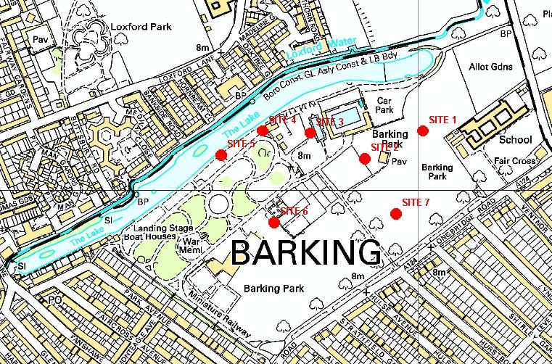

At Site 1
What terms would you use to describe Barking Park from this location?

At Site 2
Barking Park has been awarded a large amount of money to redevelop parts of the park. One of the areas they are undecided about is the old putting green. What facility would you suggest could be developed here? Why?

At Site 3
This is the old paddling pool. How should this area be used in the future?

At Site 4
The lake is an area used by wildlife as well as a boating lake. How could this area be made safer and improved in the future?

At Site 5
There are plans in the future to use the park with school groups of all ages. There is to be a building at this location catering for these groups. What would you put in it?

At site 6
The play area and skateboard area is to be totally redeveloped. What would you do in this area?

At Site 7
Parks are now assessed by series of measures called “Green Flag Criteria”.
Use the table below to give Barking Park a score on each of the main headings used. Make sure you say why you have given the score.
Give reasons here
Green Flag criteria |  | Score
 |  | 1 | 2 | 3 | 4 | 5
Welcoming | Equal access for all the community
Welcoming | Good and safe access
Welcoming | Signs to and in the park
Healthy, Safe, and Secure | Safe equipment and facilities
Healthy, Safe, and Secure | Toilets, drinking water, first aid, public telephones and emergency equipment
Healthy, Safe, and Secure | Secure for all the community to use or cross.
Healthy, Safe, and Secure | Dog fouling
Clean and Well Maintained | Litter and other waste management
Clean and Well Maintained | Grounds, buildings, equipment and other features
Clean and Well Maintained | Litter, vandalism and maintenance
Conservation and Heritage | Landscape features
Conservation and Heritage | Buildings and structural features
Conservation and Heritage | Natural features & wildlife
Community Involvement | Use by the community
Community Involvement | Recreation facilities for all the community
Marketing | Promotion of the park
Marketing | Information to users
Overall score

