When was the coldest you’ve been and where were you?

Name | Location | Context | Notes
Neil | Hungary | Walking – so cold my eyelashes had icicles
Helen | French Alps | Walking through a snowdrift to get to work, wearing cotton trousers, brrrrr
David | Pennine Hills, UK | Mountain Leadership course in January and camping overnight in Edale. So cold the tent pegs wouldn’t go into the ground. I put all my clothes on to try to get to sleep
Nicole | Budapest | New Year, just after swimming outside in a thermal spa. Sub zero and felt cold in a different way to the UK, but it was beautiful
Estelle | Snettisham, Norfolk, UK | It was -15°C – I was de-icing my car and the tips of my fingers froze
Anne | Blackpool | Playing hockey during the winter. I’d regularly be unable to hold the hockey stick because my hand hurt so much.
Simon | Luosto, Finland | December 2002 and -37°C (see image)
Bryan | Findus Foods | Working in the blast chillers one summer. I had to clear them of ice. They were set around -40°C to -50°C but we had steam guns to blast the freezer elements. The liquid in our nose, mouth and eyes crackled as it froze.
Robert | Portland, Maine | December 1976 – coldest winter on record in the USA. They stopped us going out when the temperature dropped to -40°C (which is also -40°F) There was also an eight foot snow drift in front of the door
Stephen | Derby, UK | Frozen to the core. Winter and below freezing but with wind chill factor. Like a mini Ice-age for a boy from London.
Bob | New York | New Year’s Day 1999 – maximum temperature was 0°F (that’s - 18°C), helped by a 20mph northerly wind – I thought I’d never be warm again!
Tina & John | Paris | New Year’s Eve 1999 -17°C
Dave | Northern Alberta, Canada | -45°C – Lungs start to dry out after 20 minutes – brutal
Wendy | Australia | We were there in August 2004 and staying in a ‘fibro’ building with no insulation, so the minute the sun went down we were freezing. We arrived in the evening with sleet coming down. Going to the toilet during the night was a nightmare.
Jo | Iceland | 2003 -21°C – Froze my trousers so part of them snapped
David | Southampton | Inside the Tesco distribution centre in their blast freezer
Bob | Tullinge, Sweden | Outside Stockholm in Feb 2001 -27°C – while moving house.  It was a record-breaking cold snap
Mark | Milan | Watching Inter Milan lose in the San Siro stadium. Took a half hour walk and a few drinks to feel my toes again.
Geo | Svalbard | -30°C with a 30mph wind
Chris | Inca Trail, Peru | Doing the trail, and my coffee froze before I’d finished my breakfast
Claire | Mt. Buller, Australia | -4°C, which is freezing for Australia – couldn’t feel my face, which was quite unnerving
Sue | Sauze d’Oulx, Italy | Skiing at -26°C – top of ski lifts and hands froze to shape of button I was holding to operate the ski lift
Armin | Bremen, Germany | While growing up, winds from Scandinavia – remember walking on the frozen Zwischenahner Meer, which only happens rarely. No shelter from the wind out on the ice.
Fred | Scotland | After falling into the River Tay while rafting in the winter. My feet felt like they were going to fall off.
Emma | Rockies, USA | Swimming in a glacial lake in the spring. It took my breath away. The snow on the banks was much warmer.
Ben | Mt. Kenya | Sleeping outside Mackinder’s hut on the slopes of Mt. Kenya. Tent was frozen stiff and I was freezing despite 10 layers of clothing Climbing on the equator meant we probably felt the cold more due to the heat we’d experienced before.
Christian | River Wye, Wales | Capsizing a canoe on the river near Ross on Wye last April during the cold snap. No wetsuit and still a 20 minute paddle to the end.
Anthony | Beijing, China | Walking the streets in December. Air temperature of around -8°C (-17°C with wind chill). My nose hurt. A lot.
Amanda | French Alps | Sitting on a broken-down chair lift for an hour on a shaded North-facing slope in sub-zero temperatures
Phil | Mt. Kenya | ‘Sleeping’ in a tent the night before heading for the summit of the mountain.
Matt | St. Lary, French Pyrenees | Feb 2010 -22°C – corners of my eyes started freezing and inside of nose completely froze up
Roo | Toronto | -25°C in the early 1980s.
Duncan | Mt. Kilimanjaro | My hands have never felt colder than near the summit – my gloves weren’t up to the job and I misjudged how cold it would be
John | Auschwitz, Poland | Visited in Feb 2010, it was -14°C with snow on the ground. Thinking how horrific that place truly was. Most of W. Europe was covered with snow at the time. Clear sky during the day too.
Laura | Australia | Camping in the desert right next to Uluru in July 2006. The temperature drop at night was phenomenal
Tony | Nottingham, UK | Feb 2011, sat on a bus on the way to work at -10°C – had to walk up and down the aisle to keep warm
Peter | Greenland | Camping in Greenland doing glacier fieldwork. Thermometer hit the bottom of its scale at -30°C (see image)
Andrew | Durham , UK | Waiting for a train at the far end of the railway station platform.
Marie | Namibia | Camping one summer, at midnight. My husband had lost his glasses, so had to stay out of the tent looking for them.
Jane | Chicago, USA | In Chicago on a flight divered from Florida -22°C and I hadn’t packed a coat!
Rob | Everest Base Camp | On honeymoon. Our hot water bottles froze, and the yak dung fire didn’t throw out much heat. As soon as the sun dropped behind the mountain, the temperature plummeted.
Claire | Amsterdam, Netherlands | January 1984 - we had to buy hats and the camera shutter froze
Vicky | Krakow, Poland | 2009, -14°C – walking to the museum in a blizzard… the museum was closed, I think I may have cried
Debra | Iceland | March 2008 – waiting up desperate to see the Northern Lights – temperature was only about -5°C but with wind chill it felt like -50°C – I did get to see the lights below, and they were like nothing else I’ve seen in my life
Al | Coire an t’Sneachda, Cairngorms, Scotland | Jan 2003, after being avalanched below Jacob’s Ladder. Shock and cold.
Bryony | New Zealand | Swimming with wild dolphins off Kaokora in May – was worth it though
Elizabeth | Quebec, Canada | On a chairlift at -40°C Blizzard conditions made it painful but beautiful skiing
Jennie | Edinburgh, Scotland | Hogmanay 2001 -11°C and even the whisky couldn’t keep the cold out
WBS Geography | Matterhorn | -28°C at the top of the Klein Matterhorn on a school ski trip a few years ago. Not a cloud in the sky, but blowing a gale.
Rob | New York | Walking around the Statue of Liberty in February – I don’t know the temperature but it was COLD !
Bethan | Salar de Uyuni, Bolivia | In the mountains, staying with a family of 8. It was -23°C and we all slept in a little area around the fire. We ate llama they’d killed for dinner and then made socks out of the wool.
Simon | Manchester Airport, UK | 1am, 3 years ago -14°C, 3 days before Christmas
Chris | Wales, UK | Camping on New Year’s Eve -16°C plus windchill. So cold that the boiled kettle froze to the ground and the tea was a lump.
Gordon | Iceland | About 60 miles from Reykjavik one Easter. Temperatures were below freezing, but it was the northerly wind that penetrated everywhere. Not a gusting but a steady moderately strong wind.

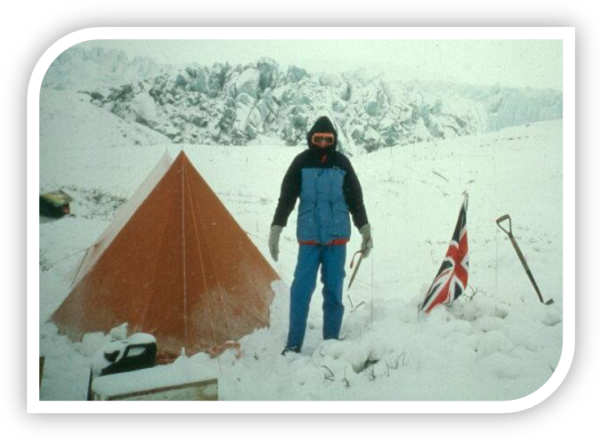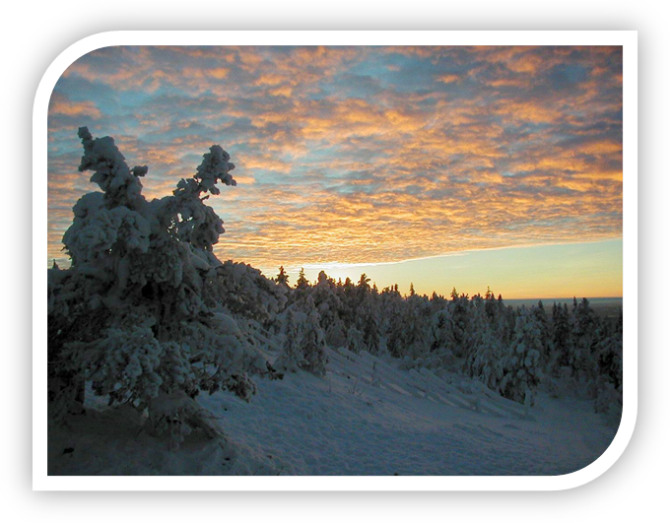
Image copyright:

Greenland: Dr. Peter G. Knight – Keele University
Finland: Simon Williams

