London under water

Fact Sheet

Lesson 2: Managing London’s changing flood risk

Starter
What is meant by risk?

(There are two methods that can be used: The risk equation and the modelling approach that uses three components – probability, consequence and vulnerability)

Risk has several elements. This is shown using the RISK EQUATION:

Risk of disaster = Hazards x Vulnerability
Coping Capacity

These are complex variables to measure:

- Hazards We require knowledge of past events, their magnitude and frequency in order to calculate return periods for both low-level and extreme events. Only then can we make statistical estimates of the probability of a disaster taking place (in London the chance of the Flood Barrier failing is 1:1000).
- Vulnerability We need to know the numbers of people that might be affected – but also their characteristics – are there vulnerable groups?
- Coping capacity What defences are in place? How resilient are they? How resilient are different people and properties to floodwater damage? How quickly would businesses be back trading (financial losses are a major part of the assessment of a disaster)?

Specification advice
Edexcel students need to know the RISK EQUATION.
The model of risk used by Greater London Authority is different, although it shares many similarities.
Get students to compare the two models of risk and discuss the strengths and weaknesses of both. But make sure they know which one to revise for their exam!

Another way of modelling risk is to say that there are three components: probability, consequence and vulnerability. This modelling approach is favoured by the Greater London Authority, where Alex Nickson is Strategy Manager for Climate Change Adaptation and Water. He is developing the first Climate Change Adaptation Strategy for a World City (London) using these three risk elements. According to Nickson, sustainable risk management must focus on all 3 components, as follows:
- Probability 15% of London is in flood risk areas where flooding is probable. Maps show the existing standards of flood protection that exist. Standards decrease along the Thames’ tributaries.
- Consequences Who and what is at risk on the flood plain? What will the consequences of flooding be? What will the total costs be?
- Vulnerability How will the costs be spread, and who is most exposed to risk? Who lives in a basement / ground floor flat? Who lives in areas with the shortest warning times (some parts of London have less than a 3 hour lag time between rainfall and peak flooding)? Who has the greatest and least capacity to react? Do people know they are at risk, do they know what to do, and do they have insurance?

The concept of RESIDUAL RISK is also very important in the context of an analysis of London’s flood defences. This is an estimate of what would happen and what costs would be incurred in the event that flood defences should ever fail.

Main activity

(1) What is an acceptable level of risk for the Thames flood basin and who should be held responsible for managing this risk?
Teaching tip
WJEC and Edexcel students can find out more about the potential high economic costs of central London flooding by reading What is at risk if London floods, 21CC website

The Environment Agency believes there is still only a one-in-a-thousand chance of London being flooded in any given year, due to the barrier being overwhelmed. However, if global climate is changing then in future the barrier may no longer offer the level of protection it was designed to give. This would be worrying news for the population of London. If flooding did occur, Westminster would be under two metres of water and 75 underground and Docklands railway stations would be flooded, as would 16 hospitals and 400 schools. 343,000 London properties face tidal flooding and 133,000 have a fluvial risk. A total of 100,000 of these are at medium to high risk.
Specification advice
AQA and OCR centres will focus their teaching on the flood risk analysis for a developed country (AQA) and the need for planning and management in resolving development and flood risk issues, and possible land-use conflicts in river basins (OCR). In both cases, students need to learn key quantitative facts about London’s risk, as shown here.

Meanwhile, London’s total level of risk is growing all the time, as more people migrate there and new housing developments increase the total value of vulnerable property. With 200,000 new homes planned by the government below the high tide mark in the Thames Gateway area by 2016, the issue of dependable flood defence is likely to become a major concern for policy-makers. The key management question that is increasingly being asked is: who is responsible for shouldering this risk? Is it the (centralised) state? Or should individuals take greater responsibility?

In the accompanying video clips for these printed resources, Alex Nickson raises the question of whether people living in flood-risk areas need to start acting independently by flood-proofing their homes – rather than making repeated calls to local government asking for sandbags to be delivered when a flood has come.
Teaching tip
Students can debate this point. Do they think a “nanny state” approach is a good one? Or should people be left to look out for themselves? What are their expectations of government?

In a different clip, Rowan Douglas-Willis, speaking on behalf of insurers, makes an even strong point. He argues that some cities have a much greater hazard risk – notably San Francisco. But the sense of living with risk is very much engrained in their culture. People know what to do if an earthquake happens, they have trained for it, they have built resilient buildings, and their emergency services are equipped to cope. In London, he argues that perhaps people need to do more in future along these lines. He asks the following questions:
Specification advice
AQA and OCR centres will be focusing their teaching on flood management strategies. In this context, schemes that build resilience for homeowners are of growing importance due to climate change. Find out more by reading the 60 second guide on ways to prepare for a flood.

- When we next re-generate areas and gentrify them, will we take the opportunity to re-design these places to become more flood resilient?
- When we next re-fit our kitchens, will we raise expensive items off the ground to make them more flood-resilient?
- Or do we want to “spend a lot of money to ensure we are kept permanently dry?”

(2) What flood management adaptation and mitigation options exist for Twenty-First Century London?

A range of adaptation measures are currently being proposed. The Thames Estuary 2100 project (TE2100), headed by Dave Wardle, is a cross-regional Environment Agency (EA) project to develop a tidal flood risk management plan for the Thames estuary through to 2100.
Key terms

Hazard adaptation refers to measures that do not attempt to tackle the physical processes causing a hazard, but instead aim to protect people by lessening the hazard impact. So hard engineering (and flood sea defences) are one route to adaptation. Managed retreat from threatened areas is another.

Hazard mitigation refers instead to attempts made to change physical systems and lessen the actual initial threat. Reducing CO2 emissions is a climate change mitigation strategy.

The strategy will take into account increasing flood risk due to:
• climate change and rising sea levels (by 2030, the Thames Flood Barrier will no longer be guaranteed to offer 1:1000 protection)
• changes in land levels (the South is down-tilting by 1-2 mm a year)
• the natural ageing of deface infrastructure (currently £15m is spent each year on repairs)
• new development in the tidal flood plain

The EA will recommend to government what flood risk adaptation management measures will be required in the estuary, where they will be needed and when, based upon the climate changes and sea level rises the capital will face.

The diagram below summarises the current EA strategy.

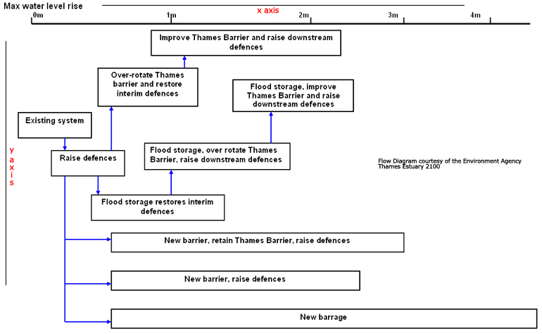

Using the diagram
Examine the x-axis. It shows possible sea-level rises up to 4.2m.
Study the boxes. Each contains a possible flood defence method.
Look at where each box ends and read off the corresponding sea-level rise on the x-axis. This tells you what rise in sea-level each proposed measure will offer protection for.
For instance, “New barrier, retain Thames Barrier, raise defences” will work up to, but not beyond, a 2.6 m rise in sea levels.

In designing this strategy, the EA has considered four possible climate change scenarios.

- Firstly, DEFRA has told them to definitely anticipate a 0.94 m rise in sea level by 2100.
- Next, there is the UKCIP medium-high risk scenario of a 1.5 m rise
- Finally, there are two high-risk UKCIP scenarios called TE2100 H+ and TE2100 H++, both of which factor in the possible effects of stronger storm surges, combined with high tides. Of these, TE2100 H++ is the worst case scenario including a significant global eustatic sea level rise due to ice melting. It takes the possible sea-level rise to 4.2 metres!

As the diagram shows, the higher sea-level scenarios will require major expenditure on either a second new flood barrier (£2-4 billion) or a tidal barrage (£20-30 billion). This is a lot of money, especially the barrage. However, a simple cost-benefit analysis suggests it could be money well spent, as there is £80 billion worth of property at risk in London.

However, as Wardle explains in one of the accompanying video clips, the EA will be advising government to “maintain the risk at an appropriate level, but don’t do what you don’t need to do – we may not need it.” His message is that if sufficient effort is made now to mitigate against climate change (saving energy and lowering CO2 emissions, etc) then we may need to spend less on adaptation later!
Specification advice

Fluvial hazard management or climate change adaptation measures are a feature of all current AS-level Geography Specifications. In particular, WJEC students will benefit from in-depth knowledge of the EA’s proposed strategies for London; WJEC requires that students take part in the “collection and analysis of literature produced by a variety of organizations” as part of their study of the methods used to combat global warming at a variety of scales. EA documents will come in useful!

There are other objections to building a massive barrage as well. It would change the ecology of the whole Thames estuary which has only recently recovered after centuries of pollution and over-exploitation, with 120 fish species now returned to its waters.

The EA are also keen to emphasise that it is not just central government’s responsibility to spend money protecting London; Londoners need to do their bit too! There is an urgent need to raise public awareness of the flood risk in a way that enhances people’s capacity to act positively when threatened. In addition, future flood risk planning is sure to incorporate:

- much more involvement from Local Authorities, who need to undertake and regularly update their own flood risk assessments
- national mapping of the pluvial (surface water) flood risk, as information about this is still poor
Teaching tip

Find out more about how the Thames Flood Barrier works by reading The Thames Barrier piece on the 21CC website. There is also an interactive that can be watched

- increased monitoring of the changing permeability of urban environments so that accurate hydrological models can be kept
- urban planning and renewal projects will increasingly be required to incorporate more green spaces, even viewing them as officially being part of the urban infrastructure response to flooding, alongside drains and sewers.

Plenary
Adaptation or mitigation?

To end the lesson, allow the students to briefly debate this important idea in relation to the building of better (and more expensive!) flood defences. Should we hold off spending more money on defences for London until we have seen whether the world can actually tackle climate change by reducing its CO2 emissions? Or do students believe that mitigation is already a lost cause - and that a need for better adaptive measures, such as a tidal barrage, is already inevitable? What evidence do they have for their viewpoints?

