Role-cards

Provide each group with a different interest group to represent at the village meeting.
Village Elders:
These young Maasai perform dances for tourists and sell things to them to make money.
“The young people are slowly forgetting their traditions because of the tourists, we are worried that future Maasai will understand nothing about their culture”.
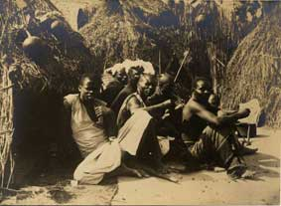

© Royal Geographical Society with IBG

Park Rangers:
“Many tourists go to Kenya to see the famous animals. If they don’t see them when they are on safari they sometimes try to make the driver go off the roads searching for the animals”. What effect do you think this has on the animals and the landscape?

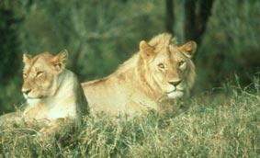

© Bryan Pereira

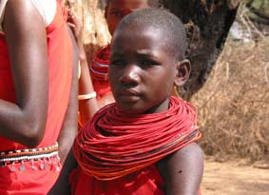
Young Maasai:
“The world is getting hotter, the lands are dry and the rains do not come. There is not enough grass for the animals to eat. I have sold many of my animals and have to find other ways of making money now”.

© Kate Winser
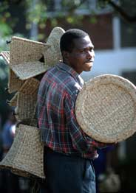
Shopkeepers:
“When tourists come to Kenya to see the animals and scenery they stay in hotels, eat in restaurants and buy things from my shop. If tourists stopped coming to the area I would have no business”.

Hotel Workers:
“Since the Maasai Mara was made into a protected area, many tourists have come to the area and increased the need for hotels and restaurants. I provide for my family by looking after tourists when they come to stay in the hotel I work in. If there were no tourists I would not have a job”.

© Friedrich Stark

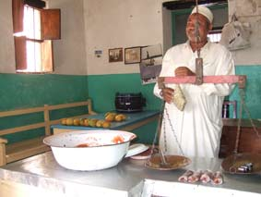

© Cliff Pereira

Ecolodge Owners:
“The environment of the Maasai Mara is being damaged by tourists. This is why we started an ‘ecolodge’. At our hotel we try to take care of the environment and the animals by recycling, saving energy and telling visitors about what they can do to help the animals”.

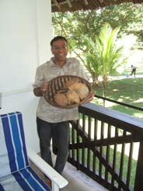

© Neil Williams

