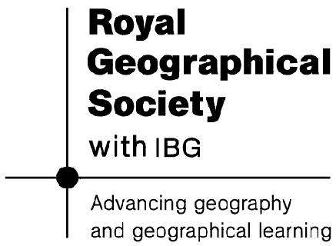

Module Assessment

In addition to ongoing teacher assessment throughout the unit, making links to previous learning and showing progression, the following suggestions will also aid end of unit assessment:

- Link back to poster made in Lesson 1 and add notes to show learning and outcomes.

- Link back to quiz from lesson 1 (main session): http://www.discoveringantarctica.org.uk/multimedia/flash/1_wilderness.html

- End of Unit ‘Antarctica’ Quizzes:
http://www.coolantarctica.com/schools/quiz/antarctica_quiz_1.htm
http://travel.nationalgeographic.com/travel/countries/antarctica-quiz/
http://www.discovery.com/tv-shows/curiosity/topics/antarctica-quiz.htm

- End of Unit ‘Endurance’ Quiz:
http://www.funtrivia.com/html5/index.cfm?qid=117256

