MODULE 4: HOW DO WE PREDICT THE FUTURE?

STUDENT ACTIVITY 1-8: global futures
GLOBAL CLIMATE PREDICTIONS
The only way we can project climate for the next 100 years, is to use very complex mathematical models. Some of the biggest models contain ten million lines of computer code and require some of the world’s largest super-computers to run them!
These complex mathematical models contain equations that describe the physical processes at work in the atmosphere, ocean, cryosphere (areas of ice and snow) and on land. We use changes in greenhouse gas, solar and volcanic emissions to drive the climate prediction models.
Scientists are confident that the models can provide useful predictions of future climate, partly because of their ability to reproduce observed features of current climate and past climate changes, such as the larger degree of warming in the Arctic and the small, short-term global cooling (and subsequent recovery) which has followed major volcanic eruptions, such as that of Mt. Pinatubo in 1991.

Activity one
Use dice to explain how climate is what we expect and weather is what we get.
- Roll a dice and imagine it tells you the ‘weather’, e.g. 1 means sunny, 2 means sunny intervals, and so on (see the table below). Roll it 100 times and keep a tally of the numbers that appear in a table like the one below.
- In the ‘frequency’ column, note the number of times each number appears. In the ‘total’ column, put the sum of the numbers in that row, e.g. if 6 appears 10 times, write 60.

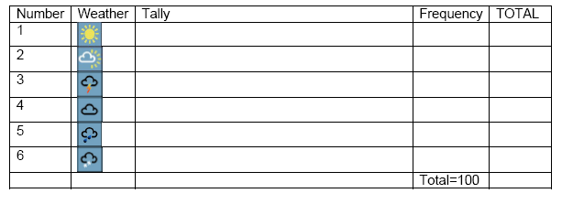
- We can compare this to the weather and climate. Each of the numbers on the dice correspond to a particular ‘weather’, with an equal probability of getting each different kind of ‘weather’ (or number on the dice). The climate is the average weather – so in this example, the climate is the average of all the numbers you have thrown. Work this out by adding up all the numbers in the ‘total’ column, and dividing by 100.
- If you throw the dice another 100 times, can you predict what the climate will be? Can you predict what the weather will be on the next throw?
- If the sides of the dice were labelled 11-16 instead of 1-6, can you predict what the new climate would be? Could you predict the weather (the number on the next throw) with any more certainty?
- Scientists find it difficult to predict what the weather is going to be like in five days time, but this doesn’t mean they cannot discover how the climate may change. The climate, or average weather, is determined by large scale features – such as how much energy the Earth is getting from the Sun. The day to day weather is much less predictable: it can be very similar to, or very different from, the climate. Can you bias your dice (change the climate) e.g. by sticking a bit of blue tack on one face? What does this tell us?

Activity two
The chaotic nature of weather makes it unpredictable beyond a few days. To predict the weather you need to know exactly what is happening in the atmosphere down to the smallest scale. Climate is the average weather pattern of a region over many years (usually a period of 30 years).

Weather forecasts are very dependent on knowing exactly what is going on in the atmosphere, down to the smallest scales (it is ‘chaotic’), climate forecasts do not to the same extent.

Climate is the long term average of weather, including its variability. Climate predictions tell us about how the trends and patterns will change: will it be generally wetter in winter? Will there be more heavy rainfall events causing flooding such as shown below.
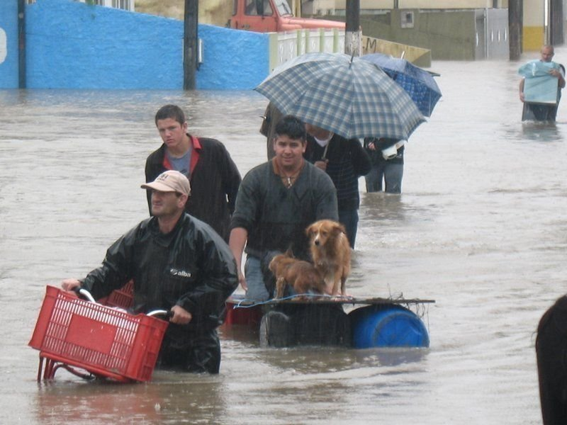
Source: Orkut Images, 2008, Santa Catarina Floods, Itajai floods, ‎Accessed: June 2009, http://commons.wikimedia.org/wiki/File:Itajai_floods.jpg#filehistory

The picture shows the 2008 flooding in Santa Caterina, Brazil. The flooding occurred after a period of heavy rainfall during late November, most significantly during days 20, 21, 22 and 23 of November.
- Which do you think is easier to predict, the weather or changes in climate?

PERSONAL ACTIVITY
Have you ever experienced an extreme weather event such as flooding or very strong winds?
How did it affect your life?

Activity three
Northern hemisphere temperatures from 700 - 2000

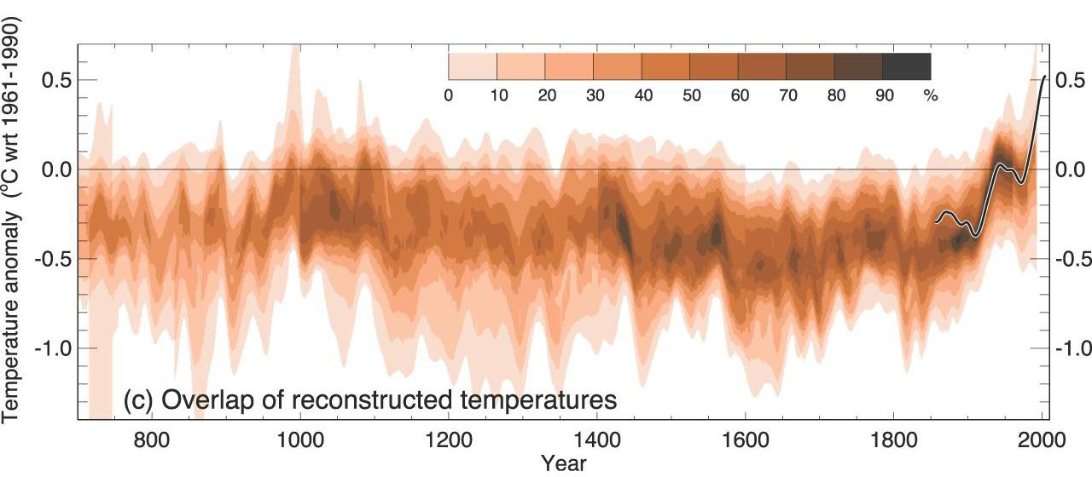
Inter Governmental Panel on Climate Change (2007) IPCC Fourth Assessment Report. Climate Change. Accessed June 2009 Available from World Wide Web: http://www.ipcc.ch/graphics/graphics/ar4-wg1/jpg/fig-6-10.jpg
- This graphic shows Northern Hemisphere temperatures for 700-2000AD.
- The vertical, y axis shows how different the temperature is from the average of 1961 - 1990 temperatures (temperature anomalies).
- The horizontal, x, axis shows time in years from 700 - 2000AD

To know what was happening before 1850, we have to rely on what things like tree rings, fossils, and the gases trapped in ice cores tell us about local temperatures. This information is much less precise, and much less global, than for example the satellite data we have nowadays.
There is no single thermometer measuring the global temperature. Instead, individual thermometer measurements taken every day at several thousand stations over the land areas of the world are combined with thousands more measurements of sea surface temperature taken from ships moving over the oceans. These produce an estimate of global average temperature every month.
It is now possible to use these measurements from 1850 to the present, although coverage is much less than global in the second half of the 19th century, is much better after 1957 when measurements began in Antarctica, and best after about 1980, when satellite measurements began.

- Write a short newspaper article explaining why it is important to have accurate data to make climate predictions. Include information on how scientists can gather data from the past and how modern methods are more accurate.
- Why do you think accurate measurements from Antarctica are important in climate predictions.
- Describe what the graphic shows in your article.
- Use the internet and other research to help you.

Activity four
Why are some aspects of climate change harder to predict than others? Believe it or not, it is much easier to predict global temperature than rainfall in Beijing, Jakarta, London or Mexico City! This is because, the smaller the scale of the physical processes involved, the harder something is to predict.

Climate models allow scientists to predict some aspects of climate change with much more confidence than others. For example:
- averages over the whole Earth are easier to get right than very local changes;
- temperature is easier than rainfall, which depends on the very small scale physical processes going on in clouds;
- predicting how the climate will change in the relatively near future (within the next 40 years, say) is easier than further ahead, as we have a better understanding of what the world and the climate system will look like.

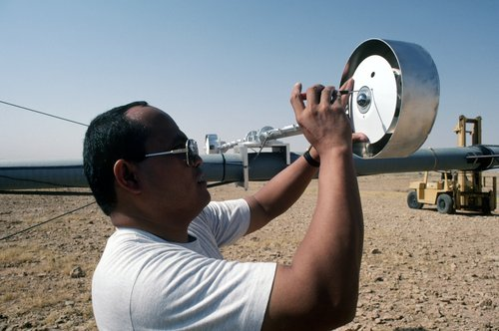
Source: No Author, No Date, Pix number 03300, Accessed June 2009, http://www.nrel.gov/data/pix/Jpegs/03300.jpg

Look back at the elements of the weather you identified in Unit 1. What instruments are used to measure these elements?

Activity five
There are many stages involved in making climate predictions. These include estimating future levels of greenhouse gas emissions and calculating the effects of those emissions on the global and then local climate (these can be seen in Graphic 4.2). Each stage involves an increasing amount of uncertainty.
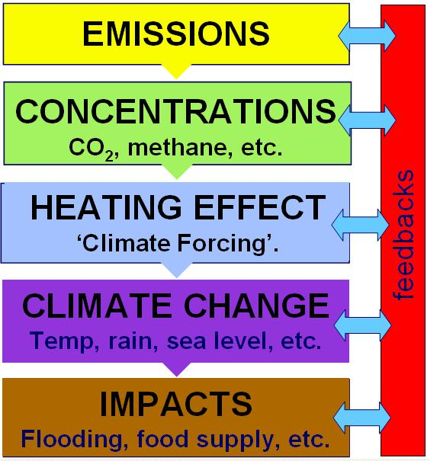

Use the information in this Unit and others you have studied to describe the uncertainties in each of the stages of making climate predictions.
- What assumptions have to be made about populations and technology and the rate of emissions?
- What assumptions have to be made when using carbon cycle models to predict concentrations?
- What uncertainties are there is using full climate models to calculate heating effects?
- What might the effect of climate change in one place on the climate of another place?
- How easy is it to translate global change into local impact?
- What might be the effects of feedback mechanisms?

Activity six
The Intergovernmental Panel on Climate Change (IPCC) “best estimate” of global warming is 2-4°C by the end of the century. This may not seem like much but it is an average; it conceals a greater warming in some seasons and some areas (particularly at higher latitudes) and less in others, for example nearer the equator.

In order to make projections about future climate change, scenarios that describe possible global emissions of greenhouse gases are used. These scenarios are based on different ‘storylines’ that illustrate how things may change in the future. They take into account different projected trends in population, economic and technological developments, as well as changes in the political environment.

Three of these scenarios are shown in the graphic below as follows:
- A2 - a high carbon world, medium-high emissions scenario. This is based on a fairly divided world, where nations are self reliant and operate independently. Population rises continually, economic development is mainly regional and technological change is slow and fragmented.

- A1B - medium-low emissions scenario. This is based on a more integrated world. There is rapid economic growth on a global scale, technological change is fast and efficient, and there is a balanced emphasis on all energy sources. Global population rises to 9 billion in 2050 then declines.

- B1 - a low carbon world, low emissions scenario. This is based on a more integrated and ecologically friendly world. There is rapid economic growth as in A1 but with rapid changes towards a service and information economy. Global population rises to 9 billion in 2050 then declines. Introduction of clean and resource efficient technologies, and an emphasis on global solutions to economic, social and environmental stability.

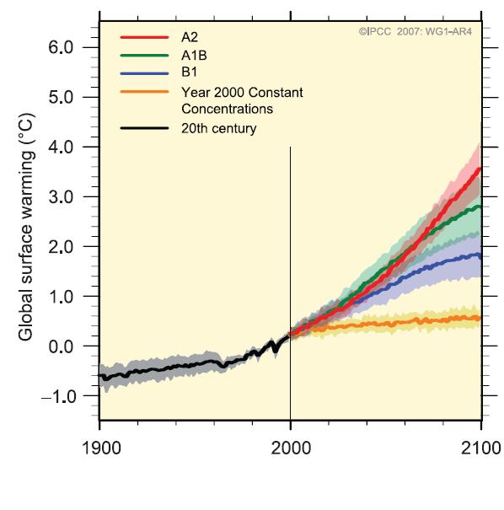
Intergovernmental Panel on Climate Change (2007) IPCC Fourth Assessment Report. Climate Change. [Accessed June 2009] Available from World Wide Web: http://www.ipcc.ch/graphics/ar4-wg1/jpg/spm5.jpg
Put a circle around the statements that can be said with certainty, whichever of the scenarios actually happens.

- The climate is changing and will change in the future due to people-made green house gas emissions.
- Global temperatures will increase over the next 30 years between 0.5 – 1°C.
- We can say exactly what will happen to the climate in the future.
- An increase in global temperatures will affect every part of the world in the same way.
- We can all change our lifestyles and be a part of the solution.
- We are getting better at saying what the climate is most likely to do and what it probably won’t do.
- We cannot say exactly what will happen to the climate in the future.
- Global temperatures will increase over the next 30 years between 2 – 4°C.
- An increase in global temperatures will affect different parts of the world in different ways.
- We haven’t got a clue what the climate is going to do.

Activity seven
Climate change doesn’t just affect temperature it also affects precipitation, changes to sea level and ice sheets.

Precipitation
Most climate models predict that globally averaged precipitation will increase over time, with the biggest increases closes to the poles and in the Indian monsoon, and the smallest changes in subtropical regions.

Sea level
The two major causes of global sea level rise are water expanding as it warms and loss of land-based ice due to increased melting. Sea level is projected to rise at an even greater rate in this century than it has done already. By the mid-2090s, for instance, global sea level could reach 0.22 to 0.44 m above 1990 levels.

Ice sheets
The two major ice sheets are the Greenland ice sheet and the Antarctic ice sheet. The Greenland ice sheet contains enough water to contribute about 7 m to sea level. A sustained rise in local temperatures of about 3 °C (that’s global warming of about 1.5 °C) is likely to be reached by the end of the century if human-made emissions are not controlled. This would melt the Greenland ice sheet, although it is estimated that this would take a few thousand years. The West Antarctic ice sheet is the part of the Antarctic ice sheet most vulnerable to climate change. It contains enough water to contribute about 6m to sea level.

You can find out more about the loss of ice in the Arctic region at http://www.discoveringthearctic.org.uk/6_losing_the_ice.html and in Antarctica at http://www.discoveringantarctica.org.uk/3a_climate.php

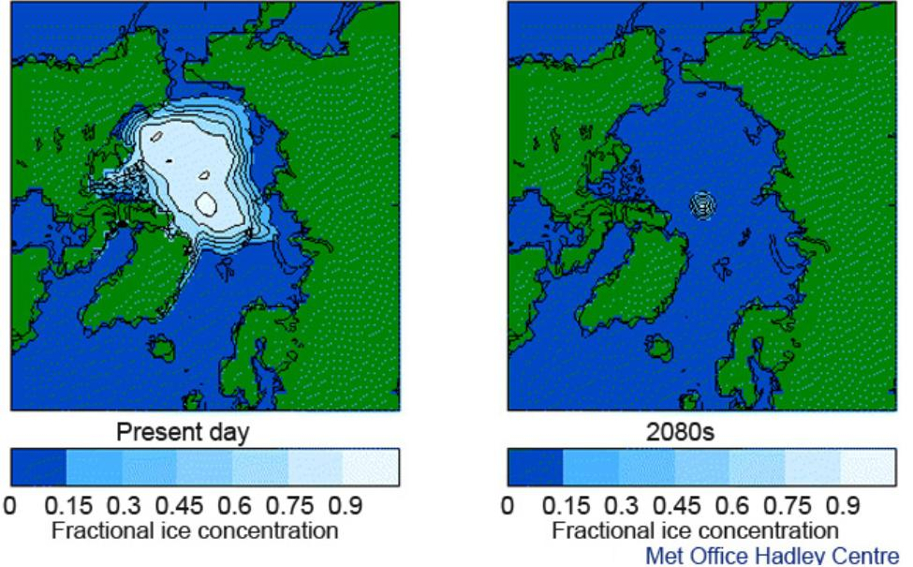
The two maps above show the extent of the Arctic ice in 2010 and the predicted extent of the ice in 2080.
- Using the information in this module and from the internet links what will be the consequences of the loss of ice in the Arctic?

Activity eight
Extreme climate events will vary from region to region. For example more flooding is expected in the Asian monsoon region and other tropical areas, future tropical cyclones could become more severe and there will be an increased risk of more intense, more frequent and longer-lasting heat waves in Europe.

Heat waves
The European heat wave of 2003 is an example of the type of extreme heat event lasting from several days to over a week that is likely to become more common in a warmer future climate. In pre-industrial times, the 2003 heat wave would have been a 1 in 1000 event. By the 2040s the average summer is predicted to be like the one we experienced in 2003; this in turn would be viewed as cold compared to the average summer temperature predicted for the 2060s.

Frost
It is also likely that a warmer future climate would have fewer frost days (i.e., nights where the temperature dips below freezing) and so the growing season is expected to get longer.

Rainfall and flooding
In a warmer future climate, most climate models project decreased summer rainfall and increased winter rainfall in most parts of the northern middle and high latitudes. Along with the risk of summer drought, there is an increased chance of episodes of intense rainfall and flooding. More flooding is also expected in the Asian monsoon region and other tropical areas and in a number of major river basins.

Cyclones
There is evidence from modelling studies that future tropical cyclones could become more severe, with greater wind speeds and more intense precipitation, although the actual number of cyclones may not change.

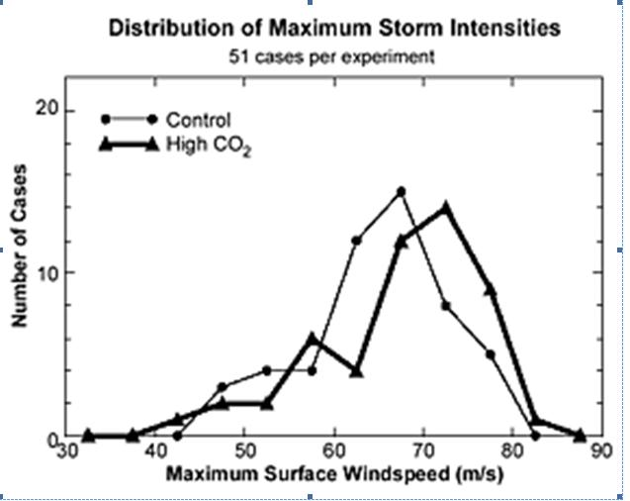

PERSONAL ACTIVITY
What will be the effect of more extreme climate events on the area where you live?

