World Environments

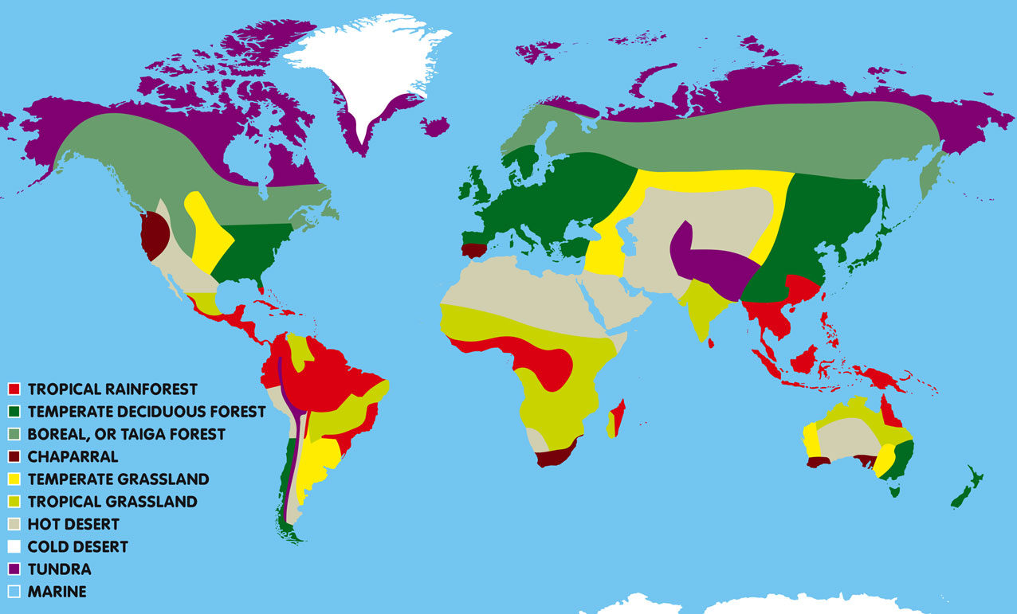

Here is a map dividing the world up into some of its different natural environments.

Look at the map key to see which colours on the map represent each of the natural environments.
Which biome?
Along the journey the helicopter will pass over many different natural environments, these are called biomes. Each biome is a large natural region home to animals and plants adapted to survive in the climate and particular conditions of that place.
On the following pages are pictures of eight places around the world. All but one of them are places that Jennifer and Colin will be flying over. Can you match each photo to the correct biome?

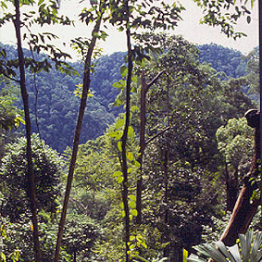 | Picture 1  This picture belongs to the  biome
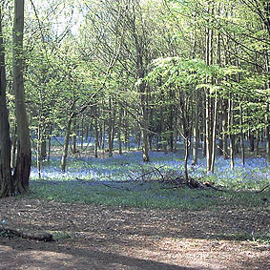 | Picture 2  This picture belongs to the  biome
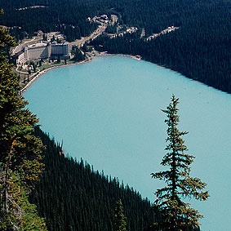 | Picture 3  This picture belongs to the  biome
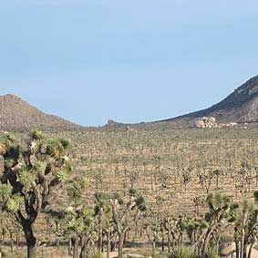 | Picture 4  This picture belongs to the  biome
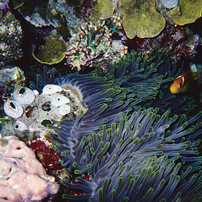 | Picture 5  This picture belongs to the  biome
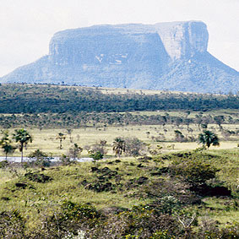 | Picture 6  This picture belongs to the  biome
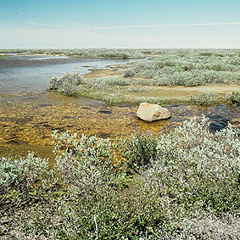 | Picture 7  This picture belongs to the  biome
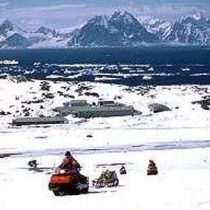 | Picture 8  This picture belongs to the  biome

Temperature and rainfall
On the following pages are eight sets of two graphs, each showing typical temperature and rainfall measurements for one of the eight biomes. Can you match the graphs to the matching biomes?

The first set of graphs matches the

biome

The second set of graphs matches the

biome

The third set of graphs matches the

biome

The fourth set of graphs matches the

biome
The fifth set of graphs matches the

biome

The sixth set of graphs matches the

biome

The seventh set of graphs matches the

biome

The eighth set of graphs matches the

biome

Look at the graphs on the following pages, and think about how the temperature and rainfall information might match with the biomes shown on the world map. Put your answers into the boxes above.

When you have finished, download the “World environment facts” document, which will give you all the correct answers along with more information about the biomes.
Graph set 1:
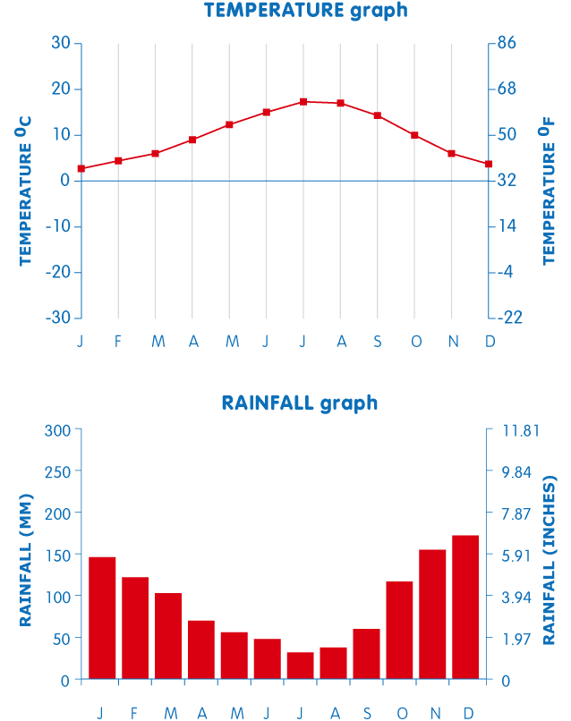
Graph set 2:
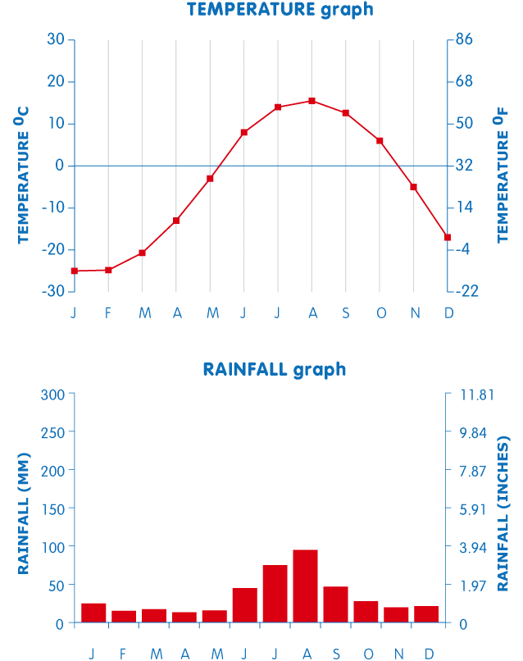
Graph set 3:
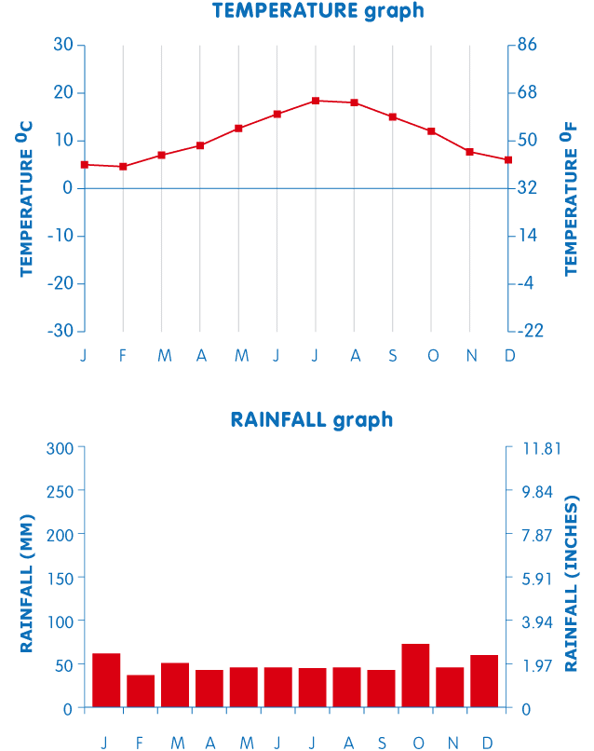
Graph set 4:
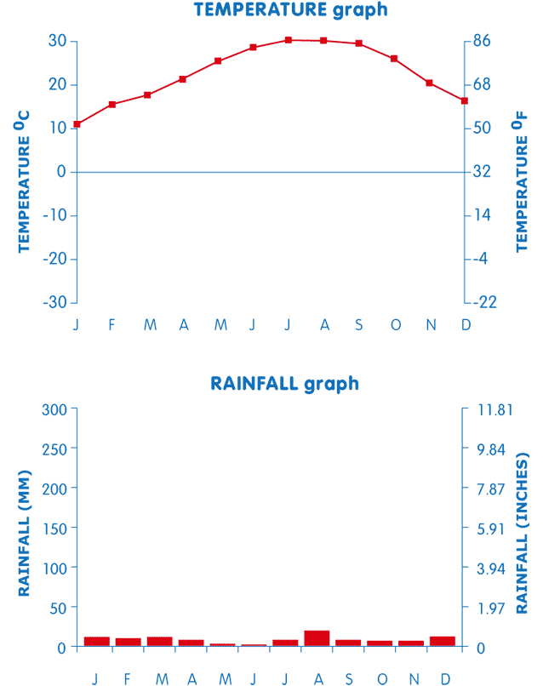
Graph set 5:
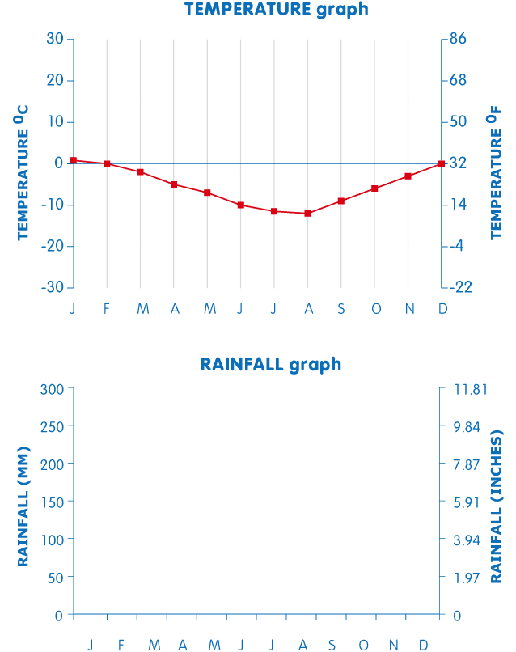
Graph set 6:
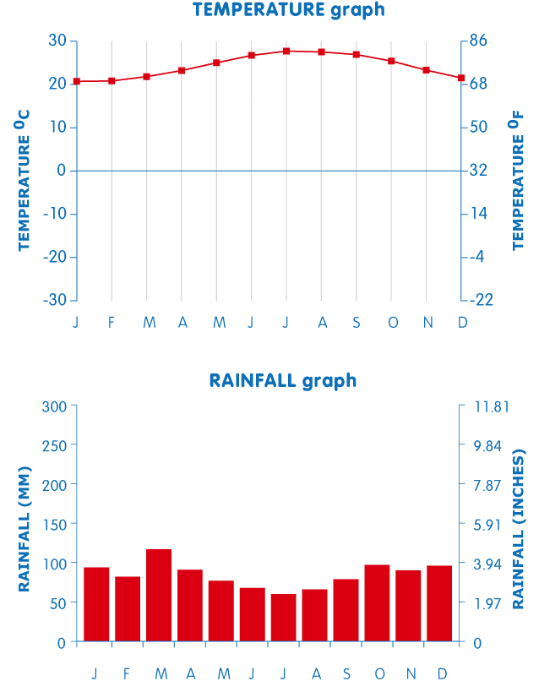
Graph set 7:
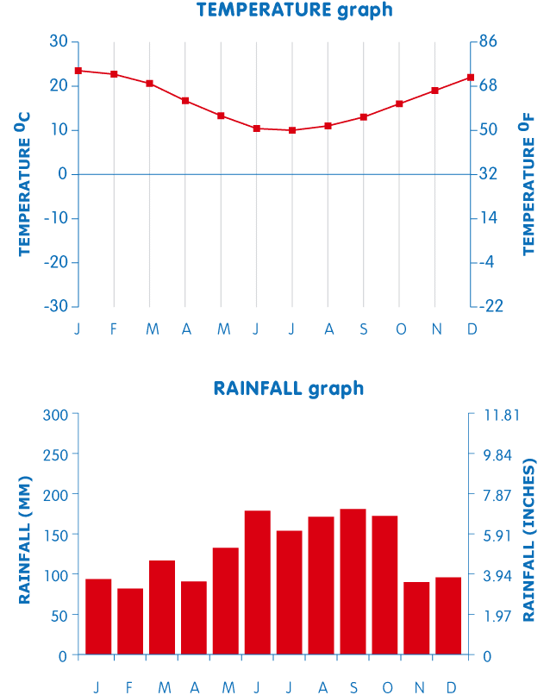
Graph set 8:
