Antarctic Treaty

Antarctica covers roughly 10% of our planet’s surface. It plays a key role in controlling the world’s weather and ocean circulation. It is a biome that provides for and supports a vast range of aquatic animals, sea birds as well as lichens, mosses and insects.

The British Antarctic Territory is the oldest territorial claim to a part of Antarctica (dating from 1908). Throughout the first half of the 20th century, a further six countries (Argentina, Australia, Chile, France, Great Britain, New Zealand and Norway) also announced territorial claims to parts of Antarctica. In the 1950s and 1960s overlapping territorial claims and Super Power confrontation caused international tensions on the issue of Antarctica to rise. However, in 1958 following a successful Antarctic Research Programme (International Geophysics year) in which twelve countries participated, a more permanent solution to the problem was devised.

In 1961 the Antarctic Treaty came into force. (Britain was the first to ratify the Treaty. Forty-five countries (80% of the world’s population) have signed up to the Treaty. The Treaty sets aside territorial claims and allows scientists the freedom to work and exchange information in and about Antarctica. Its main aim was to reduce conflict and create regulations that would help to protect the continent.
The Treaty:-

- Bans nuclear explosions and the disposal of nuclear waste
- Limits the usage of Antarctica to peaceful purposes: eg. no military manoeuvres
- Nations which have signed the Treaty will meet regularly to regulate the usage of Antarctica and develop any further policies or regulations as required

The Treaty applies to all the land and ice shelves south of latitude 60°S. The Treaty remains in force indefinitely and is one of the most successful agreements of its type in modern times.
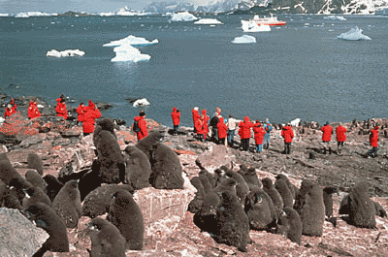
Over the past forty years the pressure on the Antarctic has continued to grow as research stations have grown and expanded. More recently the continent has been identified as the new Tourist Frontier and the impact of increasing visitor numbers is beginning to threaten its unique environment.
Source: BAS
In 1991, a Protocol on Environmental Protection to the Antarctic Treaty was negotiated in Madrid. The Madrid Protocol came into force in 1998 and 31 States (including the United Kingdom) are now Parties to the Protocol. The Protocol adds environmental protection to the original Treaty agreement. It:-

- Designates Antarctica as a ‘nature reserve’
- Bans oil and other mineral extraction
- Sets up a committee for Environmental Protection of
Antarctica’s plants and animals
- Requires contingency plans to be in place to deal with
environmental emergencies
- Requires environmental impact assessments of all activities
- Sets out strict controls for waste disposal and waste management e.g. polystyrene is
- banned in Antarctica and all packaging must be removed
- from the continent
- Requires measures to be taken to prevent marine pollution e.g. no oil discharged from
- ships

The Protocol remains in force indefinitely, although its Article 25 allows any of the Antarctic Treaty Parties to request a conference to review the operation of the Protocol, 50 years from the date it entered into force. However, any changes would need to be agreed by the majority of Parties to the Protocol, which must include at least three-quarters of the States that were Parties to the Treaty when the Protocol was adopted.

Whether any Treaty Party would seek such a renegotiation remains to be seen, but what do you think might happen, if, by 2048, we had discovered huge accessible
deposits of mineral resources in the Antarctic?

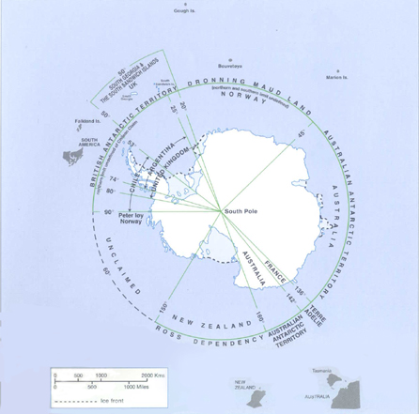
Source: FCO

Resources

Antarctica School Pack – British Antarctic Survey/Foreign and Commonwealth Office, London
www.visitandandlearn.co.uk
www.www.org.uk
www.oneworldmagazine.org/focus/southpole/
www.classroomantarctica.add.gov.au

Compiled by Margaret Cummings

