The Animals and the Environment

Many tourists visit Kenya to see some of the animals the country is famous for. Tour companies try to show tourists the ‘Big Five’, this was the name given by hunters many years ago to the five animals in Africa that were hardest to catch.
The African lion is ‘Vulnerable’ to extinction. This means that it will become extinct if it is not protected.
Number 1: The Lion
Diet: Lions are carnivores and eat other animals such as zebras, antelope and wildebeest and do not usually attack humans.
They live for: 10-14 years in the wild.
Behaviour: The females do the hunting in groups called ‘Packs’ and work as a team to catch animals to eat. Lions live in a group called a ‘Pride’.
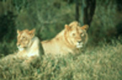

© Cliff Pereira
Number 2: The African Elephant
Diet: Elephants are herbivores and eat leaves, bushes and branches.
They live for: Up to 100 years.
Behaviour: They use their trunks to drink water and to communicate wit each other. Male elephants are called ‘Bulls’ and live alone whereas the females live in groups of up to 20 with their young.

Elephants are an endangered species and will become extinct if people do not protect them.
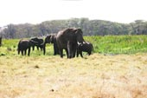

© A & D Boys
Number 3: The African Buffalo
Diet: Buffaloes are herbivores and eat grass and other plants.
They live for: Up to 30 years but usually die before this age in the wild.
Behaviour: A very dangerous animal that kills many hunters and has even been known to kill lions. They enjoy wallowing in mud to cool down. The females live in herds with their young.
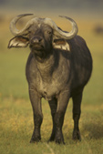

The African buffalo is not in danger of extinction.

Number 4: The Leopard
Diet: Leopards are carnivores and will eat anything from insects to humans.
They live for: 12-15 years.
Behaviour: Leopards have very good hearing and eyesight which makes then very good hunters. They hunt at night and are very good at climbing trees, which means they can drag their food up a tree and away from other animals who may want to eat it. They are solitary animals and avoid other leopards.

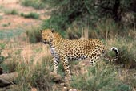
©Still Pictures
Leopards are also an endangered species and will become extinct if
people do not protect them.
© Still Pictures
Number 5: The Black Rhino
Diet: Rhinos are herbivores and eat roots, branches, bushes and fruit.
They live for: Up to 35 years
Behaviour: They search for food in the morning and evening and spend the hottest parts of the day resting or wallowing in mud which keeps them cool. Rhinos have bad eyesight and rely on their sense of smell to find food and their hearing to sense danger. When they sense danger they make a sneezing sound to warn other rhinos to watch out!

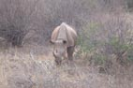
Black Rhinos are nearly extinct.

© A & D Boys
What do these words really mean?

If an animal is extinct, this means it does not exist any more and will never be seen again.
EXTINCT

If an animal is endangered this means it is in danger of becoming extinct.
ENDANGERED

Why has this happened to the animals?
There are 3 main reasons
They have lost their habitat:
Kenya has many national parks where animals are safe and free. But these parks cover only a very small part of Kenya’s total area. But many animals live outside the national parks.
As Kenya’s population grows, the cities get larger and larger. This means the animals have less and less land to live on. They often go onto farmland and damage crops. Farmers then shoot them.

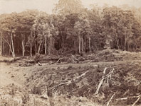
© RGS, R B Buckley, 1902

They have been hunted by humans for:
- Sport
- Killing the farmers animals
- Damaging the farmers crops

All hunting in Kenya was made illegal in 1977, but criminals still kill animals. The animals are hunted for their ivory (from elephants), horns (from rhinos) and skins (from lions).

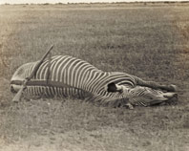
© RGS, N Dracopoli, 1912

Climate change:
The climate of the world is changing. We know that the earth is getting hotter and weather patterns are changing. In Africa the rains often do not come so there is not enough water to grow food or for the animals and people to drink.
If the climate keeps on changing animals will die because there is no food or water for them.

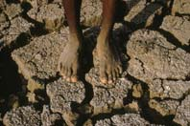
© J Evans

How can you help?
Lots of people are trying to help the animals in Kenya and in other countries across the world (including ours) and we can all get involved. Here are some ideas for you to think about:
Ecotourism
Ecotourism is tourism that looks after the environment. The money made by this type of tourism usually goes to the local people. The animals and plants in the area are looked after with this money. There are lots of ecotourism projects in Kenya.
- The money the tourists pay all goes to the local people.
- The money is sometimes used to buy things for the village school and the village clinic.
- The people are very proud of their projects and think more people should get involved in ecotourism.

Adopt an animal:

Money is needed to protect animals from hunters and to save the habitats the animals live in. Many companies get donations of money from people who want to help save wild animals.

Example: The World Wildlife Fund (WWF)

Kinyanjui is a black rhino and lives in Kenya. There are now less than 500 rhinos left there. Many rhinos have been killed by people who come to the parks to kill them for their horns. This is done at night so the police do not find out. People can give money to the WWF to stop people coming into the park at night.

Reduce your environmental footprint on the world:
We all know that climate change is making it harder for animals to survive by damaging their habitat. If we all do something small everyday we can help to slow down climate change. Here are some ideas for things you could do at home or at school:
- Try to use less electricity. This can be done by switching lights off when you are not using them. Try reading a good book or playing a game rather than watching television.
- If you feel cold, put on an extra jumper. Tell your families to do the same so you don’t have to turn the heating up.
- Use less water (remember water has to be cleaned before we use it and this uses lots of electricity). This can be done by having showers instead of baths.

