Reasons for the growth of out-of-town stores

Before the 1970s, household incomes were not high enough for families to buy as much food and as many consumer goods as they do today. Society has got richer as more people have moved out of factory and farming work - and into well-paid office jobs.

Bigger disposable incomes - including teenagers with more pocket money - generated a demand for goods which could not be met by existing shops in town centres. This was because of the shortage of land there.

So chain brands like Sainsbury’s, Safeway, Tesco and Ikea, along with others, all sought planning permission to build great big new stores at the edge of towns and cities.
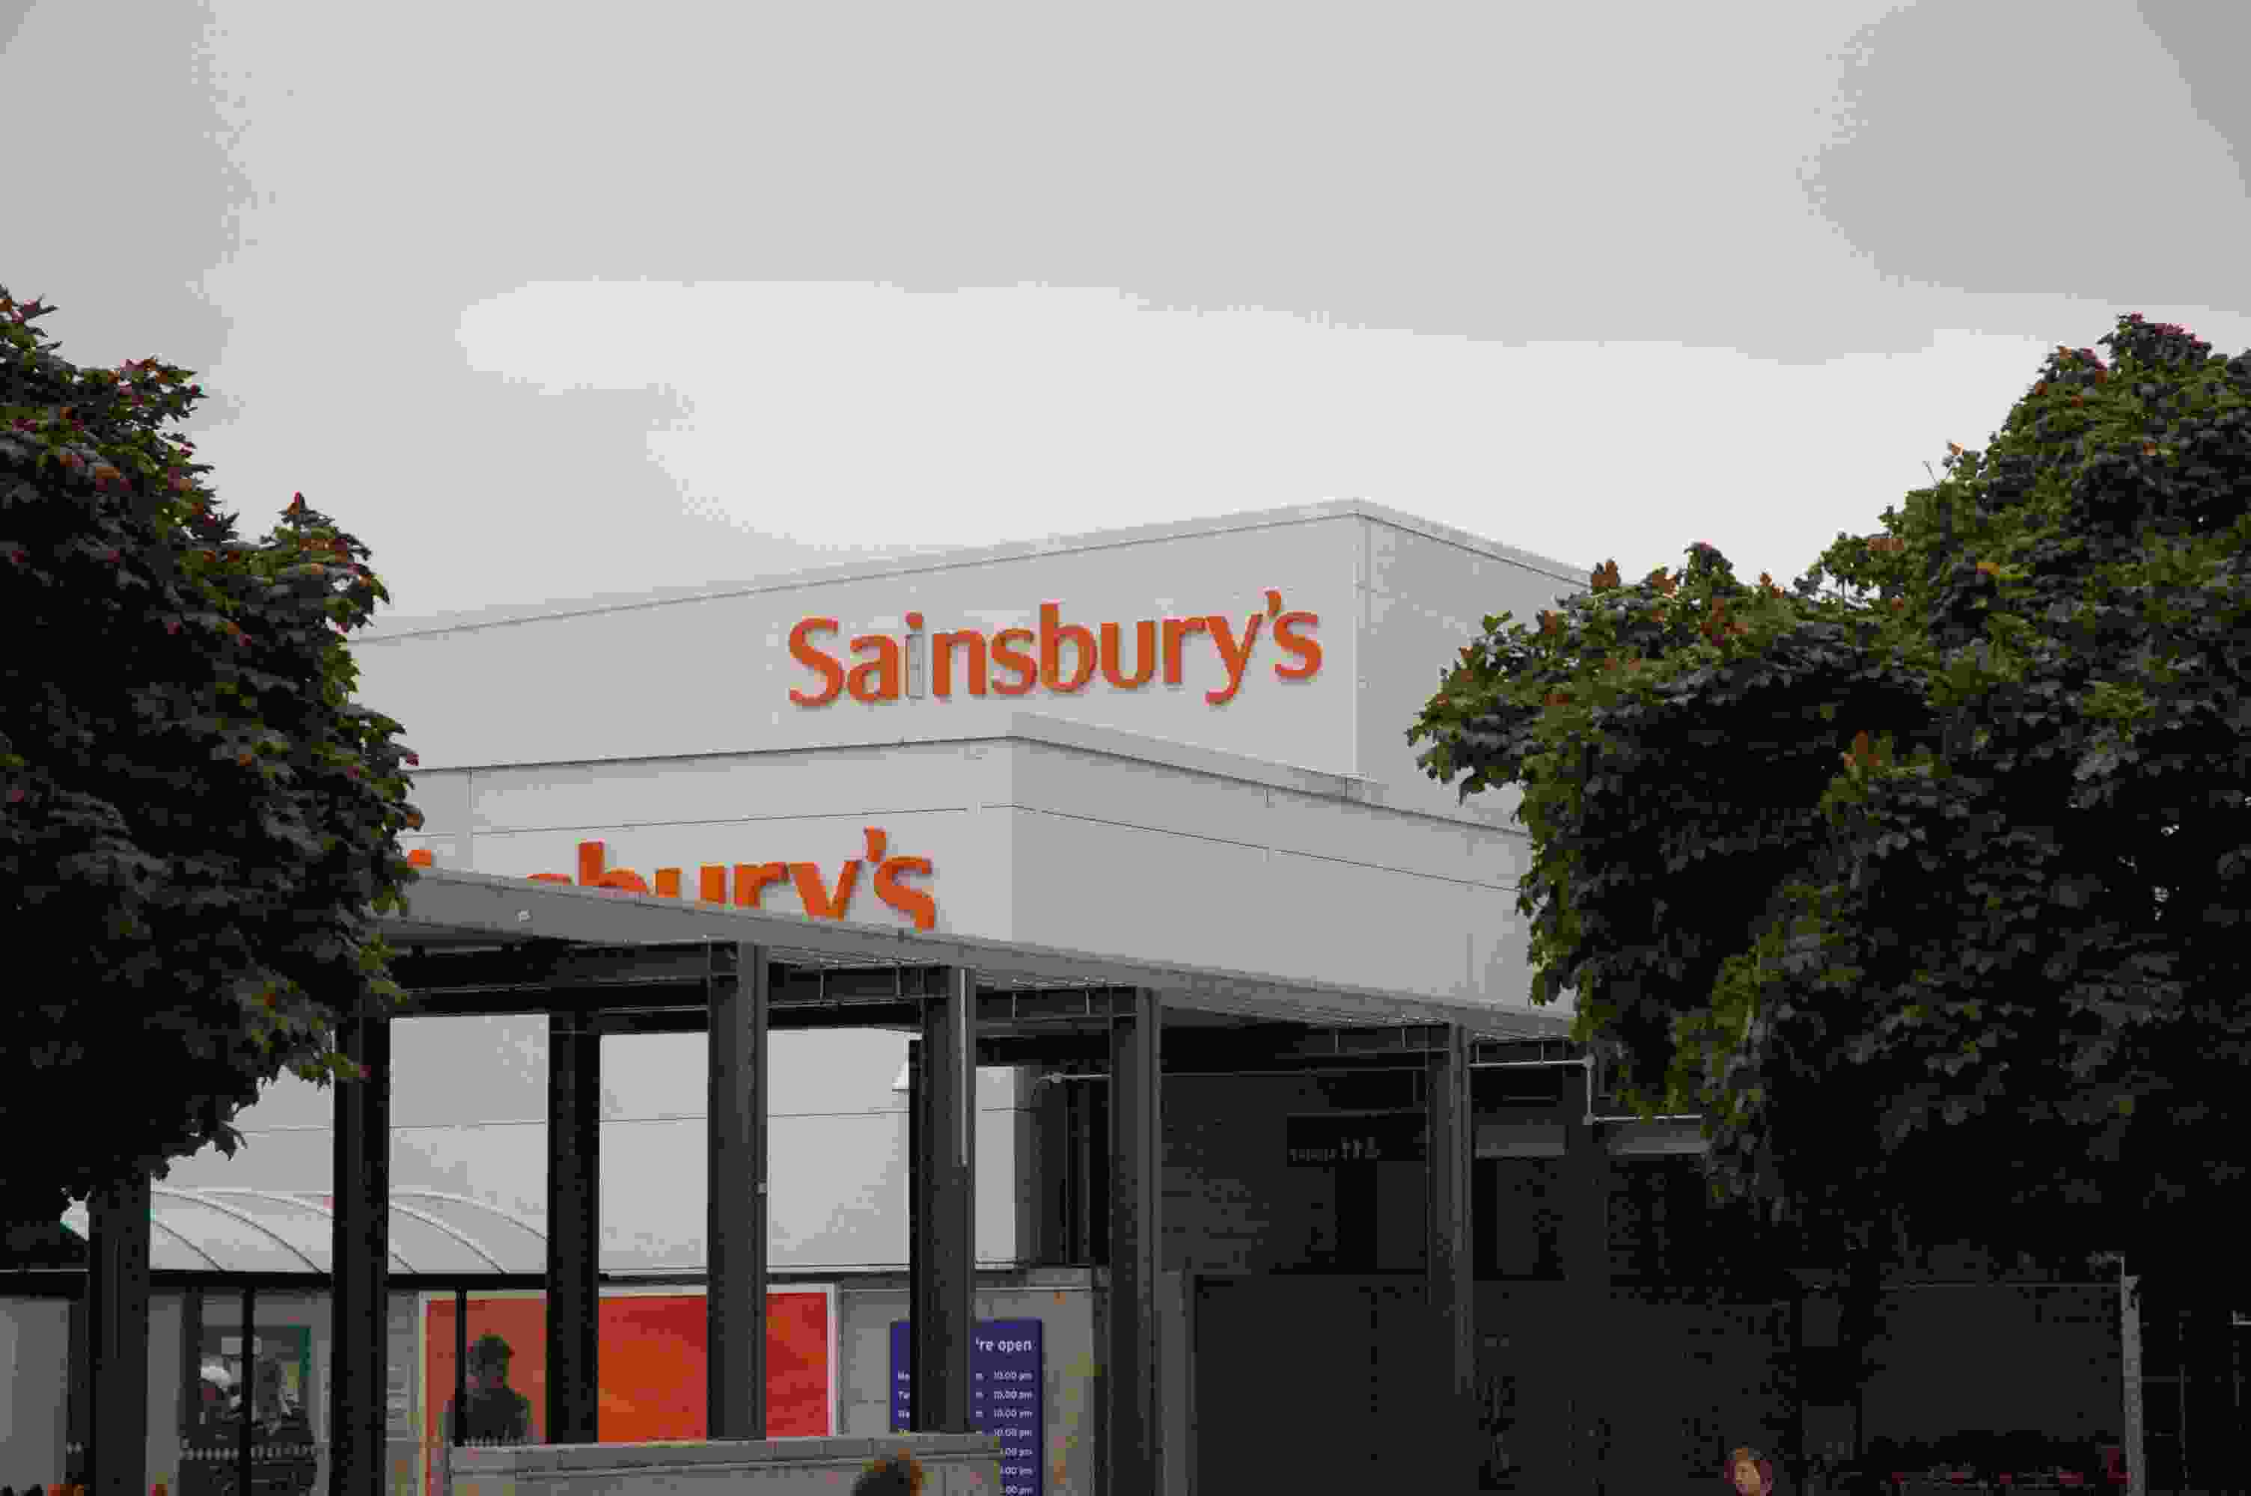
The growth of out-of-town stores has also been helped by other factors. The majority of the public now have access to a car (unlike in the past), while roads have been improved and widened in many towns and cities over the last thirty years. This has helped in making shopping sites at the edge of settlements very easily accessible for most people.

There are now over 1000 superstores, hypermarkets and retail shopping centres in the UK (with a hypermarket defined as having a minimum area of 2500 square metres). Ikea, for instance, only has four stores in the south-east but hopes to cater for all London homes with these, suggesting that all Londoners are within the market area of one of its branches. Huge warehouses at each site allow a diverse range of goods to be stocked in bulk.

