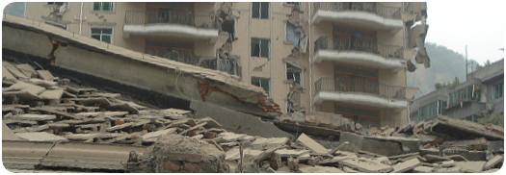
The Sichuan Earthquake occurred on Monday 12 May 2008 from 2.28pm to 2.31pm. This three minute earthquake led to the deaths of 70,000 people. Scientists and geographers are interested in earthquakes for a number of reasons. Firstly there is the science of what makes the earthquake occur and secondly there is the way that the impact of such an earthquake needs to be understood, managed and learnt from. Together those working on earthquakes have much to discover. All have to work together to make sure earthquakes are better prepared for and dealt with in the future. Despite this, the Chinese government acted swiftly. The largest earthquake of the 20th Century also happened in China in 1976 when somewhere between 250,000 and 750,000 people perished. In this instance the Chinese government was slow to act, and since that time many more procedures have been put into place to ensure that action is taken
quickly.
Sichuan Earthquake measured 8.0 on the Richter Scale which is a measure of how strong an earthquake is. This scale is a logarithmic scale which means that an earthquake measuring 8.0 on the scale is ten times more powerful than one measuring 7.0 and so on.
The epicentre of the earthquake was 80km WNW of Chengdu. In addition to those killed by the earthquake 374, 000 people were injured and 18,000 have been listed as missing. For many months after the earthquake had struck, aftershocks have continued to hit the region causing further damage.
One of the greatest tragedies of the earthquake was the death of so many children who were in school at the time. Although official numbers have not yet been formally announced, it is expected that the death toll for young people was very high. Given that many Chinese are allowed to have only one child, this has been particularly devastating for the region.

Around 70,000 people were killed, making it the 19th most deadly earthquake ever

sichuan Quake Qua;quake

e

Flashpoint 3

Devastation and despair for sichuan

Not only were 70,000 people killed in the region, but many of these were children as schools in the area had been poorly constructed and the earthquake struck at lesson time.
China

Epicentre of the earthquake
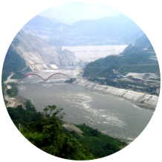


Although Sichuan lies on a fault line and is an area prone to earthquakes, recent evidence suggests that the earthquake could have been caused by the building and filling of a massive dam, five kilometres away from the epicentre of the earthquake. Zipingpu Dam is 150 metres tall and holds 315 million tonnes of water. Fan Xiao, a chief engineer at the Sichuan Geology and Mineral Bureau in Chengdu has suggested that it is very likely that the presence of such a weight on the sensitive tectonic area could have caused the earthquake. China is a country that is developing quickly and as such it has a great demand for infrastructure such as water supply and hydro electricity. It is here that geographers and scientists have to work together. Planners and engineers have to listen to geologists to ensure that such events do not happen again. Also, areas have to be surveyed to make sure that where such projects already exist, a proper risk assessment is made to ensure that people are safe and that structures of all kinds do not pose risks of any kind.
Scientists keep a careful watch on world ‘seismicity,’ and have described the event in Sichuan as being due to: “the northward movement of the India plate at a rate of 5cm/year and its collision with Eurasia, resulting in the uplift of the Himalaya
and Tibetan plateaux” (British
Geological Survey). Being aware of
where stress is building up helps
planners to zone areas so that building
is minimized or built to a standard that
has characteristics that will reduce the impact of such tremors.
Links
This Californian Institute of Technology Techtonics Observatory looks at some of the science of the earthquake.

Visit YouTube as there is a lot of primary footage from the earthquake. Search for “Sichuan Earthquake”:

See the Telegraph for a situation update.

Wordlist
Richter Scale
Earthauake
Tremor
Fault line
Epicentre
Seismograph
China
Seismic Map

315 million tonnes of water

what do the scientists & geographers have to say?

Poorly constructed schools

The Chinese have described the construction of school buildings as ‘tofu dregs.” The Chinese government has indicated that as many as 7000 poorly constructed schoolhouses collapsed during the earthquake. Scientists, engineers and planners need to work together to design and locate schools so that they are as safe as they can be. Maps need to be drawn up to determine which schools are in risk areas and plans need to be made to ensure that staff and pupils are briefed on earthquake procedures and drills.
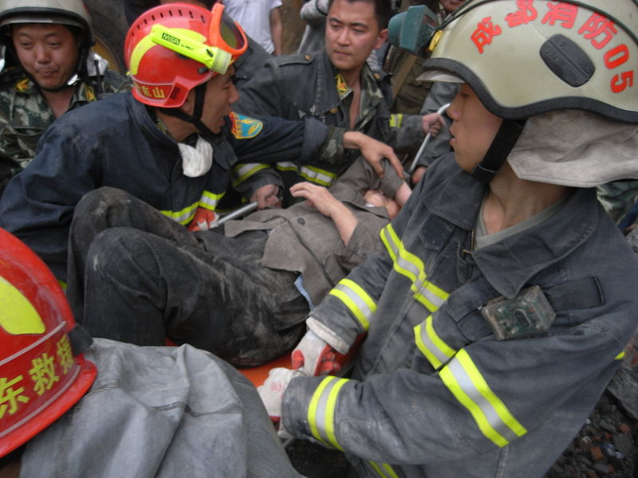

Images from Wikimedia Commons and licensed for use under Creative Commons License.

Fan Xiao, the chief engineer of the Sichuan Geology and Mineral Bureau in Chengdu, said it was "very likely" that the construction and filling of the reservoir in 2004 had led to the disaster."There have been many cases in which a water reservoir has triggered an earthquake," said Mr. Fan. "This earthquake was very unusual for this area. There have been no seismic activities greater than a magnitude seven quake along this particular seismic belt before." The Telegraph, 2nd Februray 2009

