Investigating: California Drought

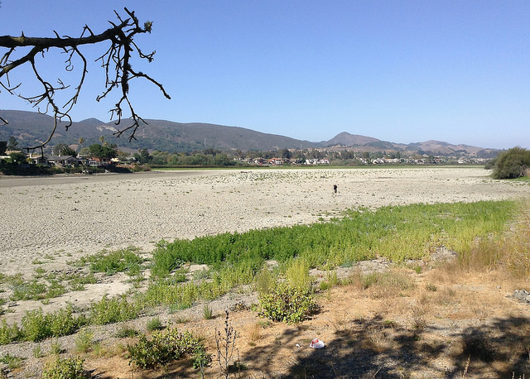
California Drought, Laguna Lake © Docent Joyce, Flickr.

Watch this video to provide the context for the activity. Go to BBC website http://www.bbc.co.uk/news/magazine-19121807

- Visit websites below to find out what happened
- Using this information complete the Investigating California Droughts worksheet
- Questions to think about include:
  - What is drought?
  - What does this tell us about drought in California?
  - What is happening in California?
  - Why is this happening?

Use these websites to complete the California worksheet:
- Go Drought Monitor website http://droughtmonitor.unl.edu/Home/StateDroughtMonitor.aspx?CA
- Go National Drought Mitigation Centre website http://drought.unl.edu/DroughtforKids.aspx
- Go Global Warming Isn’t Causing Drought? Website http://www.nbcnews.com/science/environment/global-warming-isnt-causing-california-drought-report-triggers-storm-n263941
- California’s vanishing lakes. Go to Daily Mail website http://www.dailymail.co.uk/news/article-2731091/California-s-vanishing-lakes-Before-photos-reveal-shocking-shriveling-effect-state-s-devastating-drought-decades.html

Investigating: California Drought
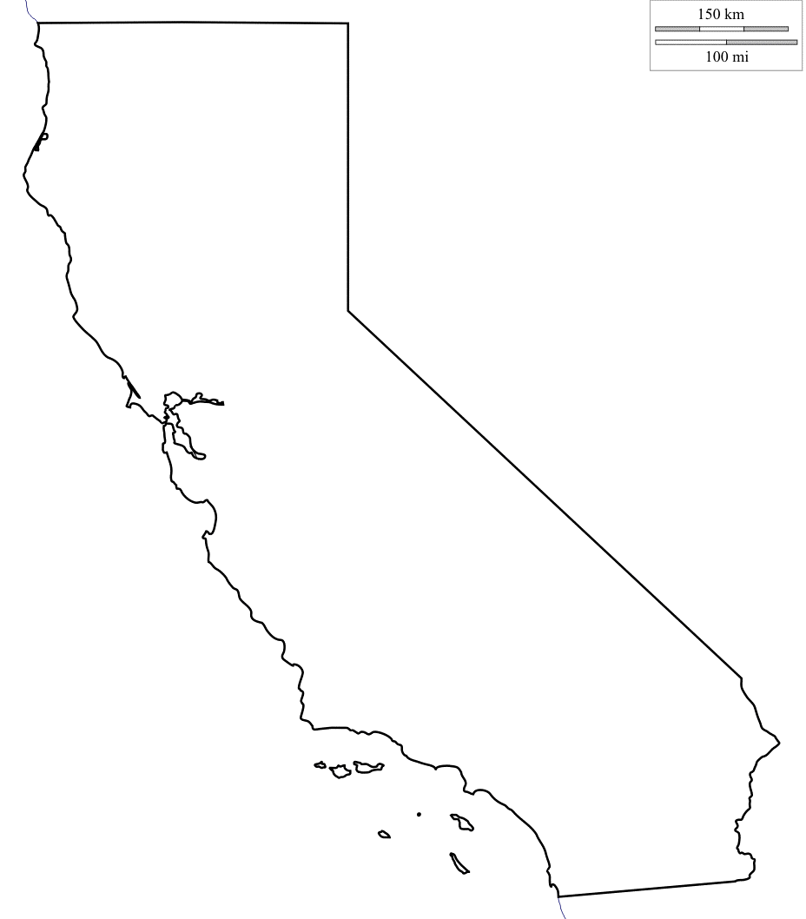 | Causes of drought in California: | Impacts of drought in California:
Social:

Economic:

Political:

 | Actions taken in response to drought in California:

Using an atlas or Google Earth label the map of California with the following key settlements:
Los Angeles; San Diego; San Jose; San Francisco; Fresno; Sacramento
Label the map of California with areas that are prone to drought using your own research

