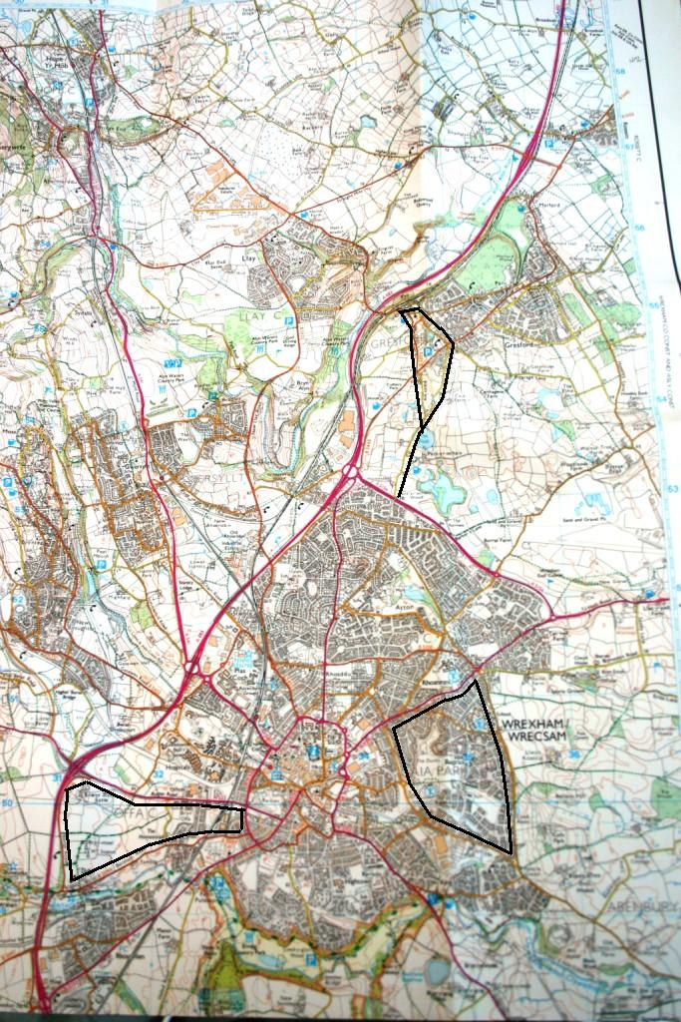
Map extract sample
C
B
A
Route C

This would be the better route; no main roads, more scenic environment, doesn’t pass too many houses
Give students a map extract of your local area with three routes marked on. Each should be approximately 5k in distance. Try to make one a more obvious “winner” if possible
Route B

This route is not very scenic and passes through residential areas. There is a stretch on a busy A road
Route A

This route is flat and more scenic, but has a long stretch on a busy A road into Wrexham town centre.

