Londonmapper: a short Scheme of Work

“London is so old, so vast, so complex and kaleidoscopic in variety and changes that it is difficult so to describe it as to make the description a verbal or pictorial microcosm of the metropolis”
Rt. Hon. John Burns (1930)

Future urbanists’ Introduction

January 2214
Floor 42
The Boris Johnson Tower

The teacher enters the classroom, pausing to look at the view spread out below her.
London.
The city sprawls outwards for as far as the eye can see, and beyond. Because of the heat haze and high levels of brown haze – the distant horizon is shrouded. Glancing down she sees a small patch of green, which represents all that remains of Hyde Park, and she can just make out the Royal Geographical Society on the edge of it. She wonders what Shackleton would have made of the changes he had seen as he stood on the corner of the building.
She turns to face her class. Their faces or avatars are projected onto the curved screen before her – a few blank rectangles indicate students who have not yet logged into the classroom, but by the time she has pulled up the materials that she intends to use, they are all present. She reminds them to authenticate their location and identity (there have been cases where students have asked someone else to sit exams for them or faked their avatars) and then brings up a series of bold images of London which circle in mid-air before her: the Houses of Parliament, the new London Eye, the Queen Elizabeth Stadium, Hoverport and Euston Transport Hub.
She sits on her floating chair, and with a glance at the clock she starts her lesson.
“Good morning class”.
“Today’s session of our course on Urban Geographies is focused on the city where I am sitting today.”
She polls the students as to which of them have visited London in person rather than virtually, and asks them to share their experiences, which she collates into a rolling screen of text and contributed multimedia material.
“We are going to look back at the early years of the 21st Century, when decisions were made which resulted in some characteristics of the city that we see today taking shape.
At that time, the city was undergoing some challenges – some of which we have solved today and others that remain. All cities are in constant flux. There have been many things written about London. Which of them do you think are still true today?”
A series of quotes scroll across the screen, accompanied by a narration:

“When a man is tired of London, he is tired of life; for there is in London all that life can afford.” - Samuel Johnson

“It is my belief, Watson, founded upon my experience, that the lowest and vilest alleys in London do not present a more dreadful record of sin than does the smiling and beautiful countryside.” – Sherlock Holmes (Arthur Conan Doyle)

“I don't know what London's coming to — the higher the buildings the lower the morals.” – Noel Coward

“Paris is a woman but London is an independent man puffing his pipe in a pub.” – Jack Kerouac

“London has the trick of making its past, its long indelible past, always a part of its present. And for that reason it will always have meaning for the future, because of all it can teach about disaster, survival, and redemption. It is all there in the streets.” – Anna Quindlen

“London, London, London town, You can toughen up or get thrown around.” – Kano

“You can't ever get bored of London ‘cos even if you live here for like a hundred and fifty years you still won't ever know everything about it. There's always something new. Like, you're walking round somewhere you've known since you was born and you look up and there's an old clock on the side of a building you never seen before, or there's a little gargoyley face over a window or something. Don't you think it's cool?” – Richard Rider

“I want you to know that I have nothing against Orlando (Florida), though you are, of course, far more likely to get shot or robbed there than in London.” – Boris Johnson

“No matter what you want to do in London, there's a million others who are in the queue ahead of you. Everything is always a hassle.” – Craig Taylor

“London in 2100 is in better health than at the start of the century. That in itself is a miracle..” – Professor Ella Parkinson

“Can you find other quotes which add to this sense of the city and its changing nature?” she asks.
“We’ll start next lesson with some of those, so come prepared. There’ll be extra credit for anyone who finds a quote that I’ve not heard of before”.

The teacher pauses and ensures that each student has recognised and noted this task. She now uses a timeline device to take students ‘back’ to 2014, and a slideshow of familiar and unfamiliar images fills the screen.

Show a slideshow of Flickr images or other images showing London and its iconic buildings.

“At the end of the first decade of the century, there was a Census: a count of the population as well as a chance to ask them some questions.”
A subtle chime draws her attention to a question from a student.
“Yes, they had to answer them, or face a fine.
The 2011 Census was also the last great Census to involve paper forms. Remember that this was a time of challenge for those in government, with financial austerity across the region, tensions over immigration and the need to improve the quality of life for people in the city, all set against the realisation that the climate was becoming increasingly uncertain and extreme. We’ve obviously faced greater challenges since, but back then, this was a time when many people questioned the authority of those who governed them, and there were even threats to the United Kingdom itself. The diversity of the city was, as now, recognised by some as offering many benefits, but also created some challenges. Those managing the city and its population needed a way to visualise the changes so that they could prioritise areas to focus on.
Was it housing, or transport, or education, or air quality that they needed to target, or perhaps crime.
Which do you think they focused on?”

She opens up an immediate polling tool, and students enter their ideas for which might be the greatest management challenges for those in charge of a global city. The results are unsurprising, but there are a few interesting observations. She makes a note of the students that made those choices, and will follow up with them separately between classes.

“OK. I need you to use your geographical imagination now. Think back to that time, when the Global InfoNet was in its infancy and was called the Internet. At that time, there were static ‘locations’ that people visited using clunky mobile devices. These were called websites. There was no standard on how these were put together.
I’m going to challenge you to use one of these websites, which emerged back in 2014 and offered a new perspective on the city. It was called ‘Londonmapper’, and used a new type of map to show some of the outcomes from the Census, and other datasets. What stories can we unpick from these maps?
Remember that this was also a time when London reached its highest ever population, after some years when it had declined from earlier greatness. This was the start of the great change that was to come.”

The teacher displays a number of question prompts on the screen, and opens up the option for students to respond to them in various formats.

- What was London like back then in 2014?
- Which areas do you think emerge as needing some sort of attention?
- How could London be improved?
- What are the benefits of the maps that are shared here, and do you have any difficulties in using them, especially as some of you are unfamiliar with the city.”

The teacher draws the students’ attention to a resource that she has created.
“I’m going to give you thirty minutes to explore the site using this resource, and also the SiteMap, and then you’ll have some challenges.”
She blanks her avatar, and it is replaced on the students’ individual monitors by a countdown timer and soft swirling music plays that has been shown to help concentration and creativity.

Use the LondonMapper – the first 30 minutes document to explore the site.
Refer to the SiteMap PPT if required
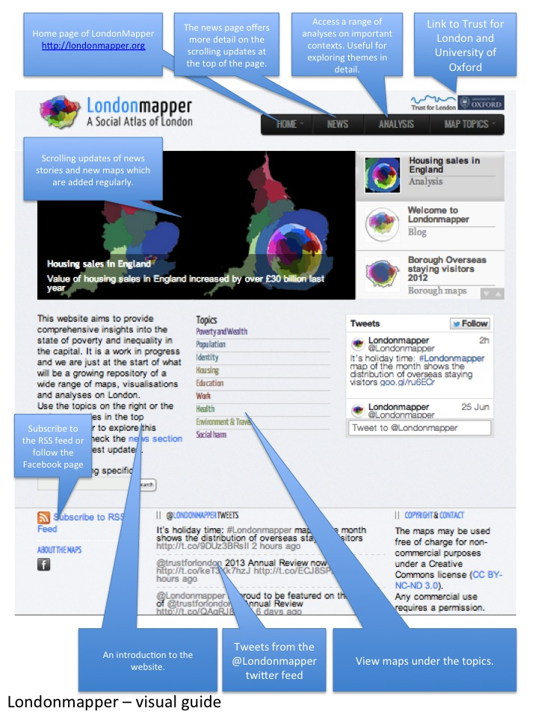

Session Plans
This section provides a basic ‘scheme of work’ for geography teachers, which includes four sessions. A session can be of variable time depending on the school’s context. The sessions are intended for those at KS3 or KS4. There is scope for teachers to adapt the resources, and this is to be encouraged.

You are encouraged to add your own ideas here.

Session 1: Back to the Future

Objectives | Activities | Resources | Outcomes
Preamble  What do we mean by a global city? What are the major features of any global city? | Play slideshow of images, while reading the introduction to the unit to the students. | Images of London – could be sourced from Flickr or alternative site.  Text of Introduction to Future Urbanists  Could create this in the form of an audio file, or ask students to produce a movie version as an extension challenge. | Students are introduced to the idea of global cities.  Opportunities to share stories of cities they have visited (within the UK and beyond) and how they compare with London.
Main Activity  Use the ‘First 30 minutes’ resource to explore the LondonMapper site | Students should explore the LondonMapper website, to familiarise themselves with the contents. There may be additional guidance from the teacher. | ‘First 30 minutes’ resource (PDF)  LondonMapper website.  LondonMapper layout (PDF) | Students explore the site, and learn about the features. Encourage them to think about, and share, the aspects of cities which they feel might be the hardest to manage for those ‘in charge.’
Reflection  How useful is the site?  What was the most interesting / unexpected discovery that you made when exploring the materials? | Key Questions  Could consider the way that cities are socially constructed by those who live in them.  Compare the comments made by those students who may have experienced life in a city (this will depend on your school context of course). | LondonMapper website.  Google Form for students to fill in their thoughts. This could be billed as an ‘exit form’  Can be filled in here:  http://goo.gl/forms/4B5XrXlHPA | Each student to have completed an ‘exit form’ with a personal reflection on the site, and how they might use it. Link opposite.

Extension activity
Question on the board:
Which city would you most like to live in when you are older?

Encourage students to articulate the reasons for their choice. Are they based on personal experience or their perceptions of those places?
An ESRI StoryMap could be created of their choices if time permits, using ArcGIS Online (free ESRI Global Account needed to save and share maps).

Session 2: Improving the city – what to focus on?

Objectives | Activities | Resources | Outcomes
Preamble | Students are placed in groups and provided with a question from the previous lesson that they need to explore. This will develop from the comments made on the ‘exit tickets’. | Mini-whiteboards | Some ideas for what the group is going to do with their time. What extra questions can they come up with.
Main Activity | Focus on a particular aspect of the Census, using the maps which have been produced as part of LondonMapper website (supported with other information) from the Census | Access to Londonmapper website and PPT – Explore the same statistic using different methods – do a comparison of the maps that are created.
Reflection | What does a city with a high quality of life look like?  Consider whether London fits the criteria for livability as shown below | Mini whiteboards  Presentation materials for Session 2 (PPT)  Livability Sheet (PDF) | Creation of some ideas for a ‘manifesto’ for improving London in 2014.

Livability [of a city] is generally understood to encompass those elements of home, neighbourhoods, and metropolitan areas that contribute to safety, economic opportunities and welfare, health, convenience, mobility, and recreation.
There are three major sets of objectives for achieving a livable city:
- Human-oriented and environmentally friendly, with features that make it attractive and make living in it convenient, safe, and pleasant; a high degree of sustainability is often a component of this characteristic
- Economically viable and efficient – is London economically viable?
- Socially sound — that is, without social, economic, or ethnic barriers, or wide variations in income, crime, and unrest; there should be a sense of togetherness and pride in the city and region.

Extension activity
Research how cities other than London have tried to improve the quality of life for their residents. Explore other European cities such as Brussels, Copenhagen, Stockholm, Zurich or Munich.
Students may be provided with

Session 3: City futures

Objectives | Activities | Resources | Outcomes
Preamble | Introduce the idea of ‘Futures’ and explain that this is one of Geography’s strengths – that geographers are able to consider the future. | Questions document from session 1  Futures PPT  http://goo.gl/forms/4B5XrXlHPA | Discussion on futures that they are sure will happen and others they know nothing about. How far into the future are students certain about?
Main Activity | City Futures Cards – use the cards to consider some futures scenarios, and how the city might be affected. | City Futures Card set. | Come up with some possible, probable and preferable futures for London.
Reflection | How likely are the futures that are explored to actually happen? Which do you think would be familiar to the Future Urbanists from 2214? | Discussion | Critique the futures that were suggested in the previous activity. Organise them on a continuum of likelihood.

Extension activity
Consider this news report from the future… could it really happen?

The Times of London
1st July 2021
Greater London National Park
Exactly seventy years after the first UK National Park– the Peak District – was designated, London today became a National Park. It is the first urban national park in the world to be given this designation, although some areas of cities such as Chicago had previously received similar protection. The decision, which was approved by the Government at the start of the year, marked the end of a long campaign by Daniel Raven Ellison, who was also given a knighthood in the Honours List.

- How likely is this to happen?
- What changes would need to take place in the ….
- How would it affect the …
- Identify some ‘winners’ and ‘losers’ from a designation such as this -

Visit the website for the Greater London National* Park: an idea which is still not quite at the stage described above, but is gaining a lot of interest.

http://www.greaterlondonnationalpark.org.uk/
* a notional park

Session 4
Then and Now…

Objectives | Activities | Resources | Outcomes
Preamble | Introduce the idea of the final assessment / presentation piece. | Ideas from Session 3 | Discussions on the nature of assessment and possible formats.
Main Activity | Preparation of a brief presentation on what London was like in the 21st Century  How had it changed in the previous half-century?  What were the warning signs that things weren’t going right for the city and what methods were tried to reduce these.  - Air Pollution  - Rising house prices  - Congestion charge and Bicycle hire scheme  - Social inequality  - Riots Summer 2012 | LondonMapper website.  Internet access.  Pinterest board of images:  http://www.pinterest.com/geoblogs/ mapping-london/ | Creation of a ‘manifesto’ for the future of London.  Presentations must include reference to existing maps from the site, as well as the possible creation of a new visualization / map / data analysis to draw together some threads of the unit.
Reflection | Is London a city that is ‘going in the right direction’? | Consider these Futures Questions  Thames Flood Barrier – is a new one needed further downstream?  Queen Elizabeth Park – how did it develop once the Olympics were over? Did the promised ‘legacy’ emerge?  Hyde Park – why was it allowed to disappear? What happened to the other Parks in London?

Final Discussion Question

What were the key decisions that were made as a result of the Census that changed the way that London is today in the 22nd century?

Appendix
Additional Information
Some notes:

A Scheme of Work and resources have been created as part of the Royal Geographical Society’s Rediscovering London project. These are called ‘Mapping London’.
These were written by the author of these materials, and are intended to complement these materials, and make reference to them. There is a long list of additional resources that link to London.

http://www.rgs.org/OurWork/Schools/Teaching+resources/Key+Stage+3+resources/Mapping+London/Mapping+London.htm
As part of this project a PINTEREST board of images has been created:
http://www.pinterest.com/geoblogs/mapping-london/

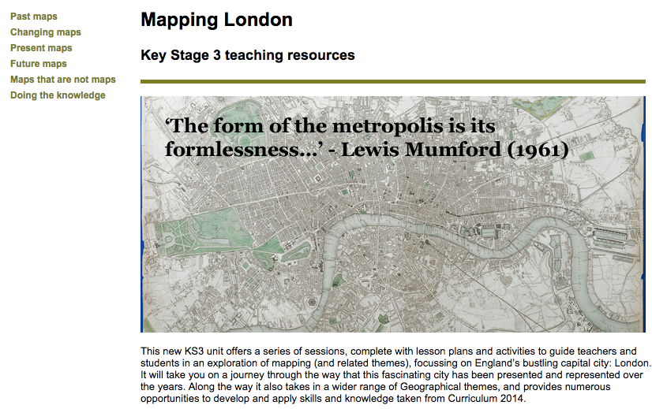

Future Skyline
Skyline of the Future – Visit this Guardian interactive where users can visualize the new skyline – what is the city like now, and how is it going to change?
http://www.theguardian.com/artanddesign/ng-interactive/2014/mar/london-skyline-changing-now-future-pictures
Consider the nature of the skyline – comparison with other cities – planning restrictions to reduce height and maintain integrity, e.g. sightlines of St. Paul’s have to be maintained

Census 2011
2011 Census – what did it say about the situation that London was facing and clues about how it needed to change ?
http://www.ons.gov.uk/ons/guide-method/census/2011/index.html
Do people still travel into the city in the same way / same numbers ?

- What jobs existed then which don’t now?
- What are these commuters moving in to do?
- What new jobs have appeared since then?

YouGov Profiler
https://yougov.co.uk/profiler#/
This tool appeared in 2014 and allows students to explore the ‘typical’ characteristics of people who fit a particular profile, or have a particular interest. These are interesting as discussion points.
Why not try searching on London to see what emerges…

FAQs
Some key questions that have been asked by teachers about Londonmapper maps

What maps can I find on the site
Londonmapper uses cartograms to visualise the social dimensions that shape the city. Some cartograms may be very distorted so that the following guide map containing labels for the Boroughs of London will help you to read the colours correctly in other maps on this website. A ‘’normal’ land area map of London has been provided for reference if you need further help to adjust your eyes to a cartogram projection.

How are they produced ?
The maps are produced using a range of data, a base map and some algorithms and computer software. There is a workflow to produce each map, although each one is bespoke, so alterations to this workflow may need to be made. Each one requires:
- Data – from an up-to-date reliable source, at the right scale (some tidying of the data may be required)
- Excel – statistics and calculations are required as well as data tidying
- GIS – ensuring locational information is accurate
- Algorithms – scripts are ‘run’ which transform the data and map them to the shapes of the gridded cartograms

Gridded cartograms – these are based on population size rather than the actual size of grid, which means that figures are connected to where people live in greater numbers rather than where the area is larger.

Rank Maps – exists for some maps – these have the same colour scheme on each map and always put the topics in order of value. Interpretation of these maps needs to be done with care.

Four things to do with our maps…

Love them (no further information required)
Compare them (with other maps and also with each other)
Print them (they make great displays for classrooms, and also discussion points for those who see them in corridors)
Critique them (do they distort or clarify patterns, how could they be improved?)

References

Websites
LondonMapper: http://www.londonmapper.org.uk/
WorldMapper: http://www.worldmapper.org/
London Curriculum documents: https://www.london.gov.uk/priorities/schools-and-education/schools-and-education/for-teachers/london-curriculum/the-london-curriculum
Lives on the Line (James Cheshire): http://life.mappinglondon.co.uk/
CASA / UCL – Ollie o’Brien: http://oobrien.com/ - this includes the London City Dashboard - http://citydashboard.org/london/
Datashine: a very good set of visualisations: http://datashine.org.uk/#zoom=12&lat=51.52&lon=-0.15&layers=BTTT&table=QS411EW&col=QS411EW0007&ramp=YlOrRd - this allows the exploration of Census data to help with the various activities that have been produced
Illustreets: http://illustreets.co.uk/
Royal Geographical Society – Mapping London resource – written by Alan Parkinson: http://www.rgs.org/OurWork/Schools/Teaching+resources/Key+Stage+3+resources/Mapping+London/Mapping+London.htm

Resources
ArcGIS StoryMap Journal app – released July 2014 – allows the creation of interactive maps which are connected with mapping: http://storymaps.arcgis.com/en/

Further reading

’32 Stops’ – Danny Dorling (Penguin, 2012) – social inequality and 32 stories of families and the circumstances they live in, related to the tube station that they live next to – connects with the idea of ‘Lives on the Line’

One focus of the unit is on the geographical theme of FUTURES. This references the work of David Hicks, who has done a lot of work in this area, and how it connects with the key concepts in Geography.
Suggested reading
Graham Butt: ‘Geography, Education and the Future’
Lambert and Morgan: ‘Geography a Conceptual Approach’
James Cheshire and Oliver Uberti: ‘The Information Capital’ (2014) - http://theinformationcapital.com/ website shows a variety of the 100 maps that are contained in the actual book.

Some relevant Twitter Feeds to follow for urban ideas

@geoviews
@urbanphotoblog
@TheCrystal
@spatialanalysis
@theinfocapital

Postscript

The lesson is over, the students disconnect, and each of the faces fades away, and a section of the screen changes back to a blank rectangle.

The teacher logs out with a gesture of her hands, and leaves the room to take the elevator down to ground level. Her implanted security chip triggers the doors, and she is provided with an update on her ongoing travel as she descends. Red rain is forecast, but the mass urban transit systems are running smoothly.

She extends her umbrifuge, and steps out into the city…

