Africa – a continent of contrasts
Lesson 6: Education in Ghana – moving forward

Primary school – variations in attendance

Percentage of children of primary school age attending primary school, Ghana, 2006

 | Net attendance rate (Male) | Net attendance rate (Female) | Net attendance rate (Total)
Region
Greater Accra | 78.3 | 81.8 | 80.1
Northern region | 52.2 | 47.2 | 49.7
Area
Urban | 75.7 | 77.4 | 76.6
Rural | 63.6 | 61.5 | 62.6
Age
6 | 29.7 | 27.7 | 28.7
7 | 47.9 | 48.8 | 48.3
8 | 65.5 | 71.6 | 68.7
9 | 80.1 | 78.5 | 79.3
10 | 82.5 | 81.0 | 81.8
11 | 88.8 | 87.5 | 88.1
12 | 88.3 | 86.7 | 87.5
Wealth
Poorest | 48.4 | 44.5 | 46.5
Richest | 87.1 | 85.8 | 86.5

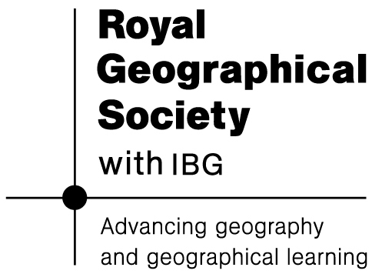

Data sourced from the Ghanaian Ministry of Education, Science and Sports: http://www.moess.gov.gh/prim.htm

