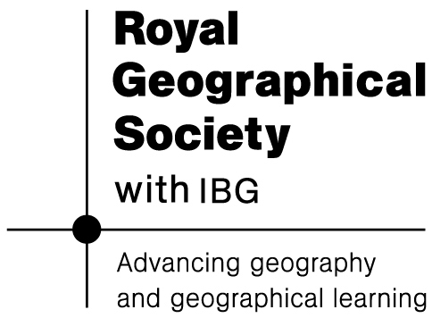
Pole of Cold
KS3

The new KS3 document, which is for first teaching from September 2014 connects with the Pole of Cold trip in several ways. A unit based on the expedition and its outcomes would connect in the following ways:

There are some key areas which can be explored

- develop contextual knowledge of the location of globally significant places – both terrestrial and marine – including their defining physical and human characteristics and how these provide a geographical context for understanding the actions of processes
- understand the processes that give rise to key physical and human geographical features of the world, how these are interdependent and how they bring about spatial variation and change over time
- are competent in the geographical skills needed to:
  - collect, analyse and communicate with a range of data gathered through experiences of fieldwork that deepen their understanding of geographical processes
  - interpret a range of sources of geographical information, including maps, diagrams, globes, aerial photographs and Geographical Information Systems (GIS)
  - communicate geographical information in a variety of ways, including through maps, numerical and quantitative skills and writing at length

See the Russia document for more detail on these areas.

