Why is the climate of Kenya so important?

Kenya’s climate is very important to the country. It uses its climate to grow foods and materials to sell to other countries for money. Kenyan people earn money by doing these different jobs:

Kenya has some very good farmland because of its good climate and good soils. 80% of the people in Kenya are involved in farming so it provides jobs for many people. When the rains come, land has to be prepared and crops planted by the farmer before the land becomes dry again. The main crop in Kenya is maize. This is ground up into flour and made into a paste called ‘Ugali’ this is eaten with stew. Other crops grown include tea, coffee, coconuts, sugar cane and tropical fruits.

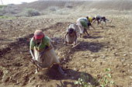

FARMING

Farm workers © Michael Hughes

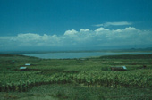
Kenya has started growing lots of flowers to sell in other countries. The area around lake Naivasha in the centre of the country, has good soils and lots of water (from the lake) making it perfect for growing flowers all year. Flowers grown include roses, lilies and carnations. This has given jobs to the local people but many scientists are worried that too much of the water in Lake Naivasha is being used. Chemicals used to make the flowers grow are also going into the water. This water is used by many people for drinking and cooking, this is very bad for their health.

GROWING FLOWERS

Lake Naivasha © Cliff Pereira

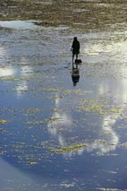

Lake Victoria provides 85% of Kenya’s fish and gives jobs to 35,000 fishermen and their families. The main fish in the lake are Nile Perch and Tilapia, these are caught and then sent to supermarkets all over the world and produce lots of money for the country.

FISHING

Fisherman © Robert Maletta


Tourism is one of Kenya’s most important industries. Many people visit the country because of the warm climate, beautiful landscape and famous animals. Many people work in hotels, shops, restaurants and parks that tourists visit and earn money by providing tourists with the things they need whilst on holiday.

TOURISM

Tourists © A & D Boys


Some of the food produced by Kenya’s farmers is sold to other countries, this is called ‘Export’. Tea, coffee, sugar, maize, rice and flowers are grown and exported.
Tea is the country’s biggest cash crop. This provides money to buy things the country needs.

EXPORT (Selling in other countries)

Arab courier delivering negatives © Royal Geographical Society with IBG

Did you know?
Many of the local fish in Lake Victoria have become extinct because new types of fish from other areas have been brought to the lake. The local fish were important for the health of the lake because they recycled oxygen and kept the water healthy. Now local fish make up only 1% of the fish in the lake, meaning the lake is slowly running out of oxygen!

