MODULE 10: HOW IS BANGLADESH’S PRECIPITATION CHANGING?

STUDENT ACTIVITY 1 & 2

Activity one
Graphic 10.1 shows the ‘precipitation anomaly’ – the difference in rain or snowfall to the 1970-1999 average. If the graph shows a positive number, then it is wetter than the 1970-1999 average. If the graph shows a negative number, then it is drier.
The first part of the graphic with the black and brown lines represents the period 1960 – 2006. The blue, green and red lines represent the predictions of change according to which if the three emissions scenarios, A2, A1B and B1 is modelled on the graph until 2100.
Graphic 10.1
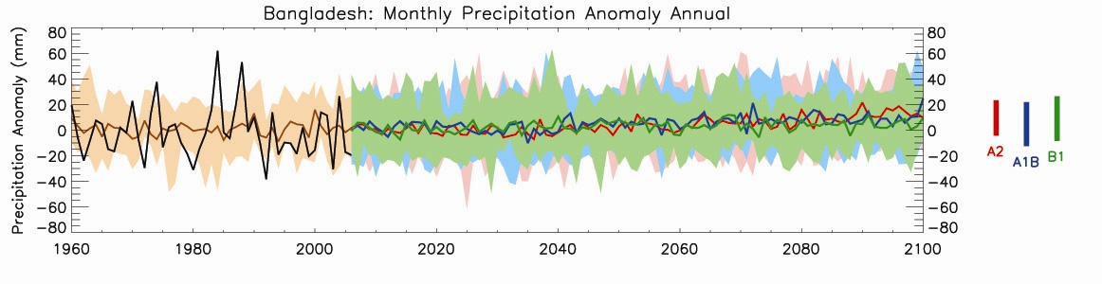
- The black line shows the actual precipitation anomaly for each year from 1960 to 2006. This is the difference in rain/ snowfall between the year’s recorded precipitation and the average of all years between 1970 and 1999.
- The brown line shows past precipitation anomalies as produced by a computer model with the brown shading showing the range produced by the model.
- What is the general trend of the brown line?

Activity two
- The green, blue and red lines show projected future precipitation from 2006 to 2100, according to three different emissions scenarios – B1 green (low), A1B blue (medium) and A2 red (high) explained in Unit 2.
- The shading around each line shows the range of precipitation that might be possible with each emission scenario.

  - What are the general trends of the precipitation in these scenarios?
  - Which regions might have more precipitation and which ones less? Think of proximity to the sea, global wind patterns, altitude and latitudinal effects.

PERSONAL ACTIVITY
- How will a change in the amount of precipitation affect your lifestyle?
- What will be the effects of changes in precipitation and temperature where you live?

