My ‘Summer’ in Antarctica, November 2003 – March 2004

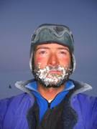
By Tim Burton
Reproduced with permission from Tim Burton. All photographs, copyright Tim Burton

This report is all about my first summer down here as a Field Assistant for the British Antarctic Survey (BAS).

Travel to Antarctica
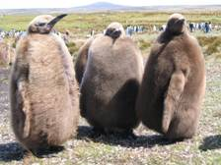
I left the UK on the 31st October last year and flew via Santiago in Chile to the Falkland Islands. My flight from there to Rothera Base was delayed for 2 weeks due to bad weather so I had some time in the Falklands to see the war sites and more importantly the penguins. I went to a King penguin colony and saw the fat fluffy chicks that were very amusing. At last the flight was able to fly to Antarctica in mid November. It was a fantastic flight and 10 of us had all the windows to look out of! When I got off the plane I thought it was a bit chilly but the views around the base were beautiful.

Base Life
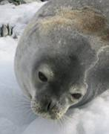
Rothera Base is very comfortable considering how remote it is, we even have showers in our twin rooms! Hot water, heating and fantastic food from our French chef makes life easier than I expected. During the summer it is light 24 hours a day and this makes it difficult to sleep as it’s always bright in your room. The views from base are spectacular and there is loads of wildlife around – we even have to chase the seals off the runway to let the planes take off!

I spent a week on base being trained to use the special Antarctic equipment that BAS supplies – because of what we do and how remote we are, things are different and never lightweight – the tent alone weighs half my bodyweight!!

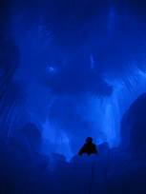
After a week I was sent off into “the field” (ie middle of nowhere!) For me this was a place called Sky Blu at almost 75º South on the Antarctic Peninsula. My other time on base during the summer was spent training people in mountain skills – travelling safely on glaciers with crevasses and how to live safely and comfortably in the cold environment as well as other things. This was good fun and sometimes involved going into a crevasse to practice crevasse rescue. These can be very beautiful places – here is a photo from inside one very close to base:
Weddell Seal
In my spare time on Base I can go skiing or mountaineering with friends in the local mountains. We don’t have a ski lift here so have to either walk up or, even better, get towed behind a skidoo to the top and then ski down!! If the weather is horrible we can stay in and watch films, play in the band or work out in the Gym. There’s a lot to do here and time is passing very quickly.

Sky Blu

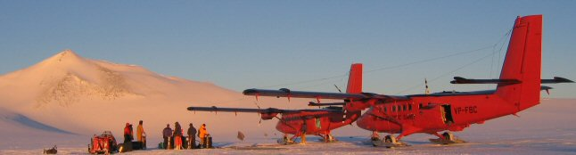
Twin Otters at Sky Blu

Sky Blu (yes it is spelt that way!) is basically a remote ice rink that you can land a plane on. It has a blue, shiny ice runway, a very small hut and 3 tents. When I arrived it was –25ºC most of the time and usually windy too (that’s why there’s blue ice as all the snow is blown away!!) This means that doing anything is time consuming as going outside the hut for just a minute involves putting on several layers, a hat and gloves. The sun is also really bright as it reflects off the snow – you even have to wear sunglasses at midnight!

Work here was very varied – everything from keeping the runway clear of snow to refuelling the aircraft and giving weather observations to the pilots. It is a very beautiful place and is higher than any mountain in the UK. There are a few mountains sticking up out of the ice, which is hundreds of metres thick here. The mountain in the photo above is called “Lanzarote” and often we climbed it and skied on it in our spare time.
The planes in the photo are called Twin Otters. They are used to carry people and equipment into remote places for scientific projects, and have skis as well as wheels so they can land anywhere on snow or ice. I got the chance to fly to lots of places in the co-pilot seat and even got to hold the controls sometimes! Flying over the massive mountains is an amazing experience that I will never forget.
I spent more than 2 months of the summer at Sky Blu, and at last the sun started to set for an hour or so before we closed down and came back to Rothera.

R.A.B.I.D Depot
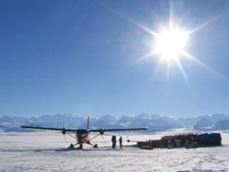
I also spent several weeks working at a deep field project site called R.A.B.I.D. Depot. This stands for Rutford Area Base of Ice Drilling. I was put in charge of inputting the fuel and equipment needed for the project next year. It is a massive joint project with NASA to drill down through 2000m of ice to see why it moves so quickly – currently one metre a day! We had to put 210 drums of fuel there and another 15 plane loads of equipment. The views of the Ellsworth Mountains are stunning and you have an excellent view of Mt Vinson – the highest peak in Antarctica at 4897m, and higher than any in Europe. The photo is of the depot with a Twin Otter and the mountains behind.
At RABID depot we managed to build two Igloos and also a park bench made from snow and wood with the most amazing view. Moving all the heavy equipment and fuel is very hard work and it’s easy to get tired quickly. Luckily when the weather’s bad the planes won’t fly so you get to rest, read, write letters and drink tea in the warm tent!!

The Winter
I came back to Rothera on the 22nd February for the last four weeks left of the summer season. In the summer we have planes and ships coming and going and they can move people around, bring in post and are able to take you home if you were injured. There are up to 110 people at Rothera during summer.
However, the planes left Antarctica at the start of March with lots of people, and on the 18th March we had “Last Call.” This is when our ship, called the RRS Ernest Shackleton, came to Rothera for the last time until next summer. It drops off food and fuel and takes lots of people away. There are now only 23 people here. This photo is some of us on the wharf as the ship was leaving.
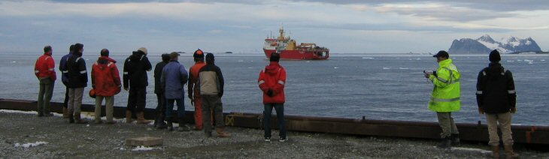
The winter is 7 months long and in that time we will not have any visitors or be able to send or receive any post. Also if someone were to hurt themselves it could take a very long time for them to be rescued. It seems very quiet here now but I like it as it is almost like a big family. We are losing up to 15 minutes of light every day so the nights are getting longer and darker. In the middle of the winter the sun will not rise at all for many weeks. It will be an amazing experience that very few people get the chance to have. The temperatures are dropping and the snow is starting to fall!!

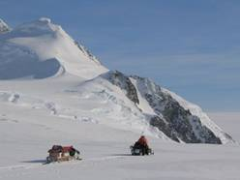
In the winter my job involves two main things. I spend 3 months in the middle of winter servicing all the field equipment used for the science projects and preparing things for next summer season. I spend the remaining 4 months taking the base staff out on “Winter Trips.” This involves taking members of base staff out into the mountains for two weeks each, one week at the start and another at the end of winter. It is a way of improving everybody’s training and also getting time away from base somewhere remote and very beautiful.

I leave for my first winter trip tomorrow. I am taking Fin, the Doctor, through to the North of Adelaide Island to explore the area and also do some mountaineering and ski touring. Hopefully the weather will be good as quite often it isn’t, so you spend lots of time lying in the tent reading and drinking tea again! We travel using skidoos (like a motorbike on skis) and pull large sledges loaded with all our equipment and provisions (see the photo above). We tie the skidoos together, using a strong rope, in case one was to fall into a crevasse, so that the other can stop it falling a long way – some of the crevasses here are VERY deep!! Each trip should be a week long but sometimes the weather changes and means you can’t get back for weeks – I hope Fin’s got some good books!

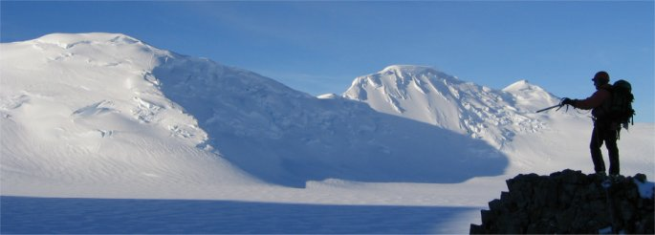
This last photo is from a few days ago whilst out looking at the safe route over the glacier for my winter trips. As you can see it’s a beautiful place, but one which needs respect, as can be dangerous if you’re not careful.

