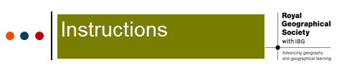
Lesson six: Instructions for pupils

- Go to the Business Insider website to find the map of your focus area:
www.businessinsider.com/every-countrys-highest-valued-export-2014-5?IR=T

2) Choose 4 or 5 different highest-value exports.

3) Go to Google World Map to check which country’s highest-value export it is:
www.google.com/maps/d/viewer?mid=zuVUPD-N5sEk.k2vClsDw8gtQ

4) Consider how the physical and human geography of each country determines its highest-value export and complete the activity sheet.

Extension Task: Use Britannica Kids website http://kids.britannica.com to research more about the country’s geography, imports, and exports. Use the two case study fact cards (USA and Liberia) below to compare the highest-valued exports of the USA and Liberia. Read your card to your partner and fill in the table below comparing the geography of the two countries, relating to their highest-valued exports.
Country | Highest-valued exports | Geographical features of the country
USA | Capital Goods | 1)  2)  3)  4)
Liberia | Rubber | 1)  2)  3)  4)

