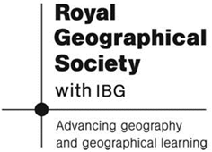
Information Sheet:
Making Money

Information on Seaweed Farming:

Indonesia is an archipelago in South East Asia. It possesses a coastline comprised largely of coral reefs. The archipelago consists of 17,000 islands. Kalimantan is the biggest island followed by Papua, Sulawesi, Sumatera and Jawa islands respectively.

Since 2003, Indonesia has decided to focus on seaweed cultivation as a main target of marine resources, in addition to its existing production of tuna fish and shrimps. About 2.1 million hectares of seawaters were prepared for seaweed cultivation and 1.8 million tons of wet seaweeds were harvested in 2008.

To support the fisheries culture programmes, including seaweed as a main program, the Ministry of Marine Affairs and Fisheries has formulated the “Indonesia Vision” - increasing seaweed harvesting. By 2014, the Ministry expects that as much as 10 million tons of wet weight seaweed will be harvested

In the period 2002 – 2007, seaweed production increased from 278,000 tons in 2002 to 1.73 million tons in 2007. The economic value of the seaweed increased by about 90 percent.

