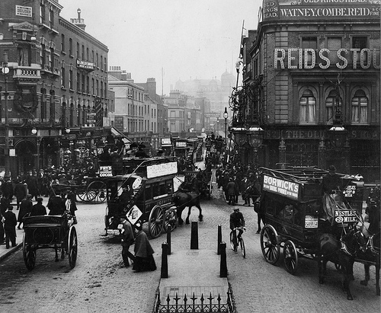
Our Place in History

Lesson 4: Religious buildings

Key ideas:
- Religious buildings can provide clues to what the local area was like in the past.
- The significance of religious buildings and their position in local history may change over time.

Starter activity:
Exploring religious buildings
The aim of this lesson is to provide a cross-curricular link with Religious Studies to investigate how religious buildings can help us to investigate the local area. The lesson starts with an interactive activity where pupils zoom into hotspots around a plan of a religious building to search for information about local history. In this instance, the religious building is a Christian church. However, it should be emphasized that throughout this lesson other religious buildings, such as Islamic mosques or Jewish synagogues, may be more appropriate to study depending on the local area.

Main activity:
Our religious building through time
This activity asks pupils to study plans of a religious building in their local area and to create a model of what it might have looked like in the past. They can then annotate their model to explain what this tells them about the local history of the area. Finally, students could use the information from the British History Online website to add additional information to their models about the religious building and its place in local history. This is a challenging activity, particularly the annotation, and, whilst the internet is a useful source of information, it may be worth asking a local religious leader about the history of the religious building – or even inviting them in to speak to the students and answer any questions they have.

Plenary:
Futures thinking
Pupils could discuss whether they think that religious buildings will be able to give as many clues about local history in the future. They should be able to justify their opinion. The aim of this plenary is for pupils to think about the role and importance of religion both in the past and in the future. Depending on the local area context there may be a variety of different viewpoints as to whether religious buildings will grow in importance or diminish. If the local area has a variety of different faiths it might be interesting to consider each separately rather than as a whole.




