More Information…
About the Butler Model

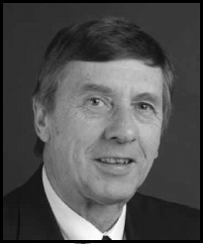
Who is Richard Butler?
Professor Richard W. Butler (1943-) is a British geographer who has researched and wrote about theories related to tourism. In 1980 he wrote a piece for the journal Canadian Geographer entitled ‘The Concept of a Tourist Area Cycle of Evolution’ which examined how the characteristics of a tourist resort of area change over time. His ideas proved to be very popular and over time his ‘Tourism Area Life Cycle’ more commonly came to be known as the ‘Butler Model’.
Source: University of Strathclyde
Professor Richard W. Butler

What does his model show?
His model attempts to demonstrate how a tourist resort can change over time both as a result of the tourists themselves and due to outside influences. His model is commonly seen as a graph with a number of different stages:
- Exploration and Discovery
In the first stage of the model the area under consideration is not even thought of as a resort. In fact this is the stage in which it is first discovered as a potential site of tourism. People who visit are likely to spread the word about where they have been and through this process and interest in the place begins to grow.
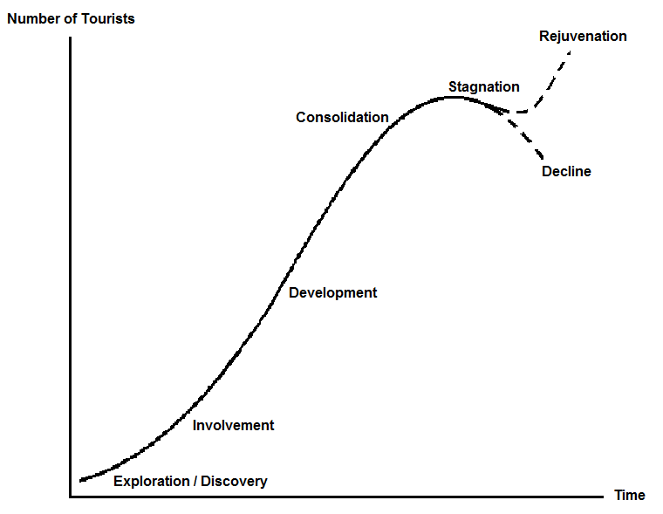
Source: RGS (with IBG)
The Butler Model with its different stages labelled
- Involvement
In this stage the local people in the area start to become involved in the tourism activities. This could mean that they rent out some of their rooms to tourists or act as an informal guide around their town. In these ways the idea of being able to supplement their income from tourism begins to become embedded and more people return as visitors each year.
- Development
The development stage sees the rapid growth of tourism as an industry in the area in question. Many local people will now be employed in tourism based activities, albeit seasonally, and the area is well known as a tourist destination. Hotels, restaurants and tourist facilities are built very quickly to meet demand.
- Consolidation
Tourism has now replaced the original industries of the area and people migrate to the place in search of seasonal work in tourism businesses. The cultural characteristics of the resort have greatly changed such as language, dress, cuisine and building styles.
- Stagnation
In the stagnation stage the resort is starting to look tired and run down. With little of the original attractions, such as landscape or culture, that drew tourists to the area remaining their numbers start to drop off and some tourist facilities find it harder and harder to stay open with the decreased footfall.
There are two possible end results according to the Butler Model:
- a) Rejuvenation
Before the resort closes completely to tourists, local or national authorities take actions to change their fortunes. This could involve the rebranding of a resort to appeal to a different clientele or building new, flagship attractions to draw the tourists back to the place.
b) Decline
If tourists continue to choose an alternative holiday destination then tourism businesses in the town find it difficult to stay open. As they close there are fewer and fewer attractions for tourists and so fewer come back to the resort, compounding the problem until the resort closes completely.

Is his model correct?

Like any model, it is a theoretical representation of real life and not necessarily a mirror of every real world situation. Different tourist resorts have individual characteristics that will actively create their own variables for change and as a result may create different outcomes to the Model that Butler produced. The Butler Model should be seen as a predictor for a lot of tourist resorts and while we should try to understand it in real contexts we should also not dismiss it if it does not fit every tourist resort globally.

