Records of Resistance Image activity

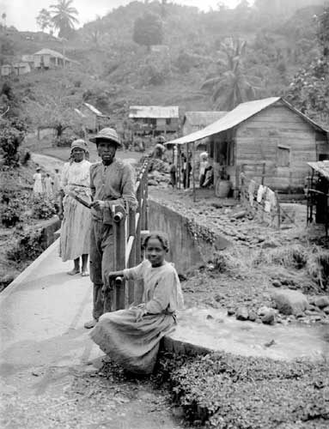

- Describe what you can see. Look at the background and the people.
- What do you think is the relationship between the people?
- What do their clothes tell us about them? How do you think they are feeling?
- What do you think has just taken place and may have happened next?
- Where do you think this photograph was taken?
- Why do you think this photograph was taken?
- What title would you give this photograph?
- Find out from the gallery what the photographer called this photograph and why it was taken. http://www.unlockingthearchives.rgs.org/themes/journeys/gallery/
- What does it tell us about these people in Jamaica?
- Do you think this photograph is an important record? Why?

