How are we linked to our environment?

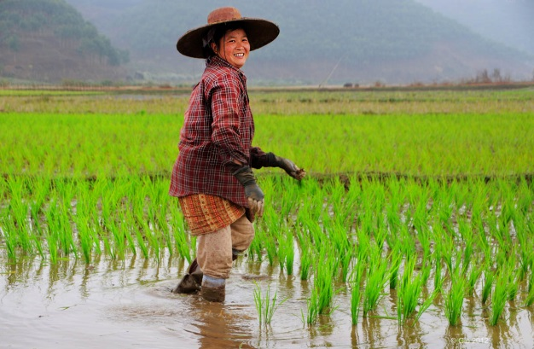  Source: Flickr Creative Commons User Gio Gallery  Source: Flickr Creative Commons User Hayley Sparkksss | 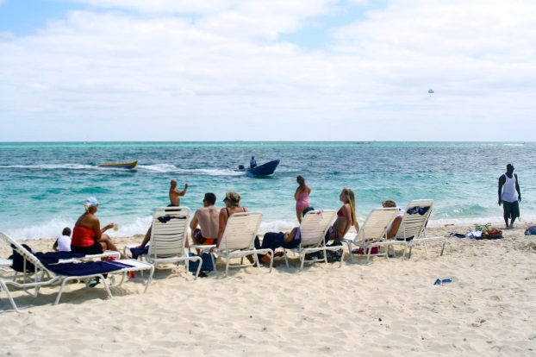
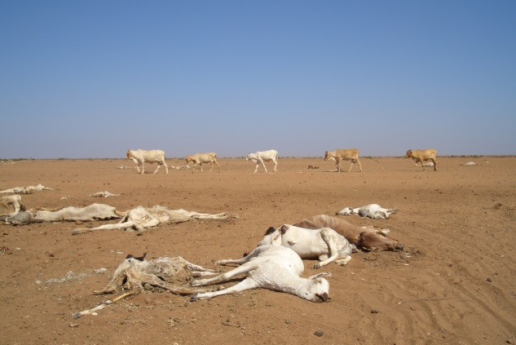  Source: Flickr Creative Commons User Wayne National Forest  Source: Flickr Creative Commons User Oxfam Int | 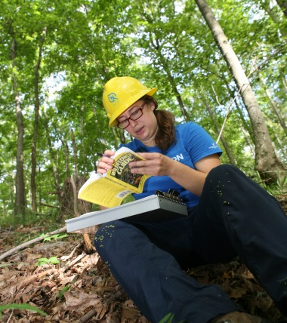
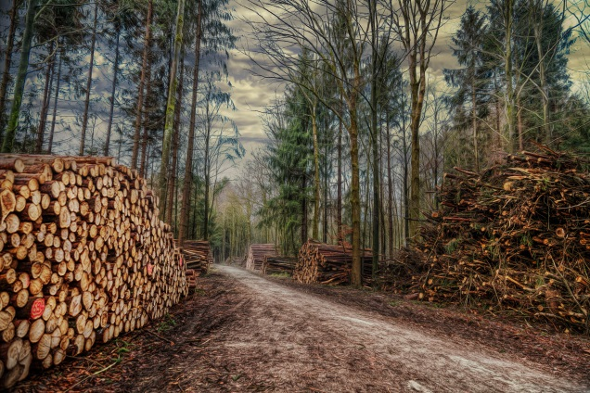  Source: Flickr Creative Commons User Chris Frank  Source: Flickr Creative Commons User John McCabe | 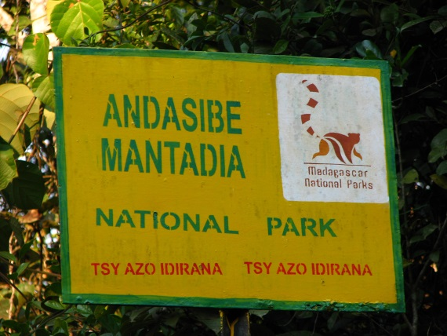
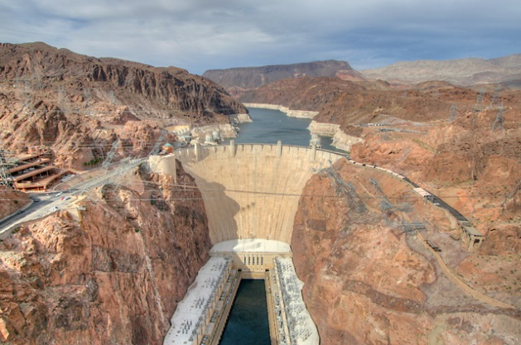  Source: Flickr Creative Commons User Christopher  Source: Flickr Creative Commons User Ralph Arvesen | 