Longshore drift on the coast of Ghana, West Africa
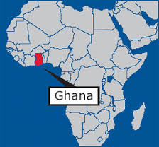
Ghana is located in West Africa. It is boarded by Côte d’Ivoire to the west, Burkina Faso to the north and Togo to the east and has a coastline on the Atlantic Ocean. The capital is Accra. The eastern edge of the country is dominated by the River Volta which flows into the Atlantic Ocean. The coastal town of Keta is under threat of coastal retreat from the process of erosion. It has been estimated that one million cubic metres of sand per year is being removed.

Due to the strong prevailing wind from the South West over the Atlantic Ocean and the power of large waves which reach the coast of Ghana, there is significant and sustained longshore drift. As a result a massive amount of sand is transported by the process of longshore drift from Ghana to the coast of Togo to the east.
Previously the River Volta deposited huge amounts of sediment at the mouth of the river at the delta. Although this sediment was transported by longshore drift, the regular and constant deposition protected the coastline. However, in 1961 the Akosombo Dam was commissioned. The dam now controls the flow of the river and also the flow of sediment from the River Volta in to the Volta Delta. Very little sediment now reaches the delta but the strength of longshore drift remains the same. As a result, not enough sand is being deposited to replace the sand transported by longshore drift leading to coastal erosion and coastal retreat.
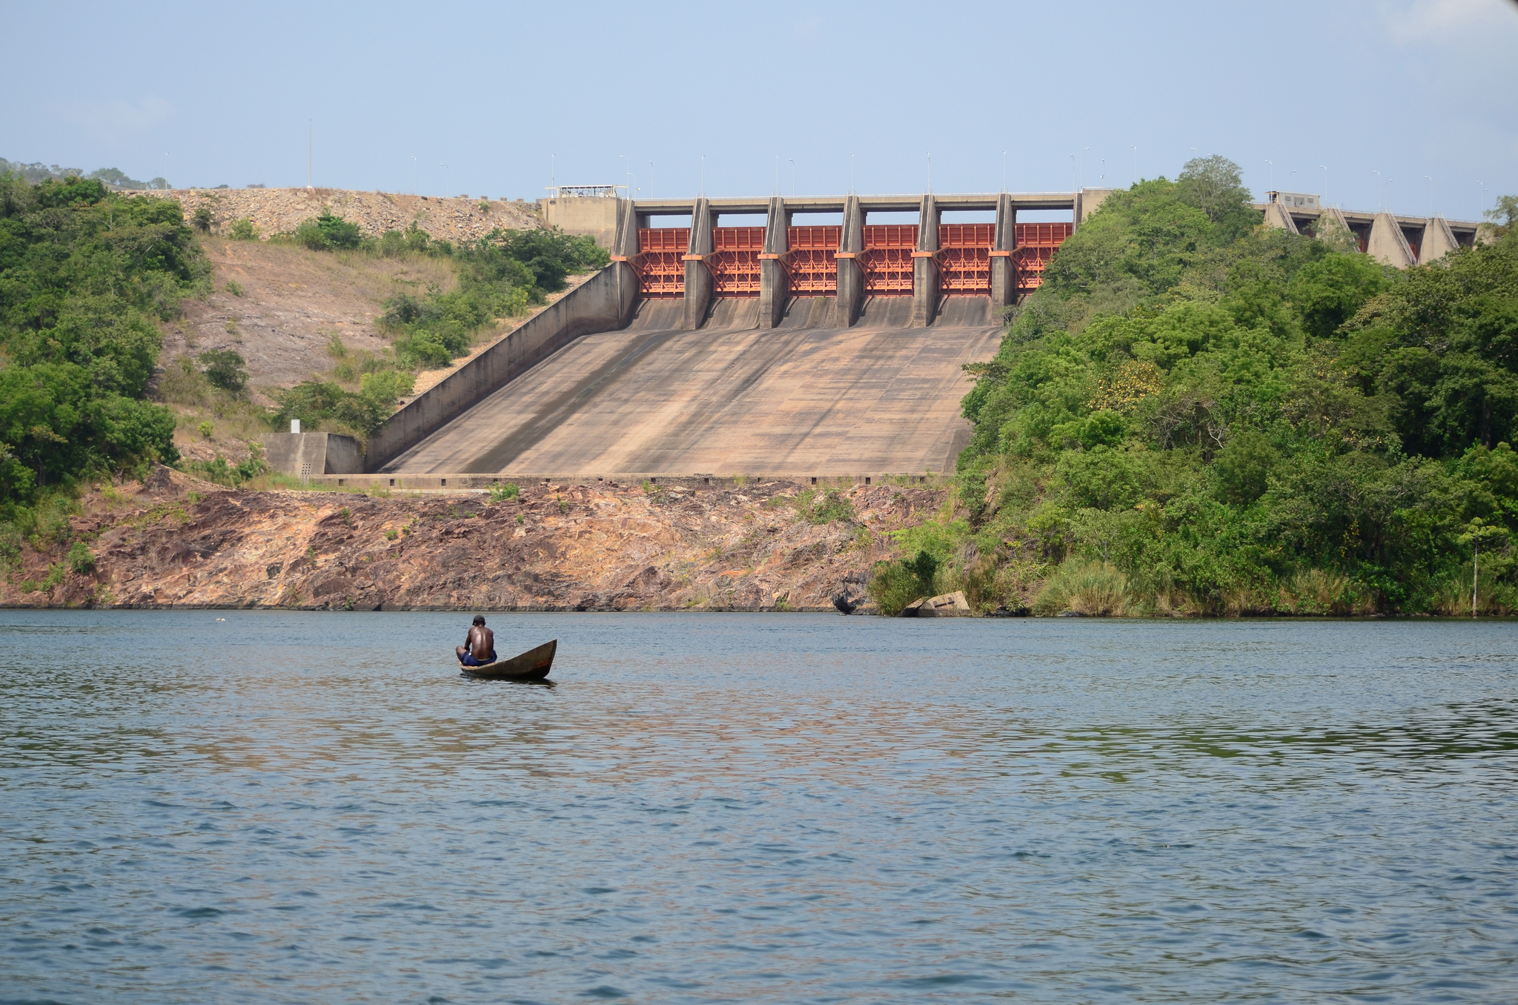

In the last 25 years, Keta, located 30km east of the Volta Delta, has experienced the removal of its protective beach which has left the town very vulnerable to coastal erosion. There has been some attempt to slow the process of coastal erosion at Keta with the introduction of an offshore breakwater and a sea wall to protect the town. In addition, a series of groynes have been built to disrupt longshore drift and a feeder beach has been created between the groynes to increase sediment supply.

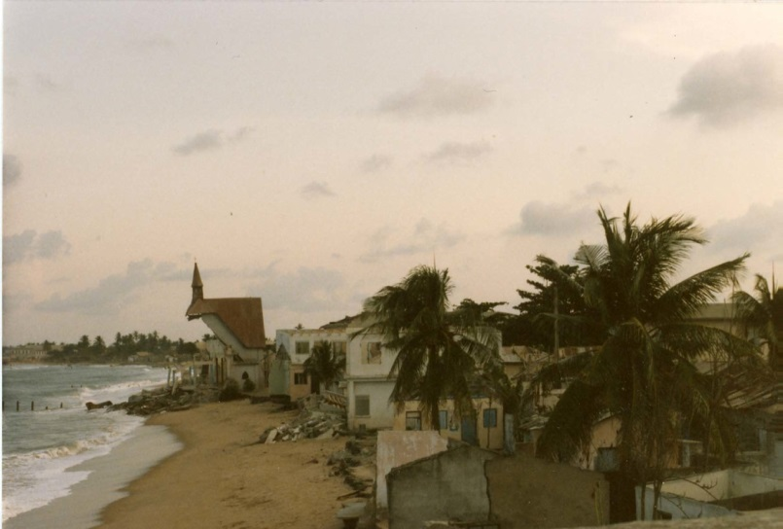
Akosombo Dam.
Source: Rene Mayorga, 2012.
Coastal erosion at Keta.
Source: Beth Knittle, 1985.
Keta – erosion between defence groynes. Source: https://www.fig.net/pub/fig2009/papers/ts04e/ts04e_boateng_3463.pdf accessed 15/8/14

