Describing London’s geology task sheet
Go to the Geology of Britain Viewer on the British Geological Survey website http://www.bgs.ac.uk/discoveringGeology/geologyOfBritain/viewer.html
Then click on the ‘Open Geology of Britain Viewer’ button.
You will see that the United Kingdom is shown with bands of different colours indicating different rock types across the country. Move the image to place the UK roughly in the middle of your screen. (You can move the view either with the arrows on the top right side of the image or by clicking and dragging the image.)
Now zoom in so that England fills up the screen (the ‘+’ and ‘-‘ signs on the top right of the image allow you to zoom in and out).
Notice that you can change the transparency of the geology colour coding with the slider bar to the top right of the image. With a middle transparency, you can see both the geology and other map features such as the location of cities and motorways.
Select ‘Bedrock only’ from the Surface Geology menu on the left side of the image. The map colour coding now just shows the types of solid rock that are either exposed at the surface or that are nearest the surface (underneath soil or other ‘superficial’ deposits).
Click on ‘Geology Key’ to see what each colour represents. Also practise moving around the map, and notice that wherever you click, you will get a pop-up box telling you what the rock is at that place and what the past environment was like when it formed. You can also experiment with the ‘Switch Basemap’ button (top right of screen).
Now click on the ‘Go to Location’ button (top right of screen) and type in London, click ‘Search for Location’, then select London, City of London.
- Make sure the ‘Bedrock only’ button is selected, then click on where you see Covent Garden. What is the bedrock at this location?

- Now, keeping the City of London at the centre of the image, zoom out until you can see the entire M25 motorway which circles Greater London. Click anywhere in central London, and you will see that the bedrock is called ‘Thames Group’ (this includes the rock type you identified for the previous question). What are the thick bands of rock (coloured yellow) which are north and south of Greater London?

- Find Windsor (west of central London, near the M4). Notice that Windsor Castle is built on an outcrop of this rock that overlooks the River Thames. What is the bedrock under Slough? (The town just north of Windsor.) Also, name an area of London with this rock.

- Zoom in closer to central London and find Hampstead and Highgate. Describe the bedrock here (these are areas of higher ground, e.g. Parliament Hill offers a great view of central London).

- Zoom back inwards, keeping the City of London in the middle of your image. Now select ‘Superficial only’ from the Surface Geology menu. (You will notice much more variation in the colours.) Superficial deposits are mostly loose deposits of sands and gravels (not solid rock) that sit on top of the solid geology. The superficial deposits of London have been deposited from the start of the Ice Age up to the present day. Click on the River Thames itself, or along its banks. What is this type of deposit called? (Hint: it starts with an ‘A’.)

- Find Covent Garden again and click here. What is the name of the superficial deposit under Covent Garden?

- Now zoom out of central London far enough until you can see the Finchley area (this is just north of Hampstead and Highgate). Now move the map and zoom into Finchley and click in its central area. What is the name of the superficial deposit found here?

- Note that the pop-up box calls this type of deposit a ‘diamicton’. This means glacial till (a ‘poorly sorted’ jumble of rocks of different sizes deposited by a glacier). The presence of a layer of till at Finchley indicates that the edge of an ice sheet was once here. Using the scale on the image, give a rough estimate of how close the British ice sheet once came to central London.

- Zoom out and see if you can spot the same till found at Finchley at other locations in the north-eastern part of Greater London. Name an area where you find it.

- Now try to imagine these till deposits as what remains of glacial deposits that formed along the southern edge of a large ice sheet that covered most of the UK. At the time the ice sheet was there, try to describe what the area that is now central London would have been like. (Hint: think of temperature, type of vegetation, and what the River Thames would have been like then with all that summer meltwater coming off the edge of the ice sheet.)

- To finish this task, explore some of your own London geology. If you live in London you could look at the geology of the area where you live. If you don’t live in London, you could choose an area you have visited or would like to visit.
Describe both the ‘Bedrock’ geology and the ‘Superficial’ geology of the area of your choice here:

If you live in Greater London, this diagram will help you to locate your own London borough.
Location map for London’s boroughs http://en.wikipedia.org/wiki/London_boroughs
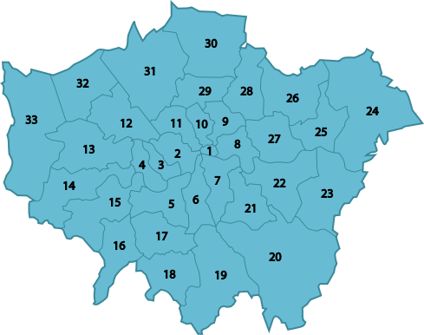
- 1 City of London
- 2 City of Westminster
- 3 Kensington and Chelsea
- 4 Hammersmith and Fulham
- 5 Wandsworth
- 6 Lambeth
- 7 Southwark
- 8 Tower Hamlets
- 9 Hackney
- 10 Islington
- 11 Camden
- 12 Brent
- 13 Ealing
- 14 Hounslow
- 15 Richmond
- 16 Kingston Upon Thames
- 17 Merton
- 18 Sutton
- 19 Croydon
- 20 Bromley
- 21 Lewisham
- 22 Greenwich
- 23 Bexley
- 24 Havering
- 25 Barking and Dagenham
- 26 Redbridge
- 27 Newham
- 28 Waltham Forest
- 29 Haringey
- 30 Enfield
- 31 Barnet
- 32 Harrow
- 33 Hillingdon

