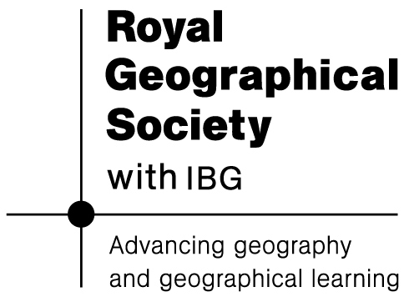
Africa: a continent of contrasts

Lesson 1 starter activity: Ranking the seven continents

a) Ordering the continents by size (AREA):

North America  AREA | 24.5 million square kilometres
South America  AREA | 17.8 million square kilometres
Europe  AREA | 10.1 million square kilometres
Africa  AREA | 30.2 million square kilometres
Asia  AREA | 43.8 million square kilometres
Oceania  AREA | 9.0 million square kilometres
Antarctica  AREA | 14.0 million square kilometres

a) Ordering the continents by the number of COUNTRIES:

North America  COUNTRIES | 23
South America  COUNTRIES | 12
Europe  COUNTRIES | 46
Africa  COUNTRIES | 53
Asia  COUNTRIES | 44
Oceania  COUNTRIES | 14
Antarctica  COUNTRIES | 0

a) Ordering the continents by size (POPULATION):

North America  POPULATION | 500 million
South America  POPULATION | 360 million
Europe  POPULATION | 730 million
Africa  POPULATION | 830 million
Asia  POPULATION | 3,780 million
Oceania  POPULATION | 32 million
Antarctica  POPULATION | 0



