
Ocean Acidification sample exam question

Answer all questions

1 (a) Study Figure 1, a scattergraph which shows the relationship between the temperature and dissolved carbon content of seawater samples collected in the Arctic Ocean.

Figure 1

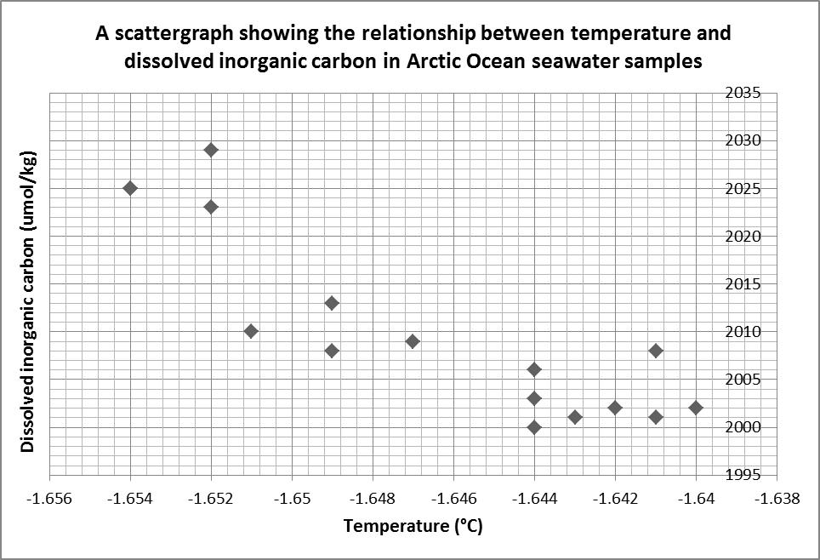

1 (a) (i) Complete the scattergraph by adding the following data

Sample date | Temperature (°C) | Dissolved inorganic carbon (umol/kg)
04/04/10 | -1.646 | 2007
10/04/10 | -1.645 | 2010
16/04/10 | -1.652 | 2018
22/04/10 | -1.650 | 2024
(4 marks)

1 (a) (ii) Draw a best-fit line on the graph to show the trend between the two sets of data. (1 mark)

1 (a) (iii) Describe the relationship between the two sets of variables, as indicated by the scattergraph in Figure 1.

………………………………………………………………………………………………………………………………………………………………………………………………………………………………………………………………………………………………………………………………………………………………………………………………………………………………………………………………………………………………………………………………………………………………………………………………………………………………………………………………………………………………………………………………………………………………………………………………………………………………………………………………
(3 marks)

The next step when investigating the correlation between two variables is to use statistical testing to determine the validity and strength of the relationship.

1 (a) (iv) Write a hypothesis for this dataset that you could investigate through statistical testing.

…………………………………………………………………………………………………………………………………………………………………………………………………………………………………………………………………………………………………………………………………………………………………………………………………………………………………………………………………………………………………………………………………………………………………………
(2 marks)

Question 1 continues on the next page

1 (b) Study Figure 2 below. This table sets out the preliminary workings for a Spearman’s Rank Correlation Coefficient calculation.

Figure 2

Sample date | Temperature (°C) | Rank | Dissolved inorganic carbon (umol/kg) | Rank | d | d²
17/03/10 | -1.644 | 7 | 2003 | 15 | 8 | 64
19/03/10 | -1.644 | 7 | 2000 | 19 | 12 | 144
21/03/10 | -1.644 | 7 | 2006 | 14 | 7 | 49
23/03/10 | -1.643 | 5 | 2001 | 18.5 | 13.5 | 182.25
25/03/10 | -1.641 | 2.5 | 2001 | 18.5 | 16 | 256
27/03/10 | -1.640 | 1 | 2002 | 16.5 | 15.5 | 240.25
29/03/10 | -1.641 | 2.5 | 2008 | 11.5 | 9 | 81
31/03/10 | -1.642 | 4 | 2002 | 16.5 | 12.5 | 156.25
02/04/10 | -1.647 | 11 | 2009 | 10 | -1 | 1
04/04/10 | -1.646 | 10 | 2007 | 13 | 3 | 9
06/04/10 | -1.649 | 12.5 | 2013 | 7 | -5.5 | 30.25
08/04/10 | -1.649 | 12.5 | 2008 | 11.5 | -1 | 1
10/04/10 | -1.645 | 9 | 2010 | 8.5 | -0.5 | 0.25
12/04/10 | -1.651 | 15 | 2010 | 8.5 | -6.5 | 42.25
14/04/10 | -1.652 | 17 | 2023 | 5 | -12 | 144
16/04/10 | -1.652 | 17 | 2018 | 6 | -11 | 121
18/04/10 | -1.652 | 17 | 2029 | 1 | -16 | 256
20/04/10 | -1.654 | 19.5 | 2025 | 2.5 | -17 | 289
22/04/10 | -1.650 | 14 | 2024 | 4 | -10 | 100
24/04/10 | -1.654 | 19.5 | 2025 | 2.5 | -17 | 289

1 (b) (i) Using the formula (where = the number of samples) calculate the Spearman’s Rank Correlation Coefficient for this data set. Show your workings in the box below and give your answer to two decimal places. (5 marks)
= ……….....

1 (b) (ii) Explain how you would establish the significance of the correlation between water temperature and dissolved carbon content.

………………………………………………………………………………………………………………………………………………………………………………………………………………………………………………………………………………………………………………………………………………………………………………………………………………………………………………………………………………………………………………………………………………………………………………………………………………………………………………………………………………………………………………………………………………………………………………………………………………………………………………………………............................................................................................................................................................................................................................................................................................
(4 marks)

Question 1 continues on the next page

1 (b) (iii) Use your knowledge of the process of ocean acidification to explain the significance of a correlation between water temperature and dissolved carbon content in the Arctic Ocean.

…………………………………………………………………………………………………………………………………………………………………………………………………………………………………………………………………………………………………………………………………………………………………………………………………………………………………………………………………………………………………………………………………………………………………………………………………………………………………………………………………………………………………………………………………………………………………………………………………………………………………………………………………………………………………………………………………………………………………………………………………………………………………………………………………………………………………………………………………………………………………………………………………………………………………………………………………………………………………………………………………………………………………………………………………………………………………………
(6 marks)

(Extra space) …………………………………………………………………………………………………………………..
…………………………………………………………………………………………………………………………………………………………………………………………………………………………………………………………………………………………………………………………………………………………………………………………………………………………………………………………………………………………………………………………………………………………………………

END OF QUESTION


Total marks: 25

