
Our energy use

Tick to show lights, computers, taps left on and window open but radiators on in each room. Tick more than once if more than one is left on.

Room number/name | Lights left on  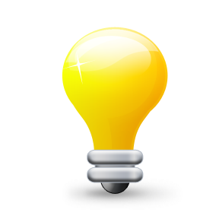 | Computers left on | Taps dripping/left on  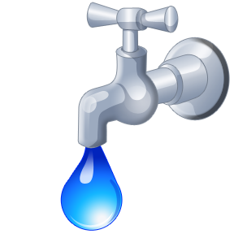 | Windows left on when the radiators are on

